

**[Dynamic Website]**

Assignment Title:

**[Home Gym Equipment]**

Submitted To:

[ Sayar Kyaw Swar Thant]

Submitted By:

[Hlaing Hpone]

[Student ID - 00185329]

[BIT Batch-6]

NCC L5DBIT: **Strategy First University**



**NCC Education**

**Level 5 Diploma in Computing with Business Management**

**Dynamic Website**

|  |
| --- |
| Centre Name : Strategy First University  Assignment Title : Home Gym Equipment  Exam Cycle : Spring 2022  Candidate Name : **Strategy First University**  NCC Education ID No. : 00185329  Submission Date : 17.2.2022 |
| Marker’s Comment :Lack of own reasoning and recommendation. Read questions carefully.  Moderator’s Comment :  Mark: Moderated Mark : Final Mark : | |



**Strategy First University**

|  |
| --- |
| ***A signed copy of this form must be submitted with every assignment.***  ***If the statement is missing your work may not be marked.*** |

**Student Declaration**

I confirm the following details:

|  |  |
| --- | --- |
| Candidate Name: | Hlaing Hpone |
| Candidate ID Number: | 00185329 |
| Unit: | Dynamic Wbsite |
| Centre: | Strategy First University |
| Qualification: | Level 5 Diploma in Business Information Technology |
| I have read and understood NCC Education’s Academic Misconduct Policy.  I confirm that this is my own work and that I have not colluded or plagiarized any part of it. | |
| Candidate Signature: | Hlaing Hpone |
| Date: | 17.2.2022 |
| Word Count; | 1359 |

# Running the project code

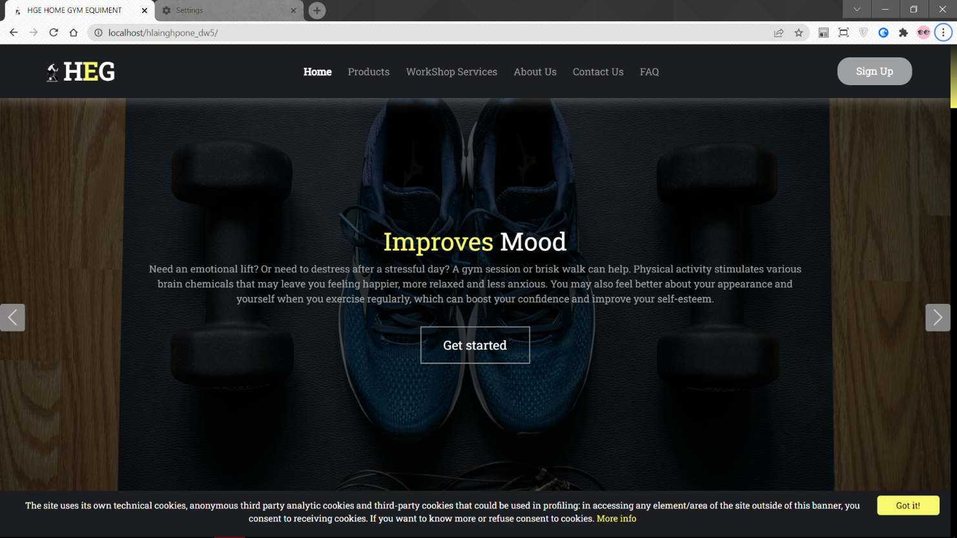

Fig 1.1.1 Running the Home Page part1

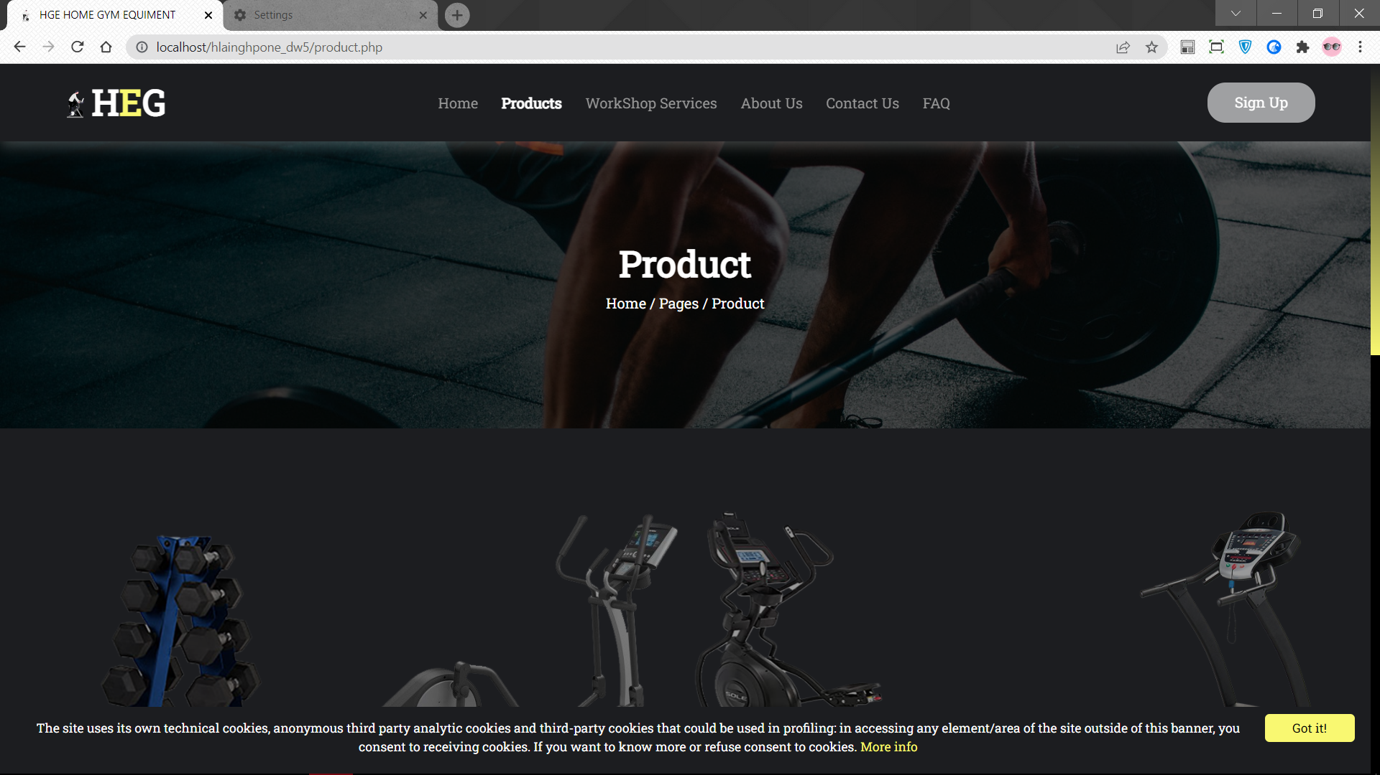

Fig 1.2.1 Running the Product Page part1

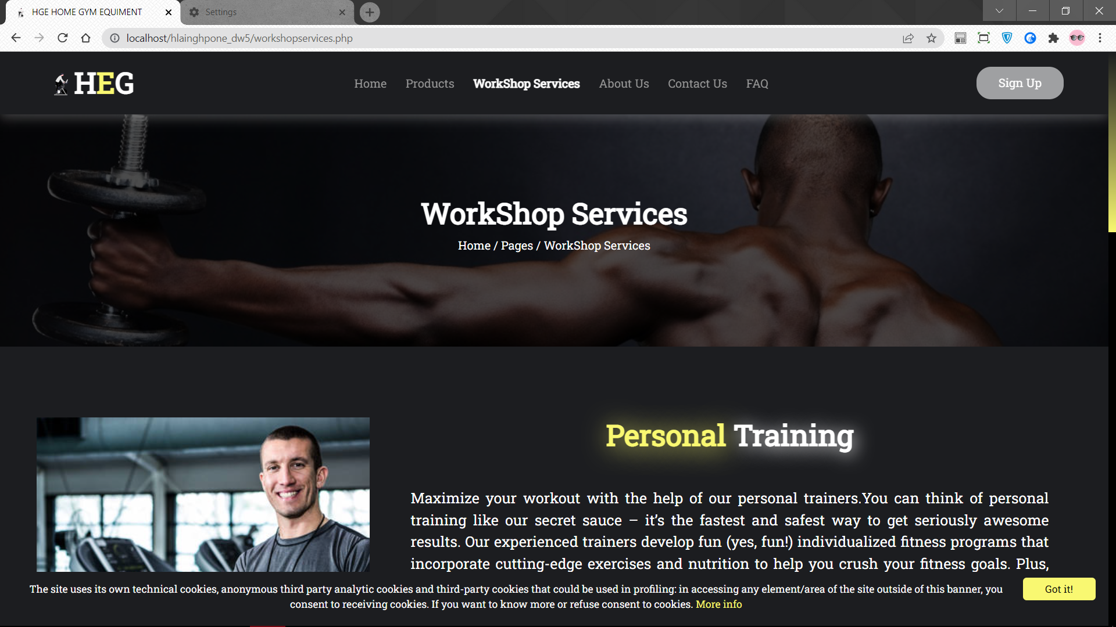

Fig 1.3.1 Running the Workshop Page part1

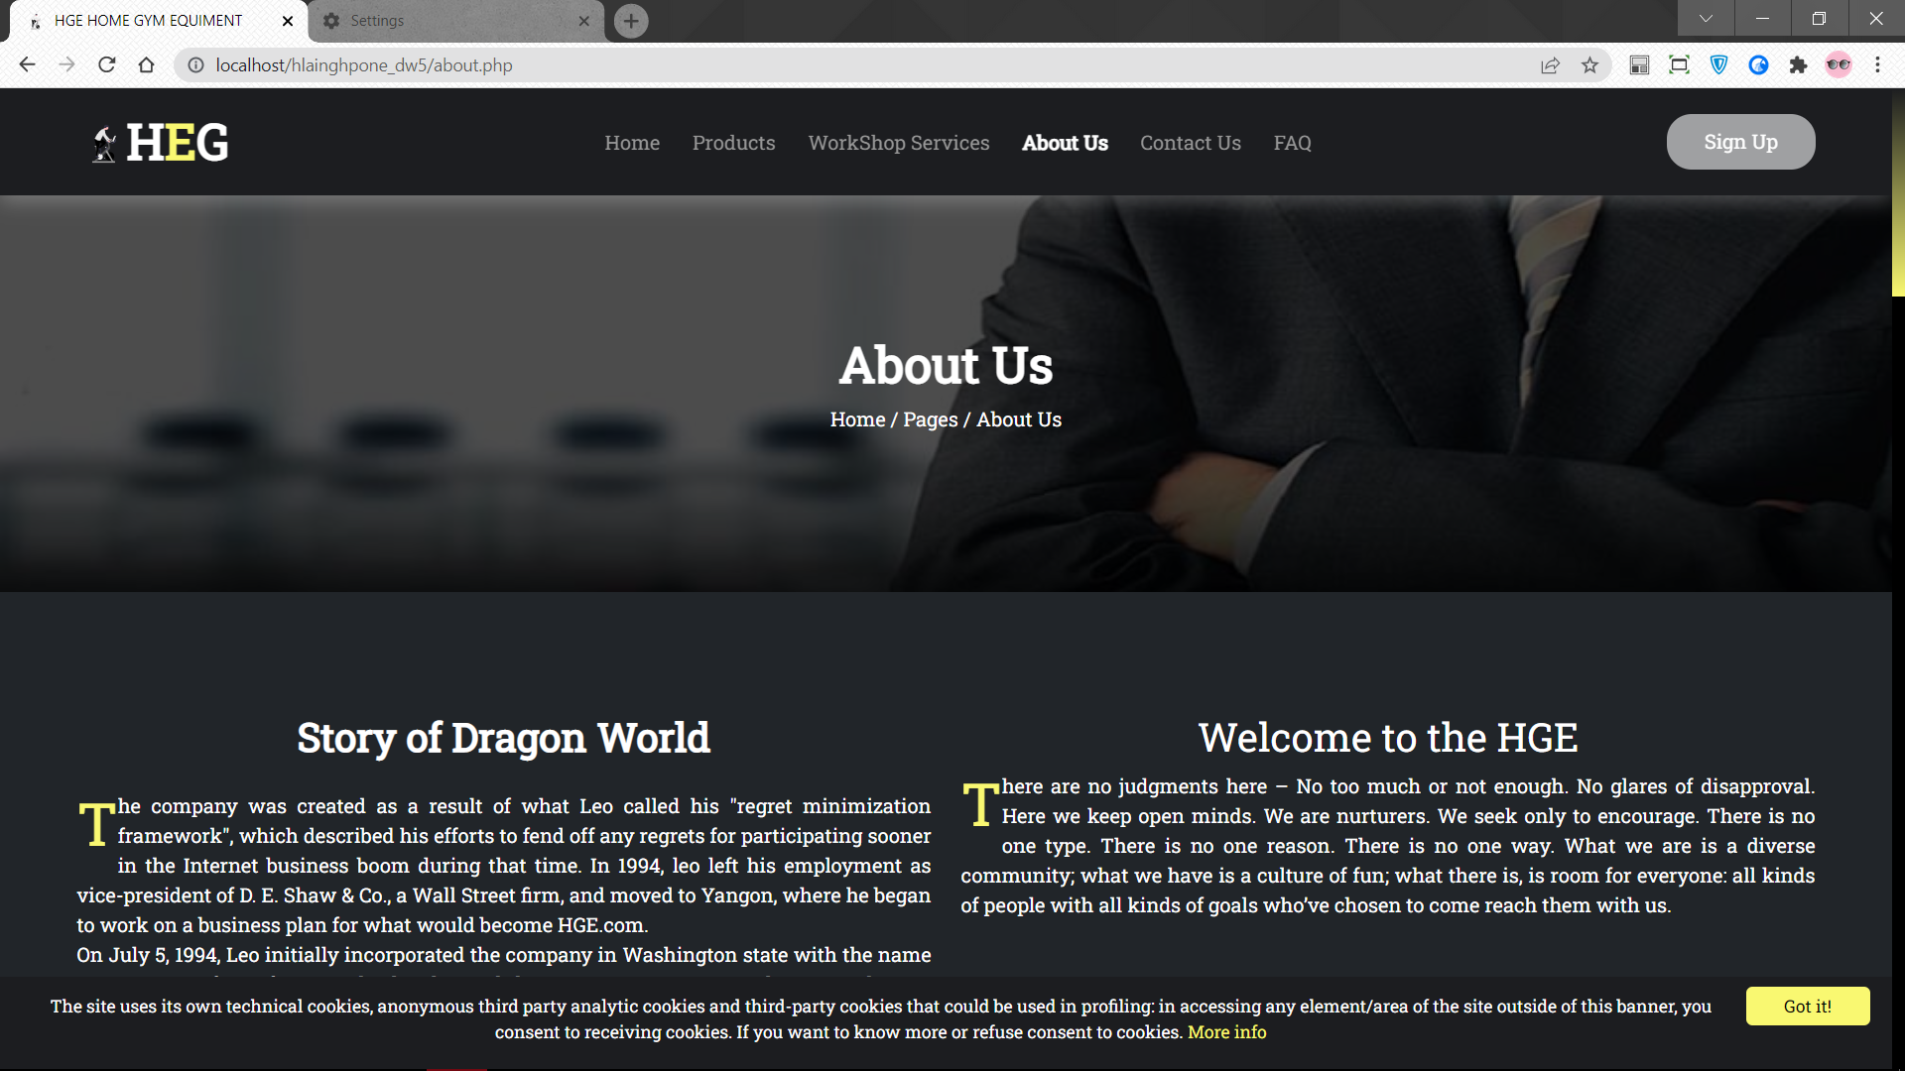

Fig 1.4.1 Running the About Page part1

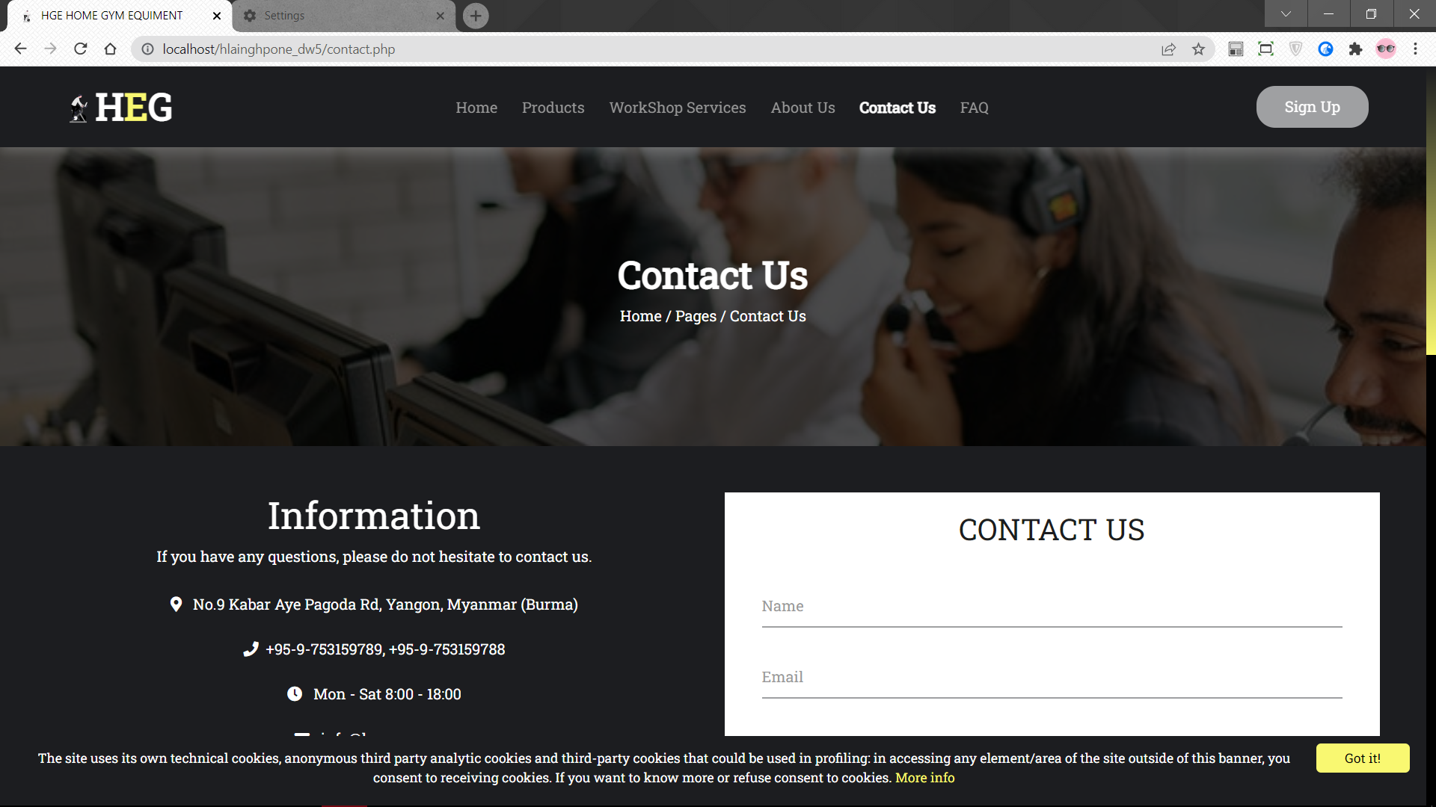

Fig 1.5.1 Running the Contact Page part1

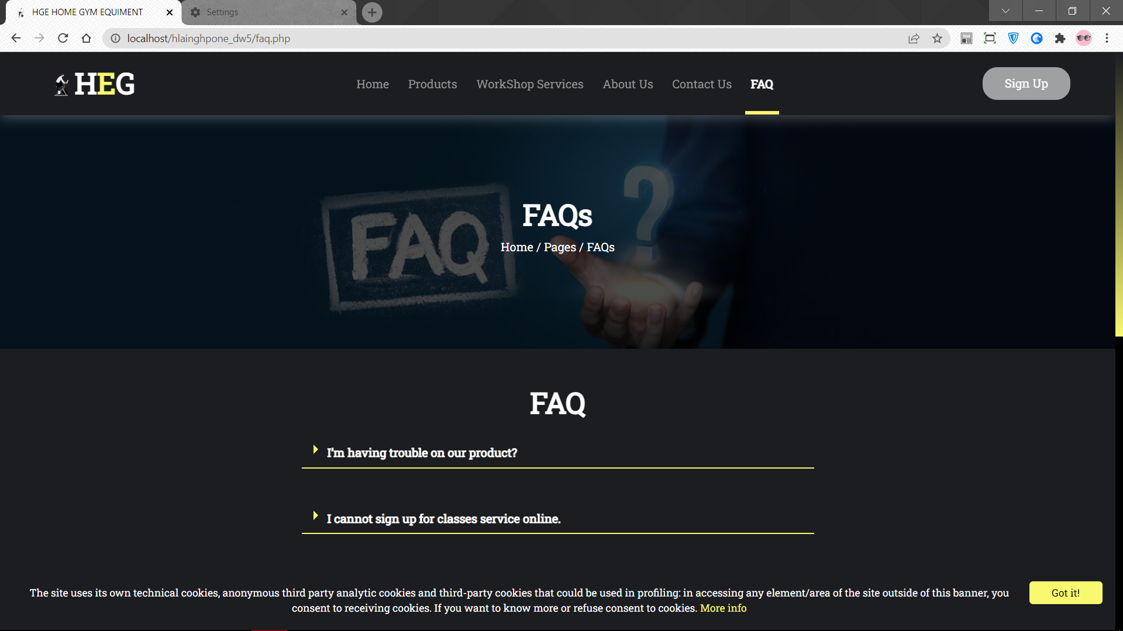

Fig 1.6.1 Running the FAQ Page part1

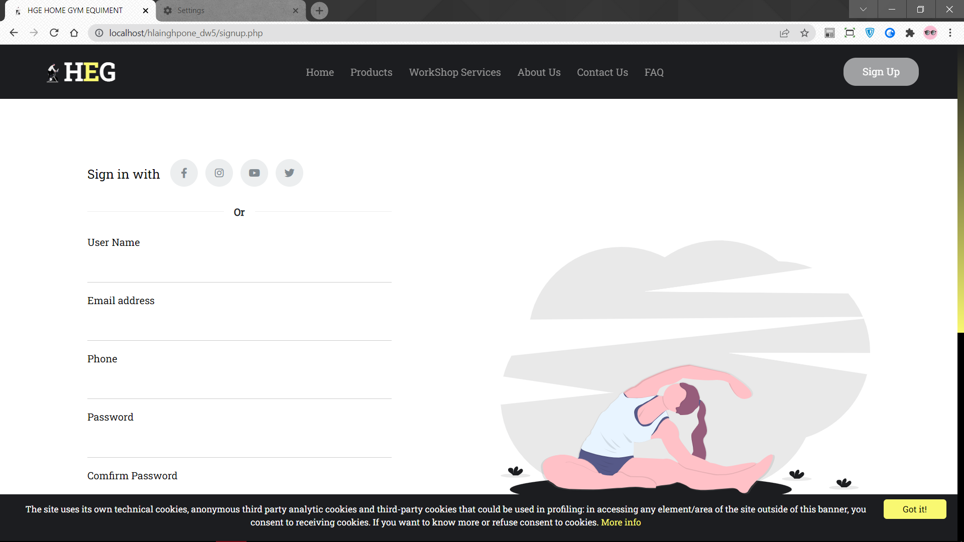

Fig 1.7.1 Running the Sign Up Page part1

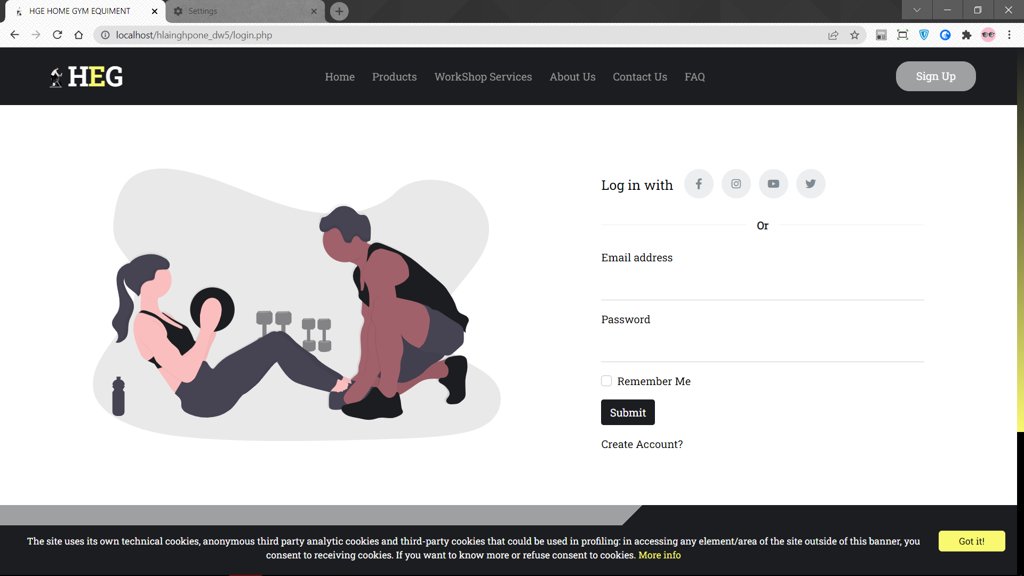

Fig 1.8.1 Running the Log in Page part1

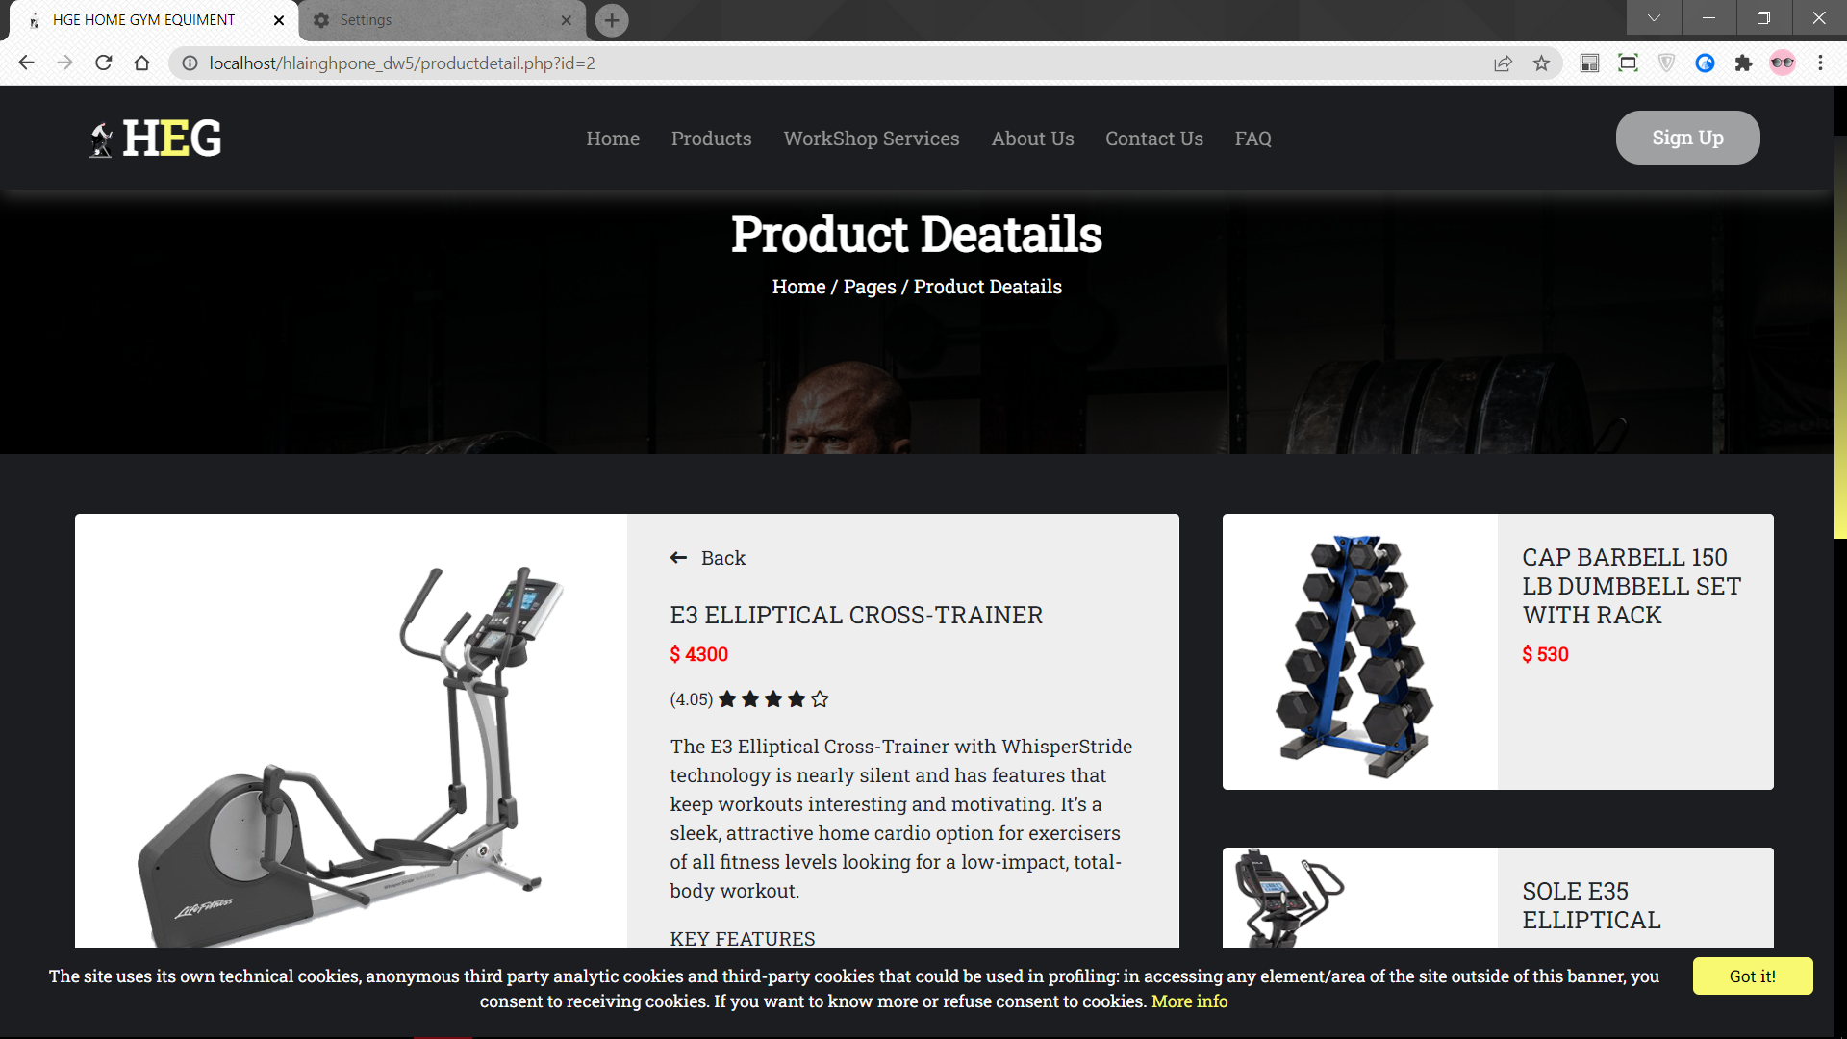

Fig 1.9.1 Running the Product Detail Page part1

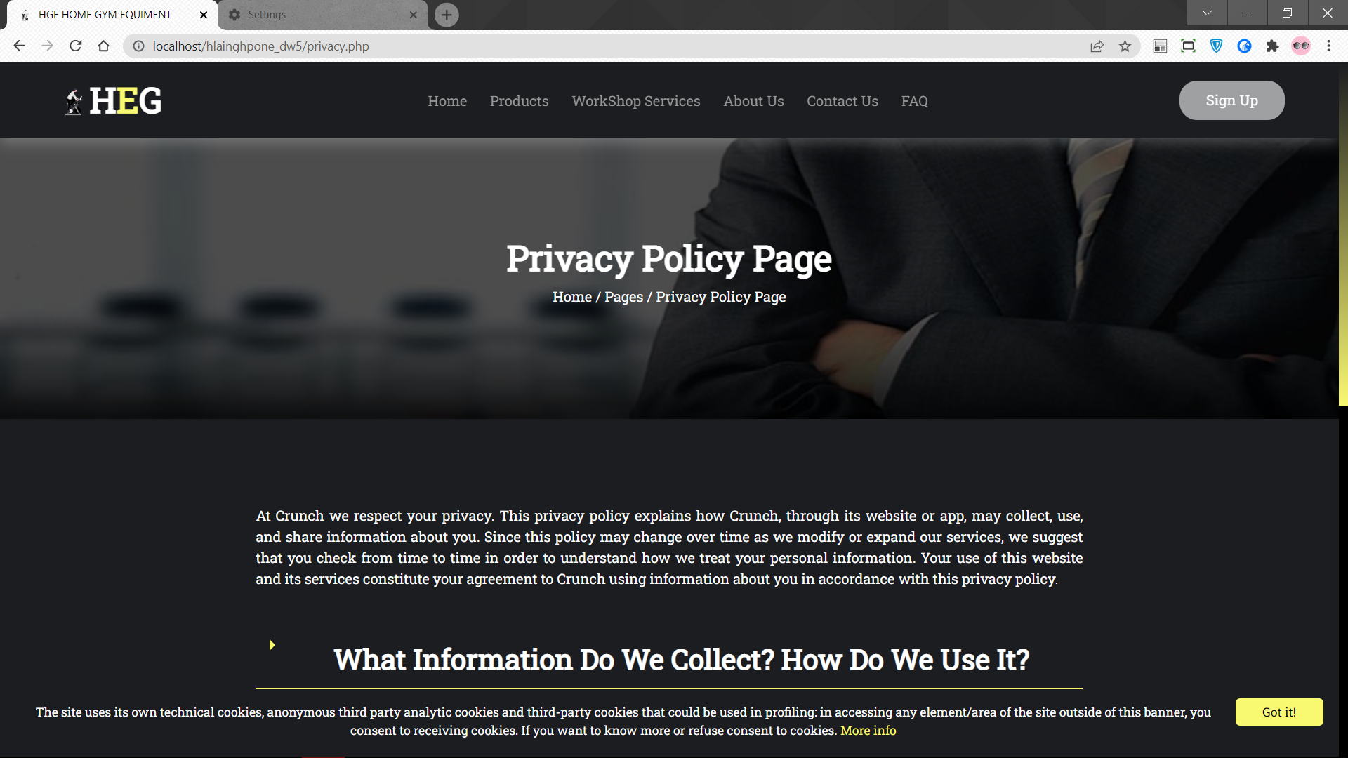

Fig 1.10.1 Running the Privacy Page part1

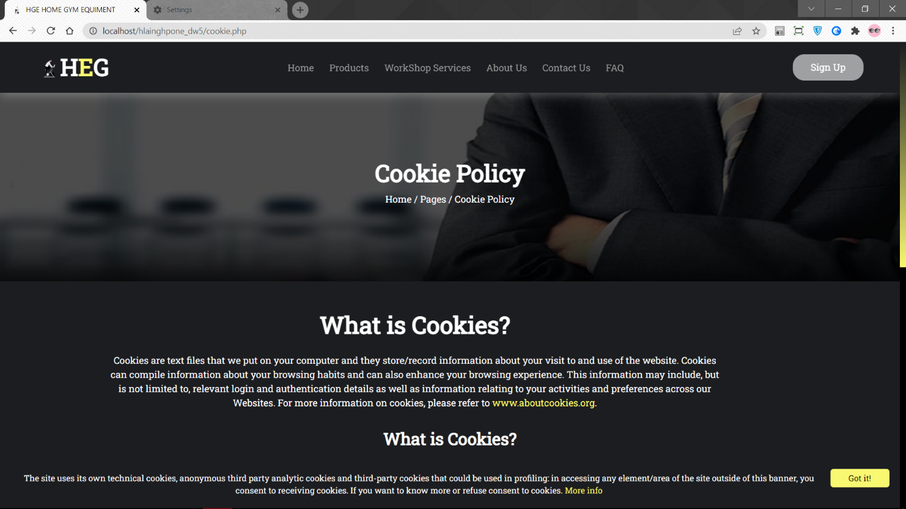

Fig 1.11.1 Running the Cookie Page part1

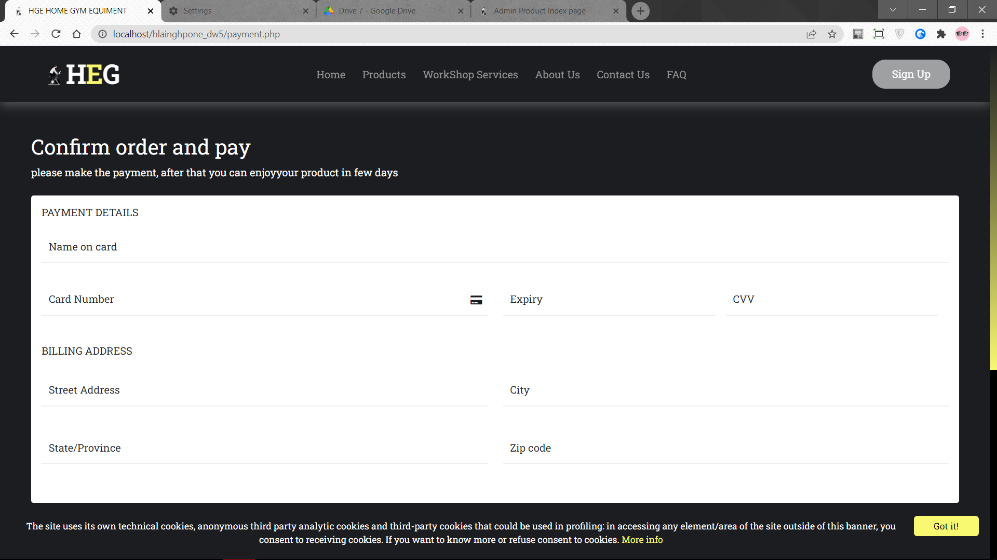

Fig 1.12.1 Running the Payment Page part1

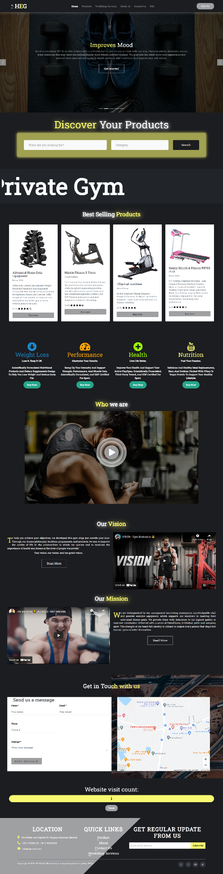

Fig 1.1.2 Running the Home Page part 2

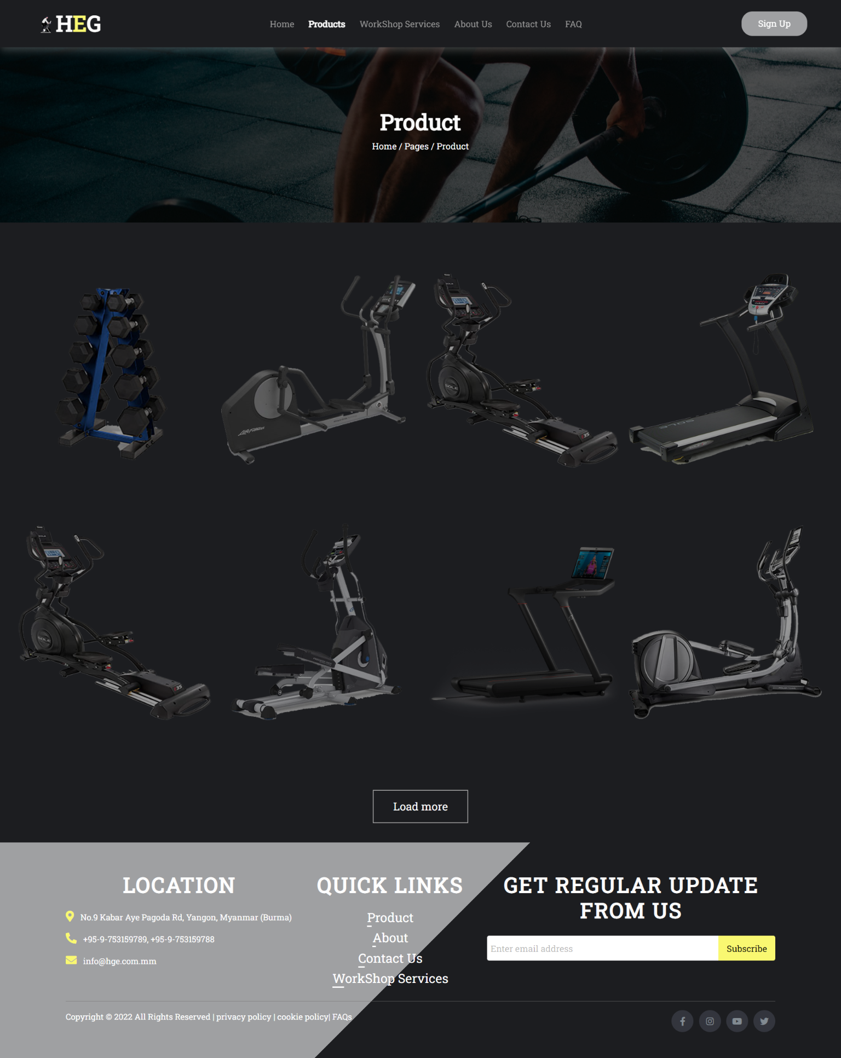

Fig 1.2.2 Running the Product Page part 2

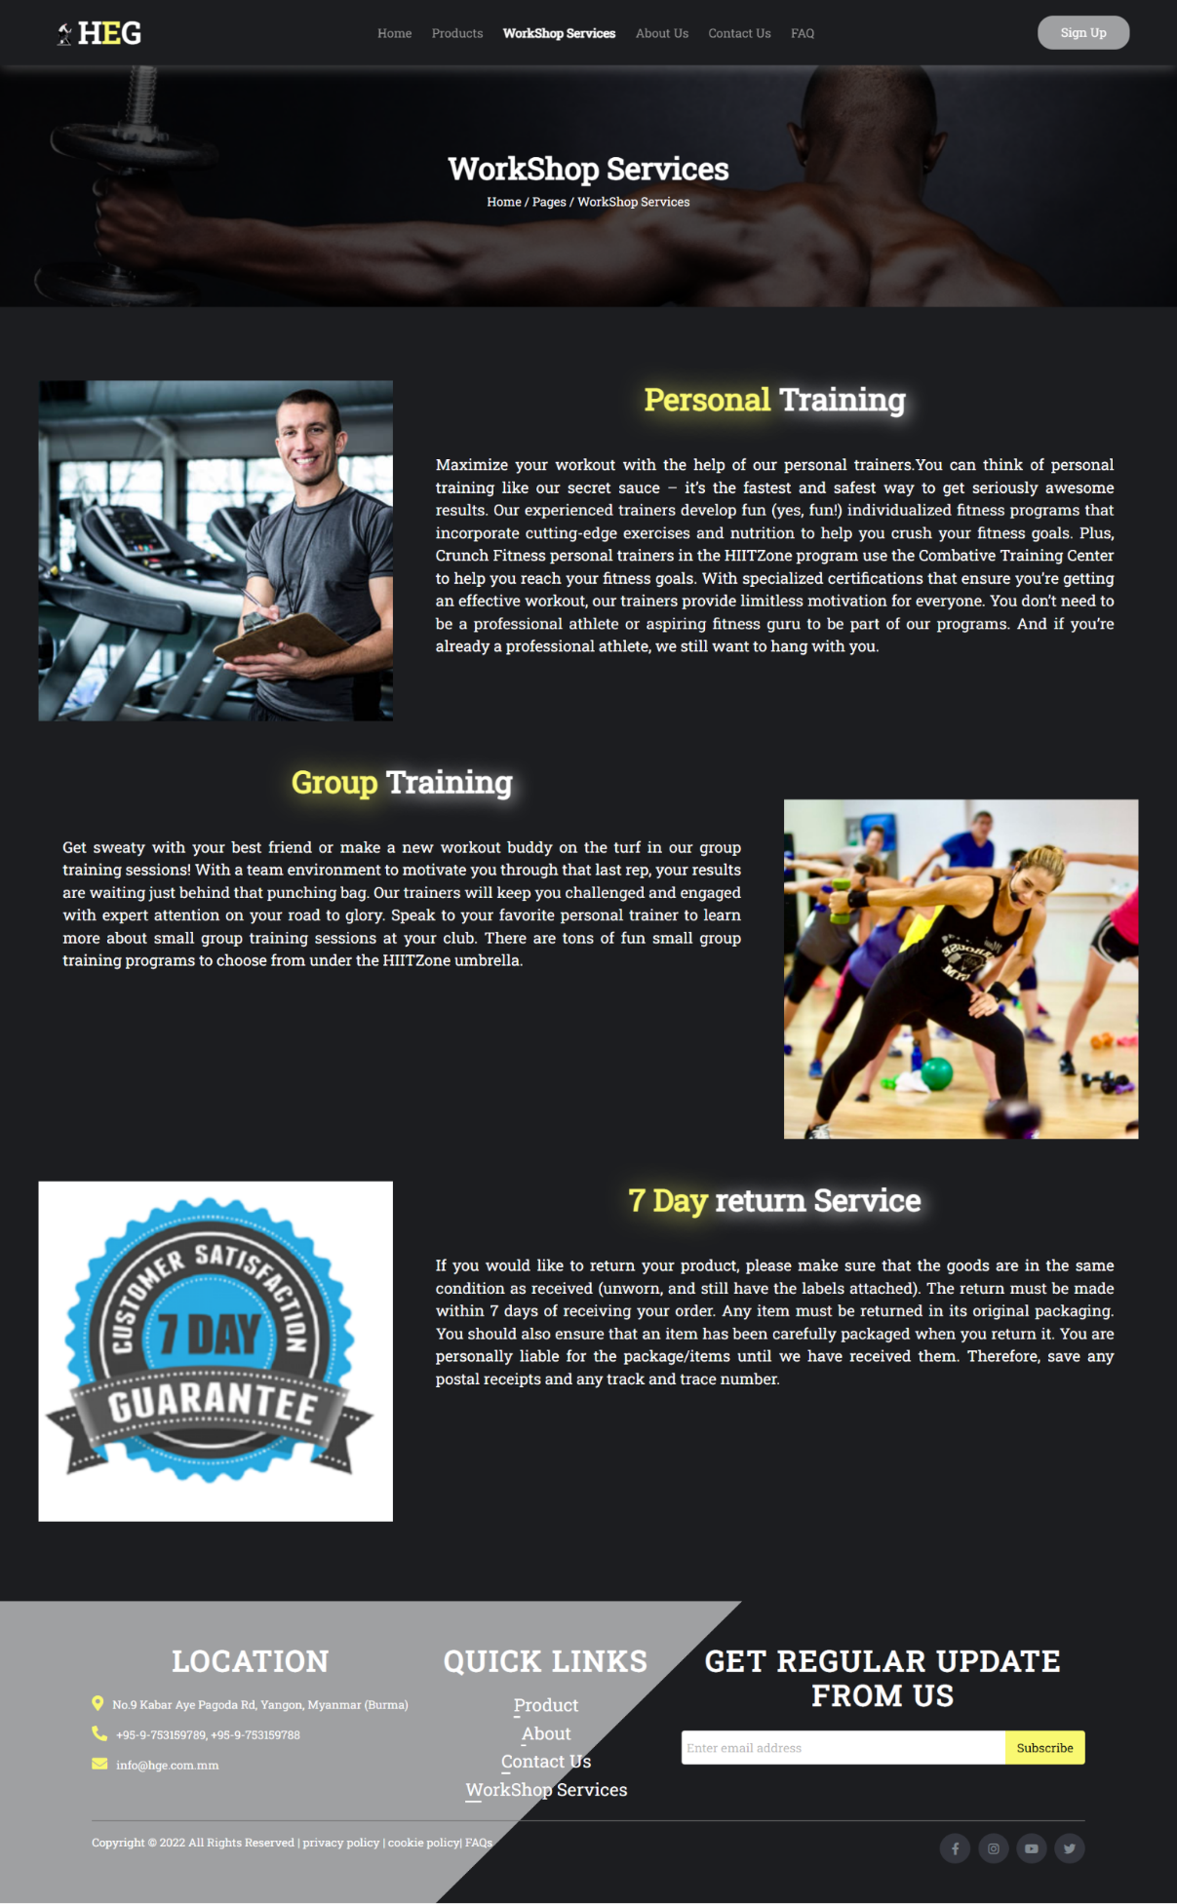

Fig 1.3.2 Running the Workshop Page part 2

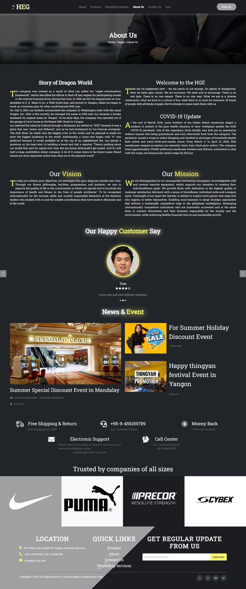

Fig 1.4.2 Running the About Page part 2

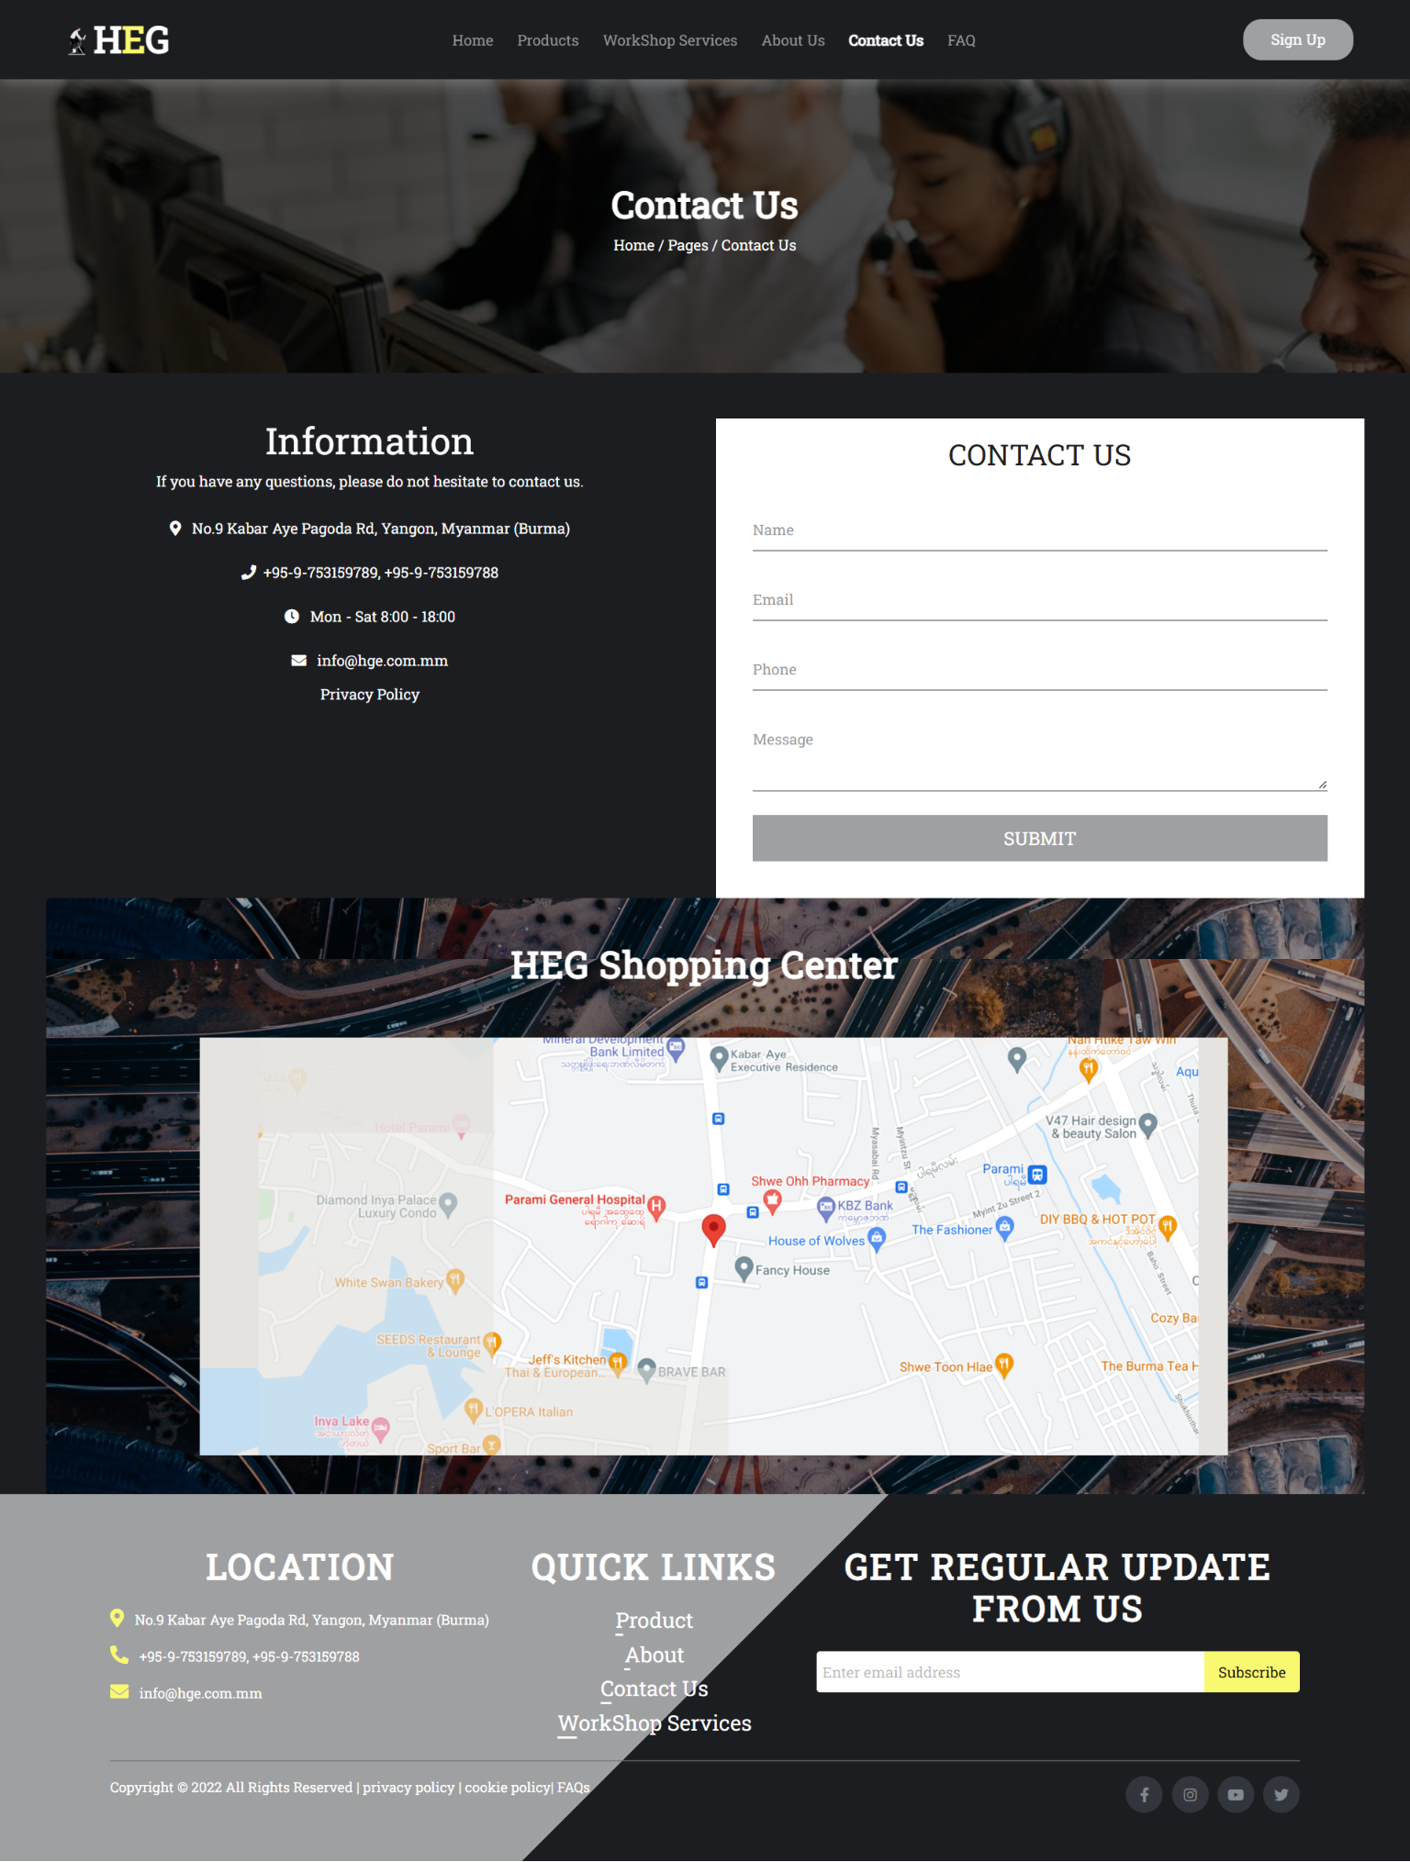

Fig 1.5.2 Running the Contact Page part 2

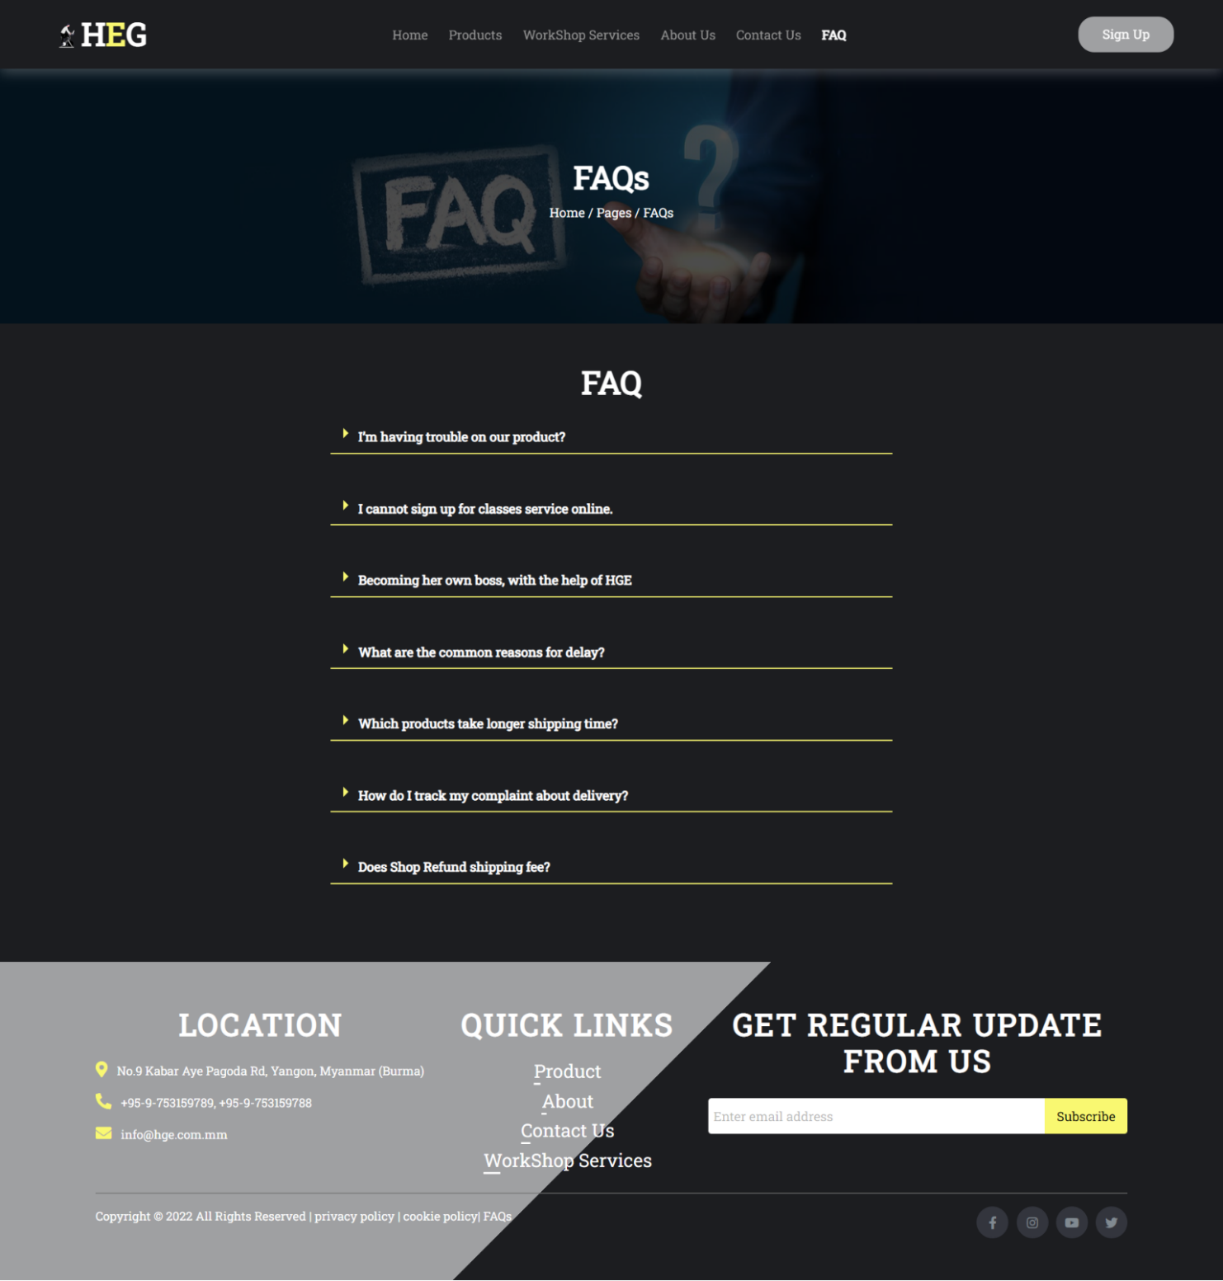

Fig 1.6.2 Running the FAQ Page part 2

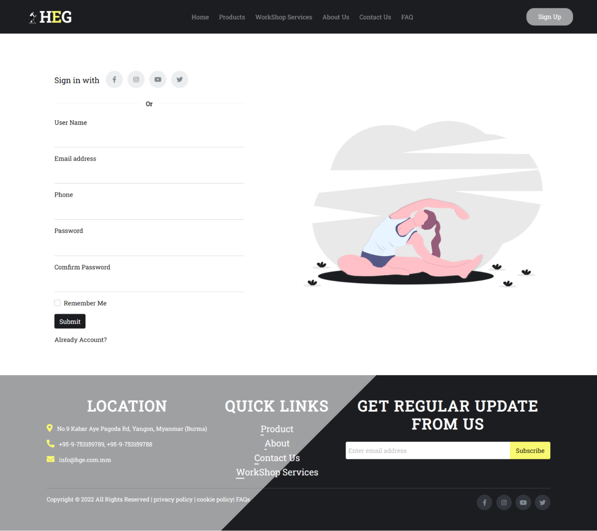

Fig 1.7.2 Running the Sign Up Page part 2

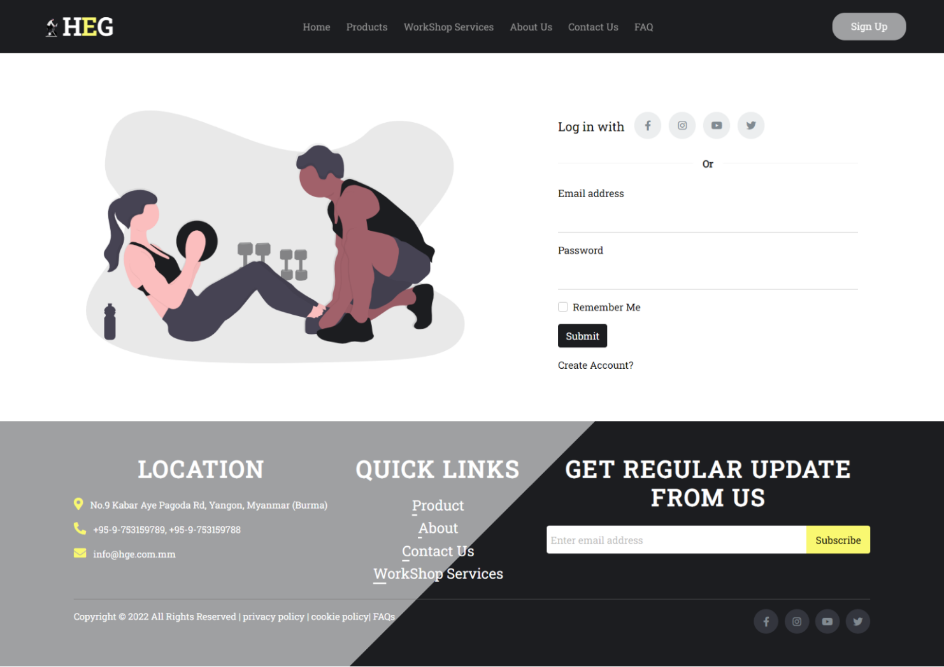

Fig 1.8.2 Running the Log in Page part 2

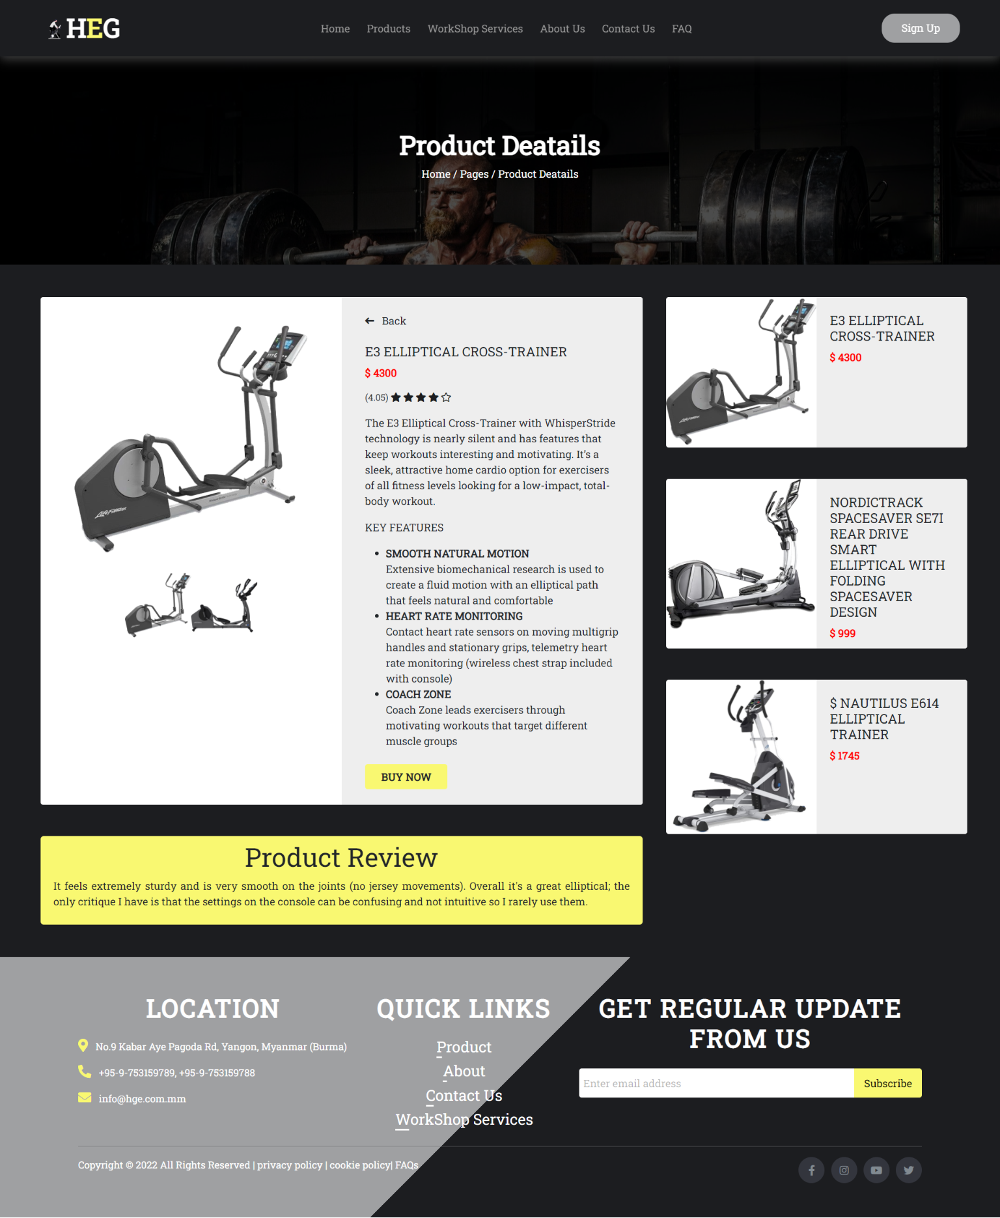

Fig 1.9.2 Running the Product details Page part 2

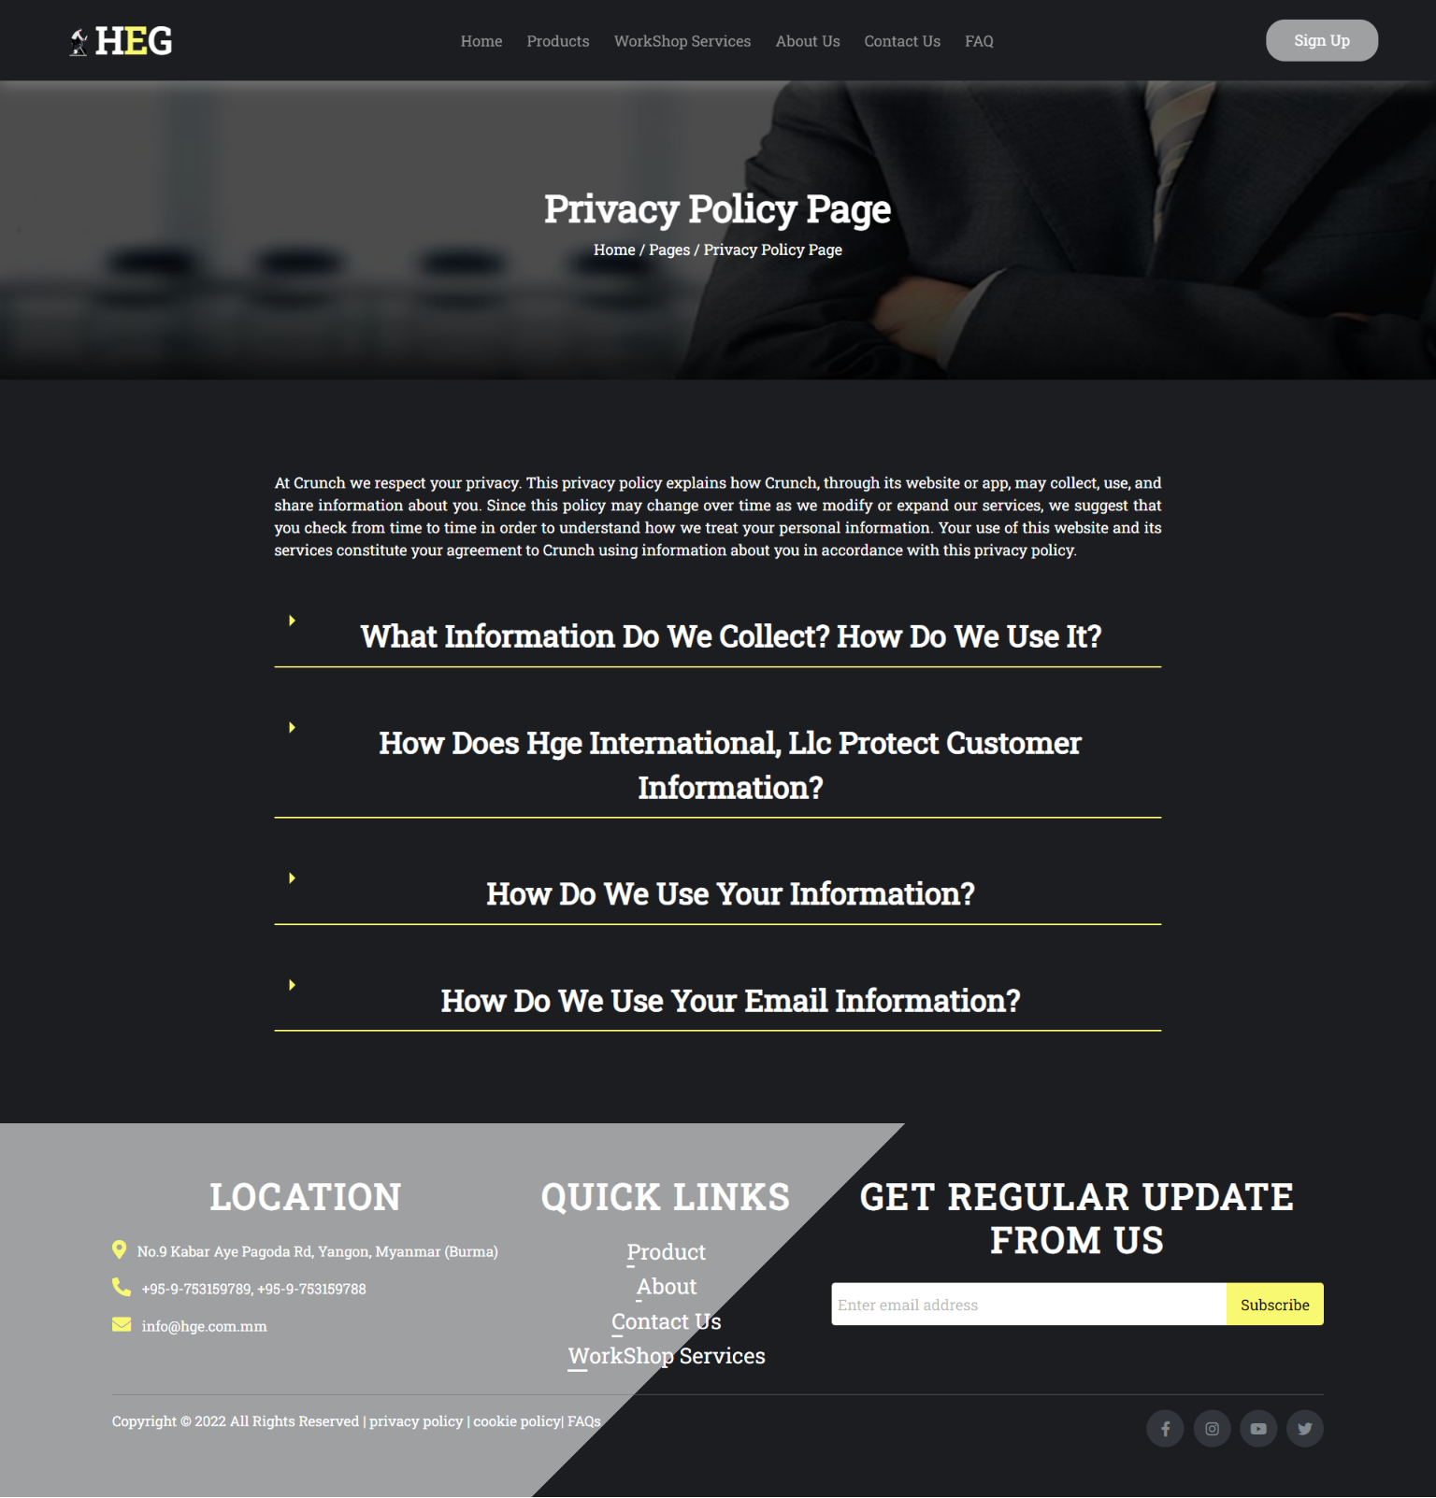

Fig 1.10.2 Running the Privacy Page part 2

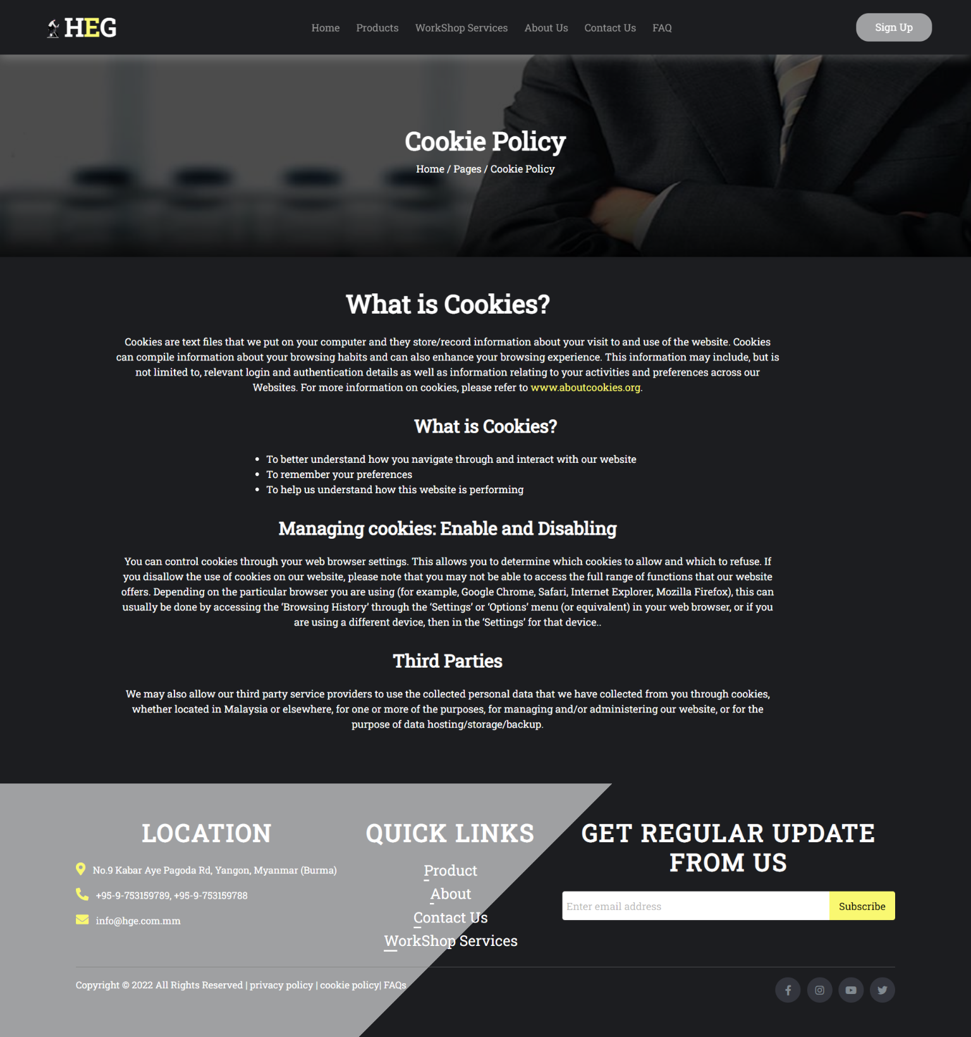

Fig 1.11.2 Running the Cookie Page part 2

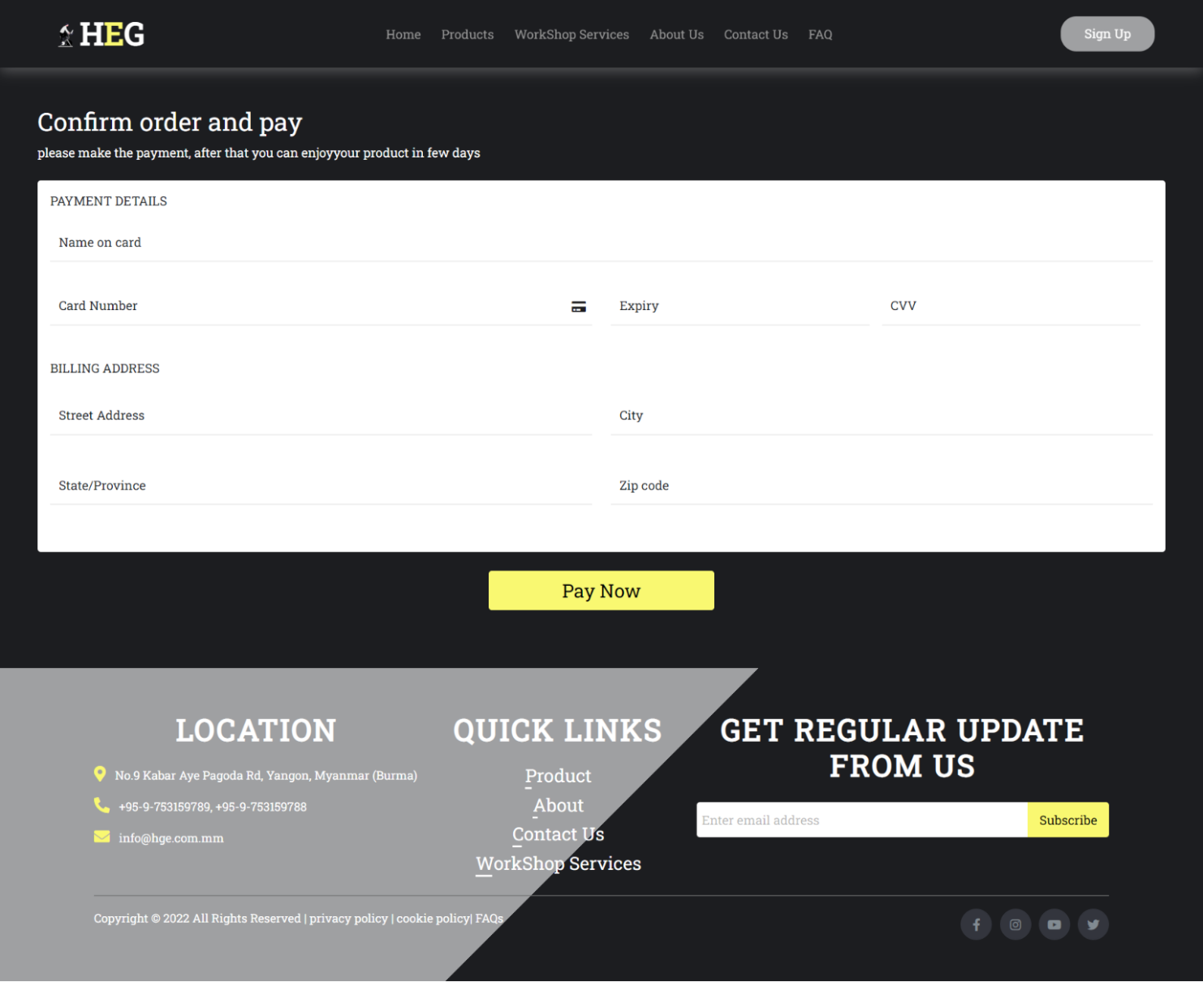

Fig 1.12.2 Running the Payment Page part 2

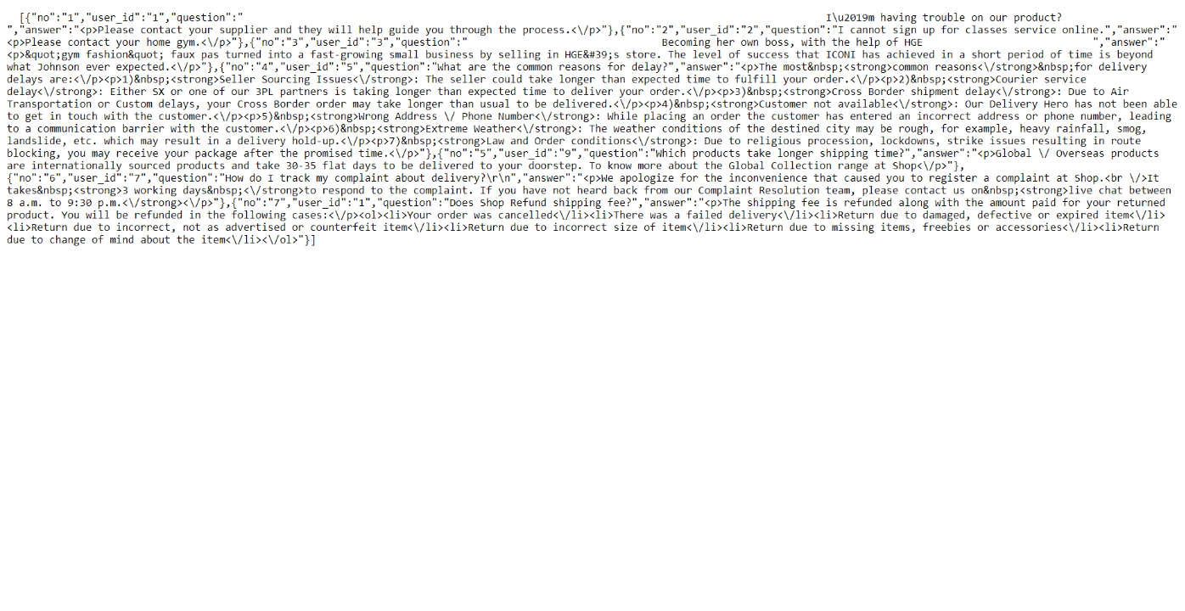

Fig 1.13 Running the Webservice Service Page

# Describe the Front-end code

**Header page code**

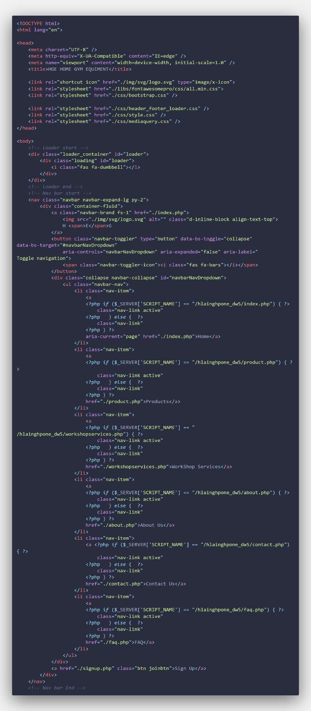

**Index page code**

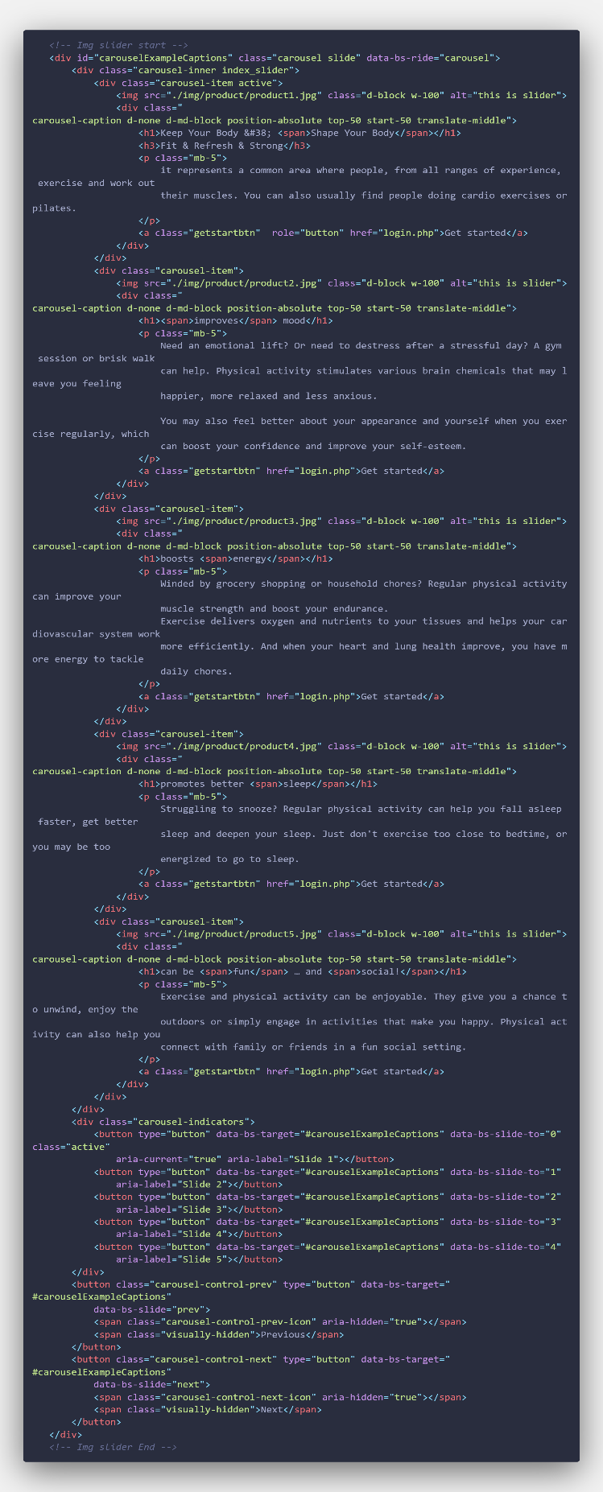

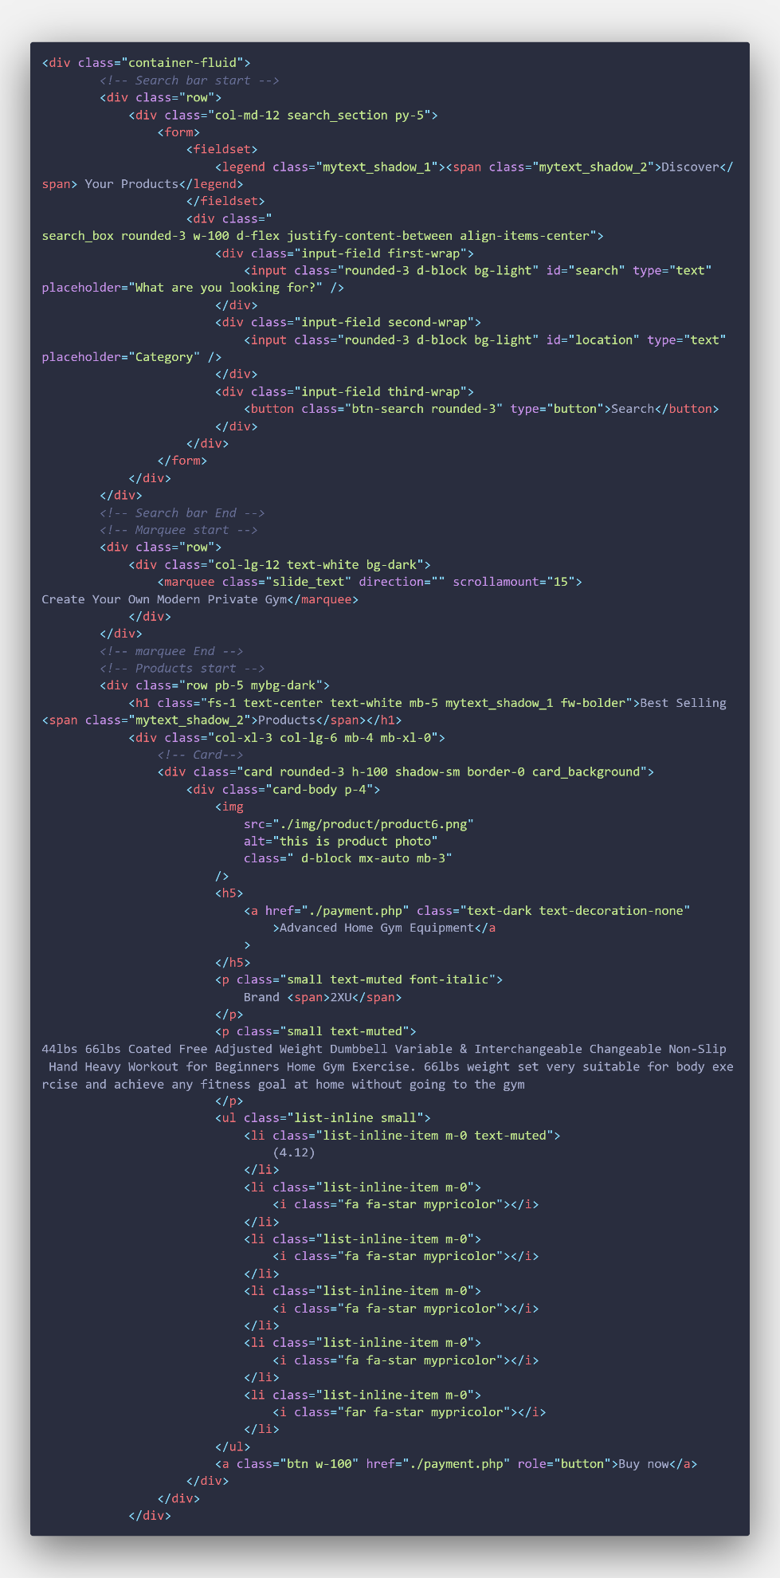

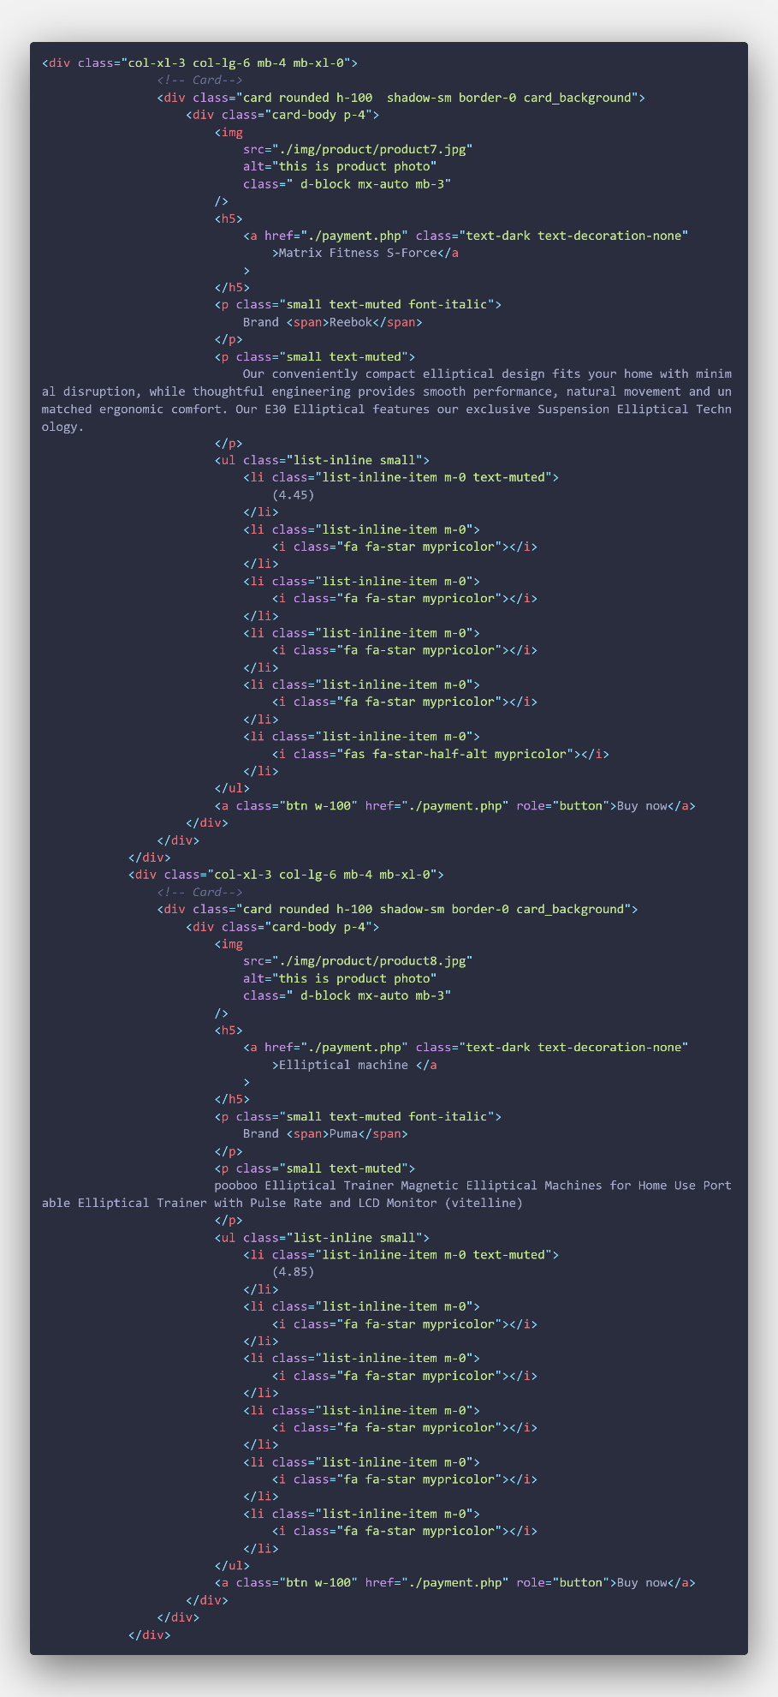

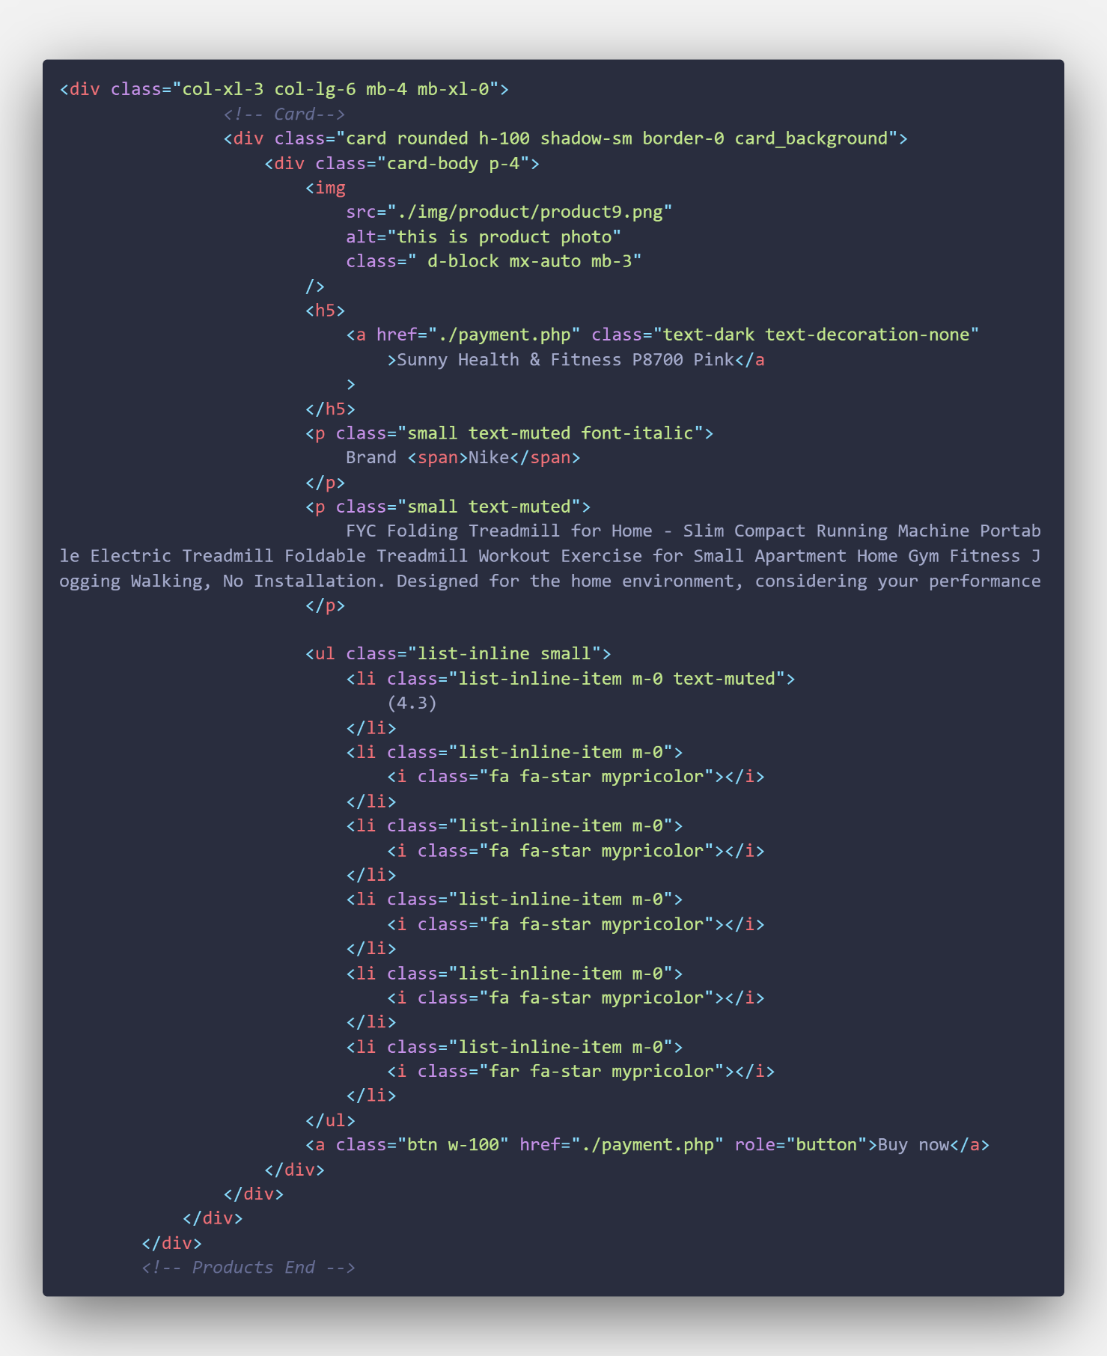

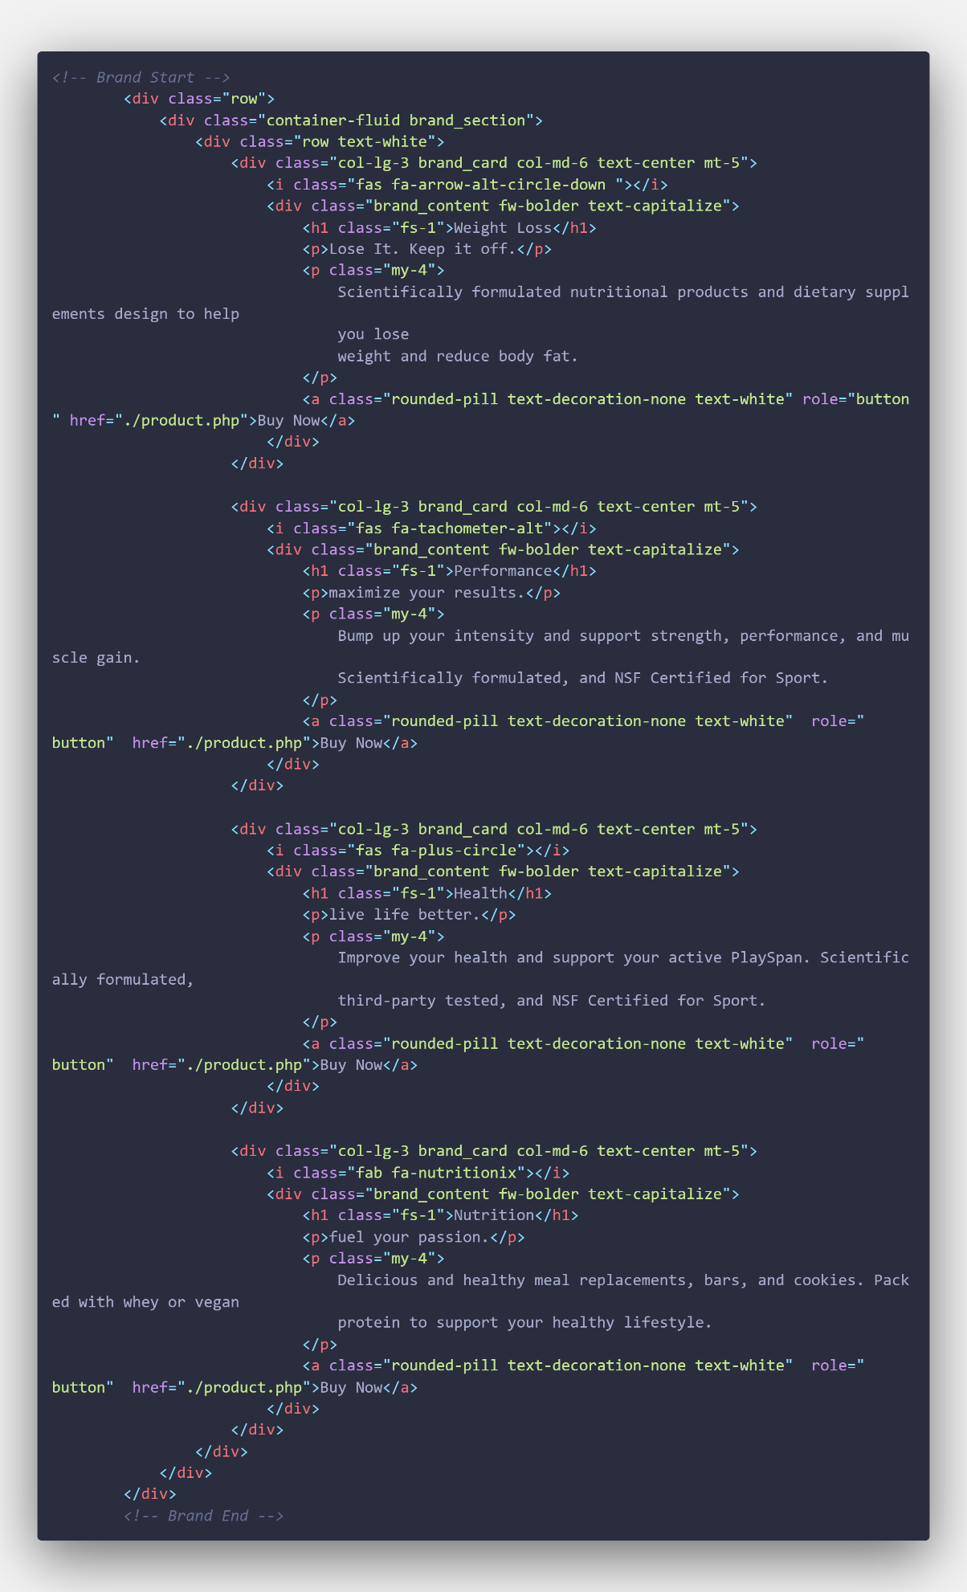

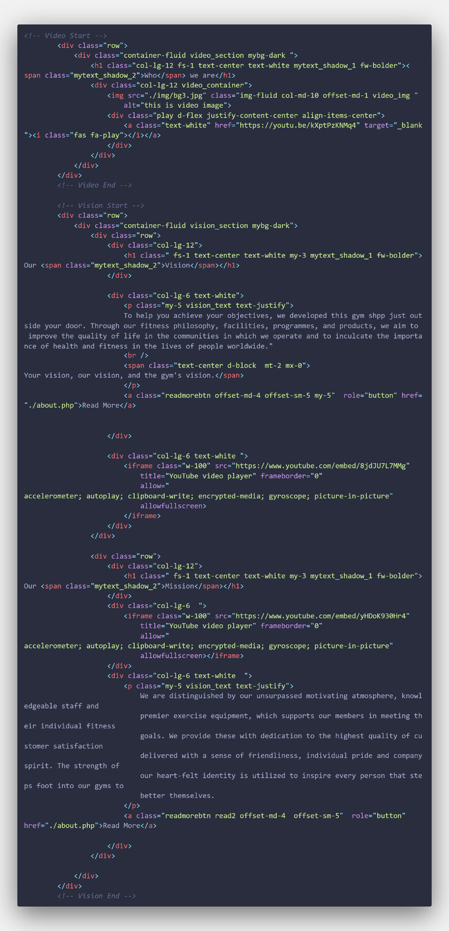

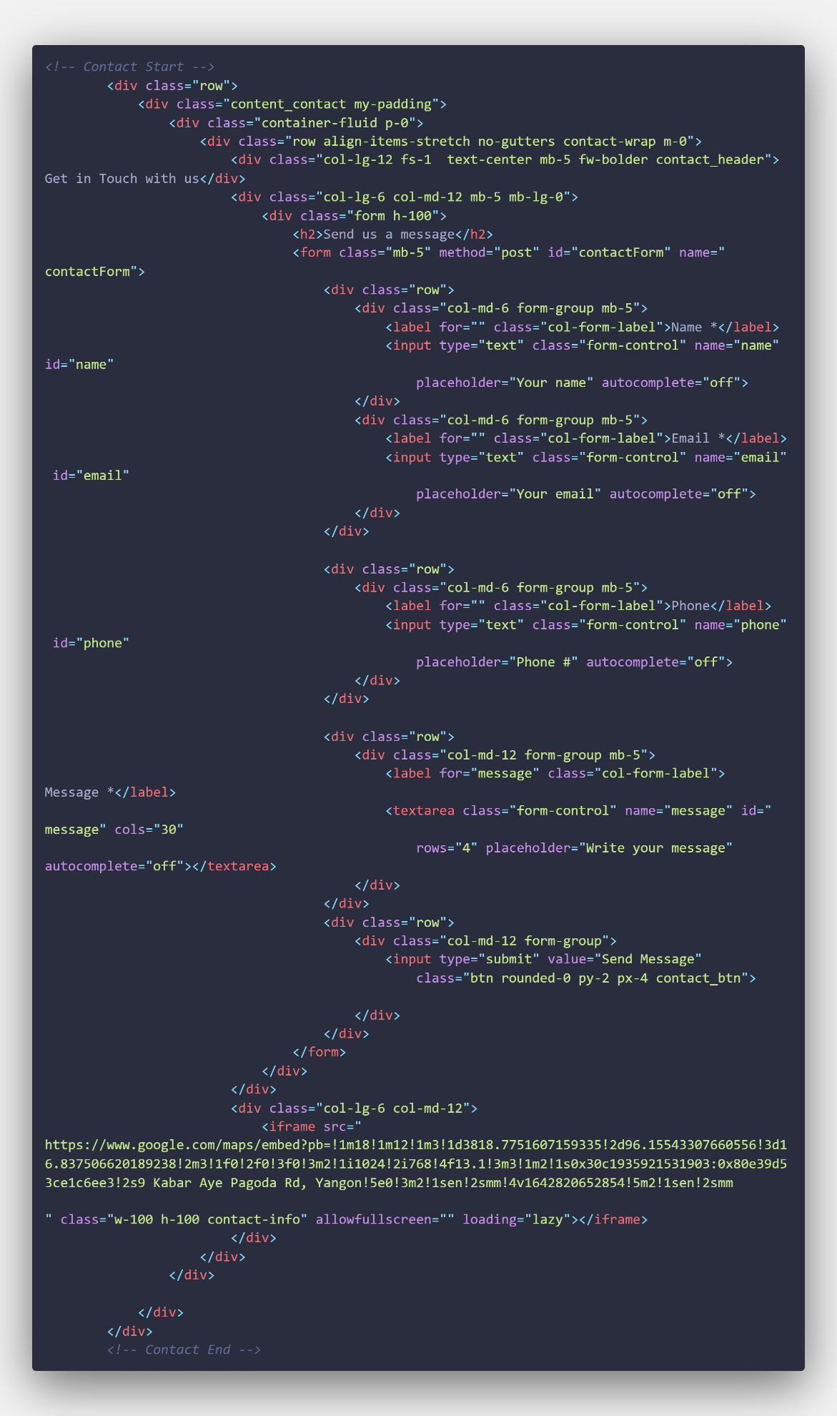

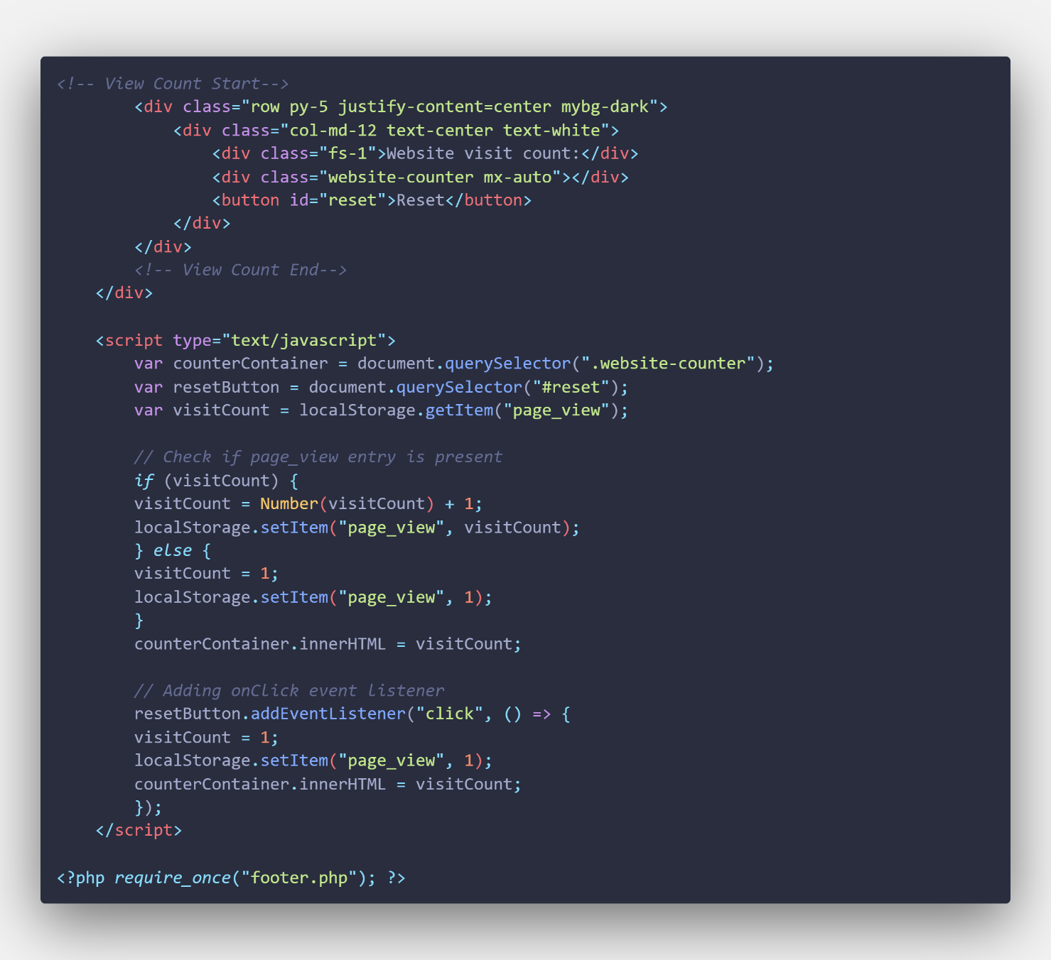

**Product page code**

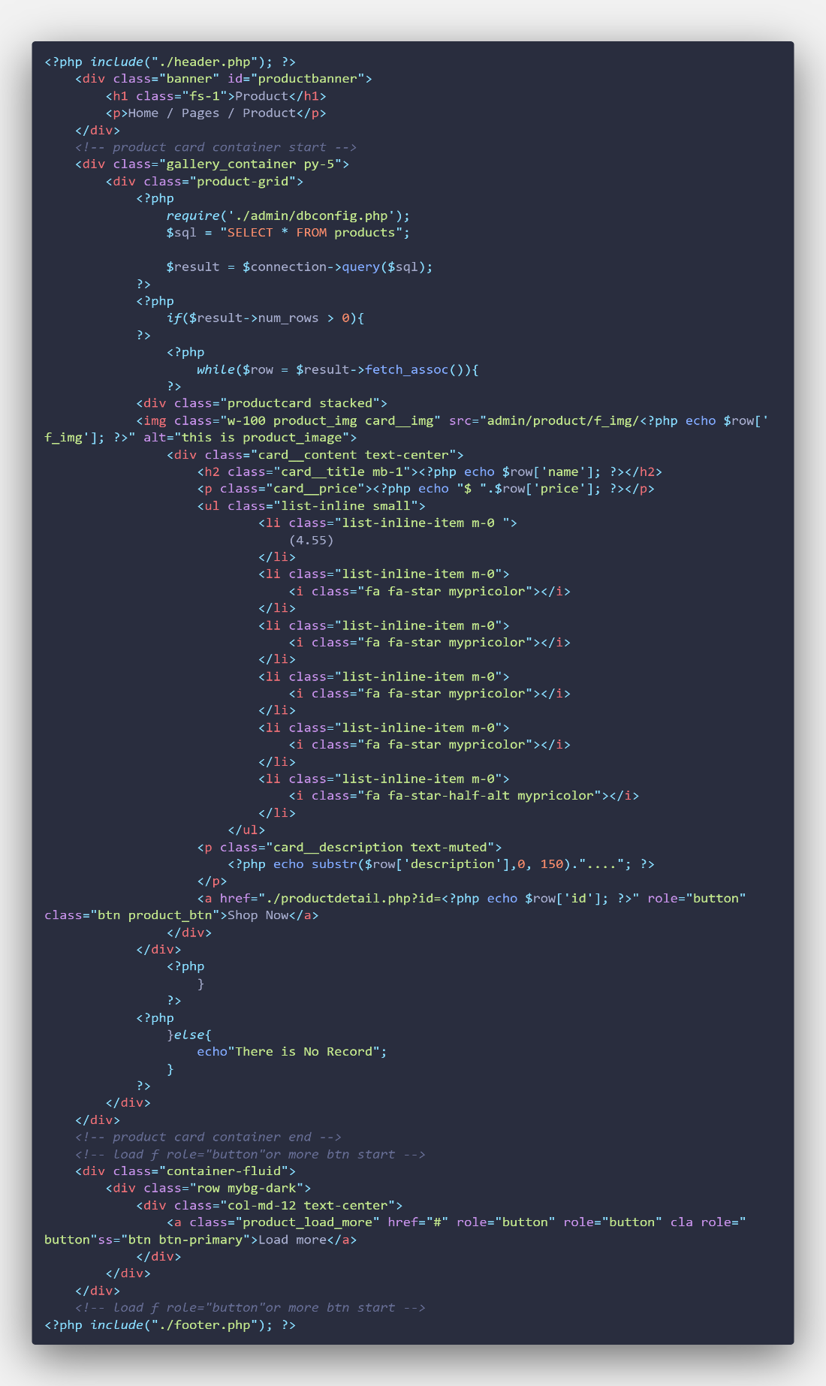

**Workshop Service page code**

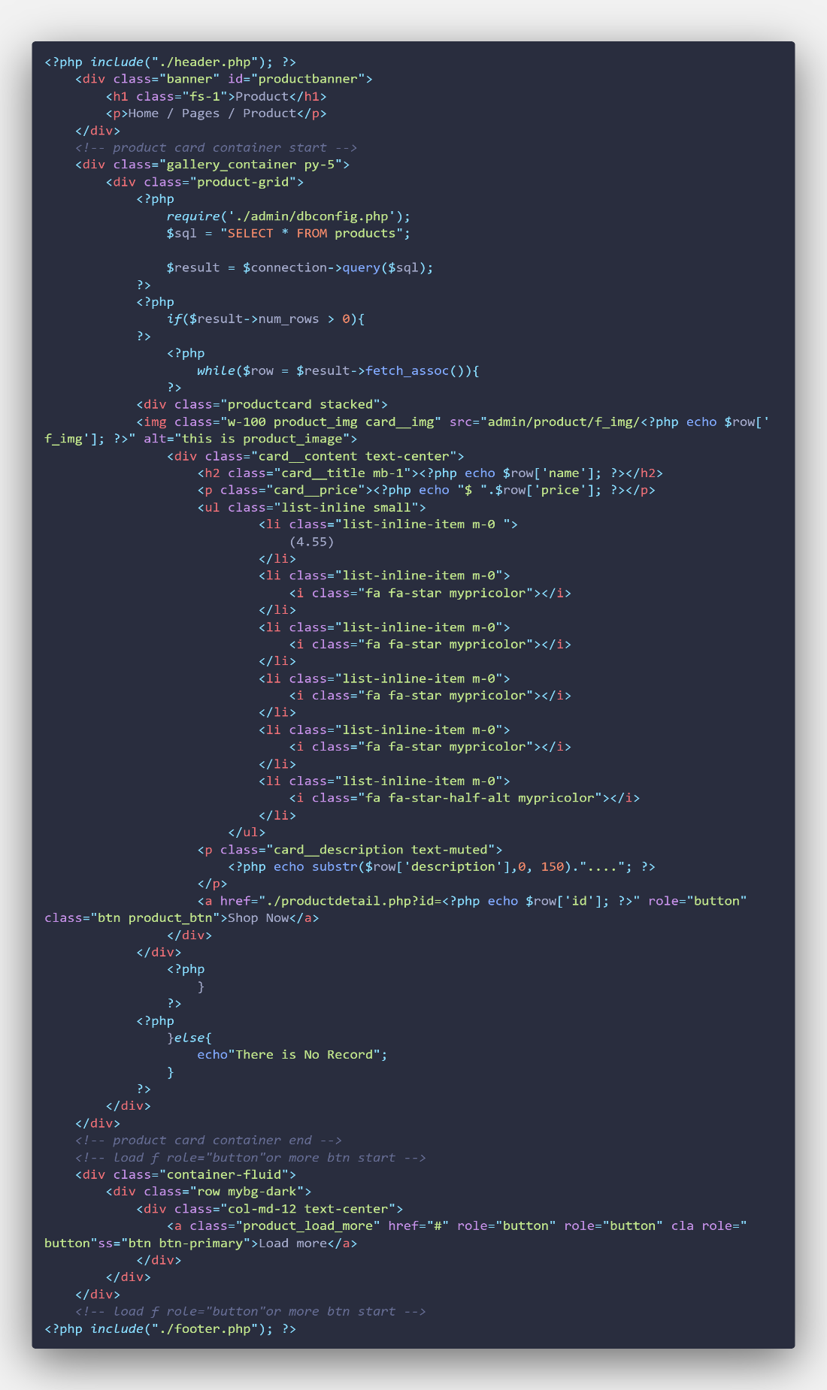

**About page code**

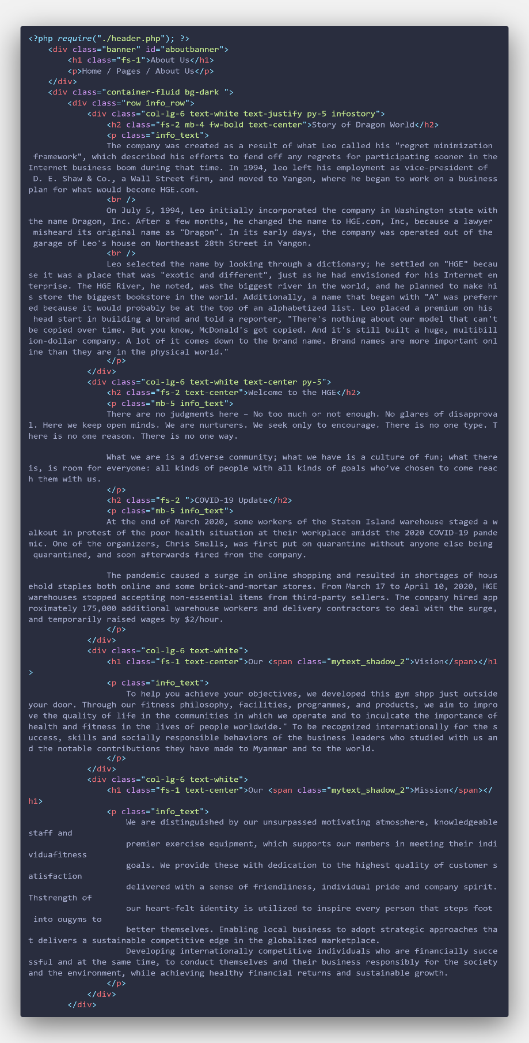

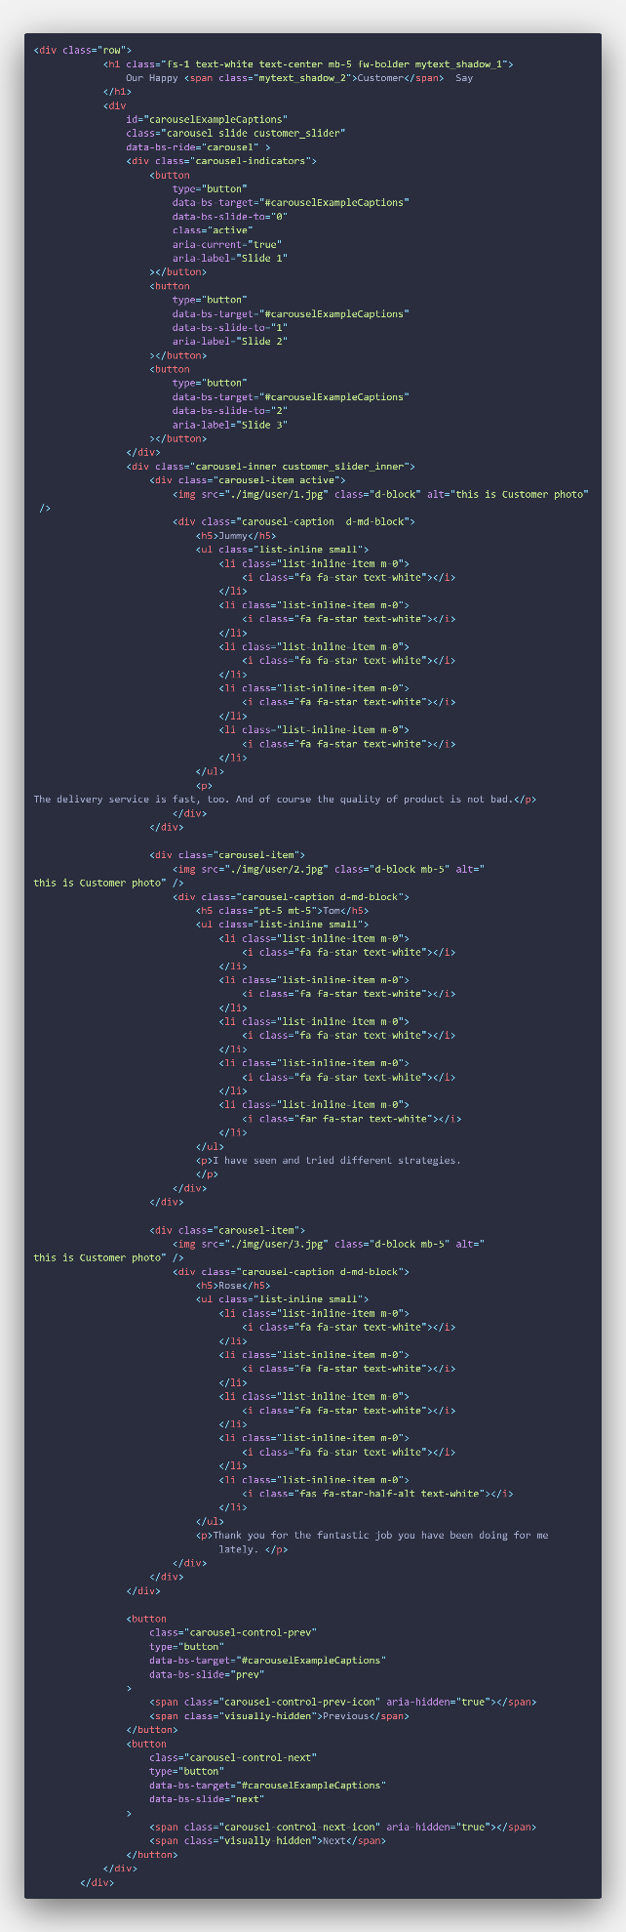

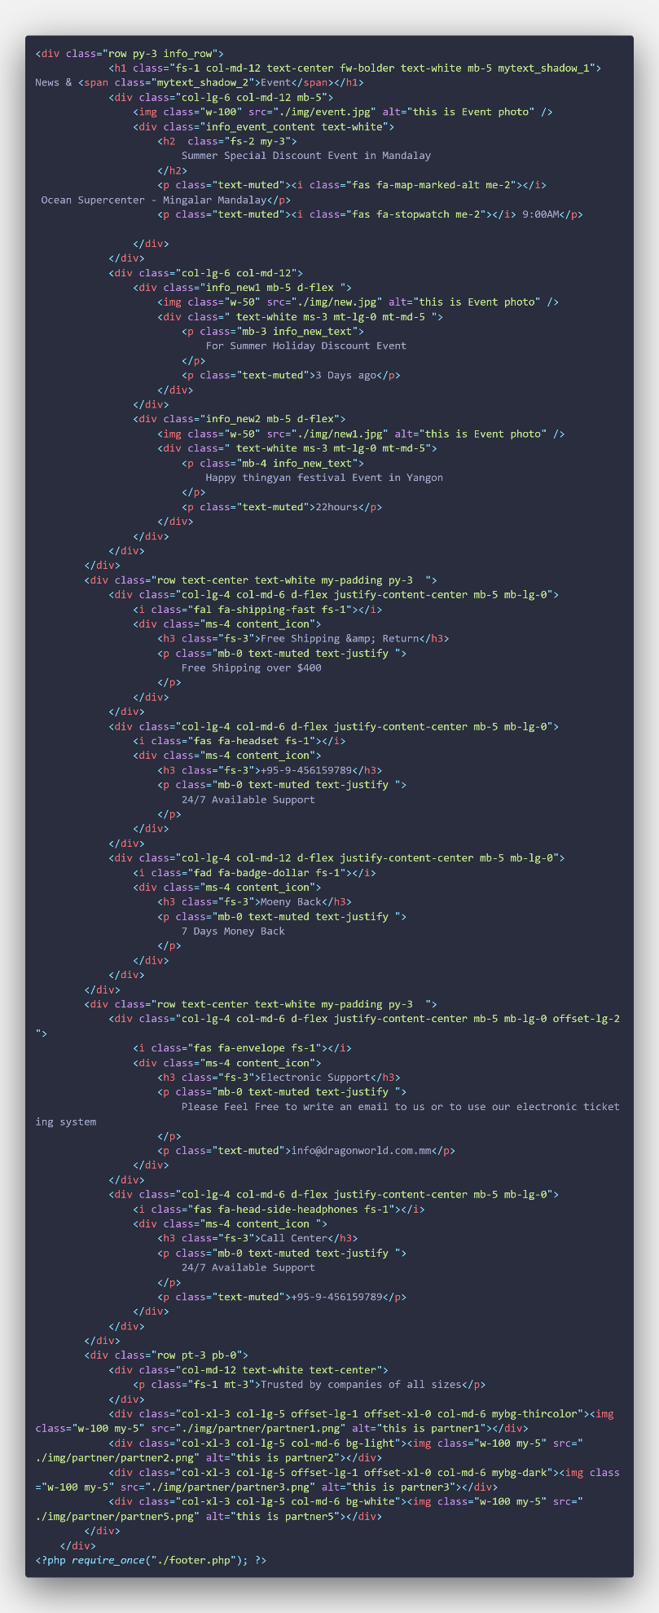

**Contact page code**

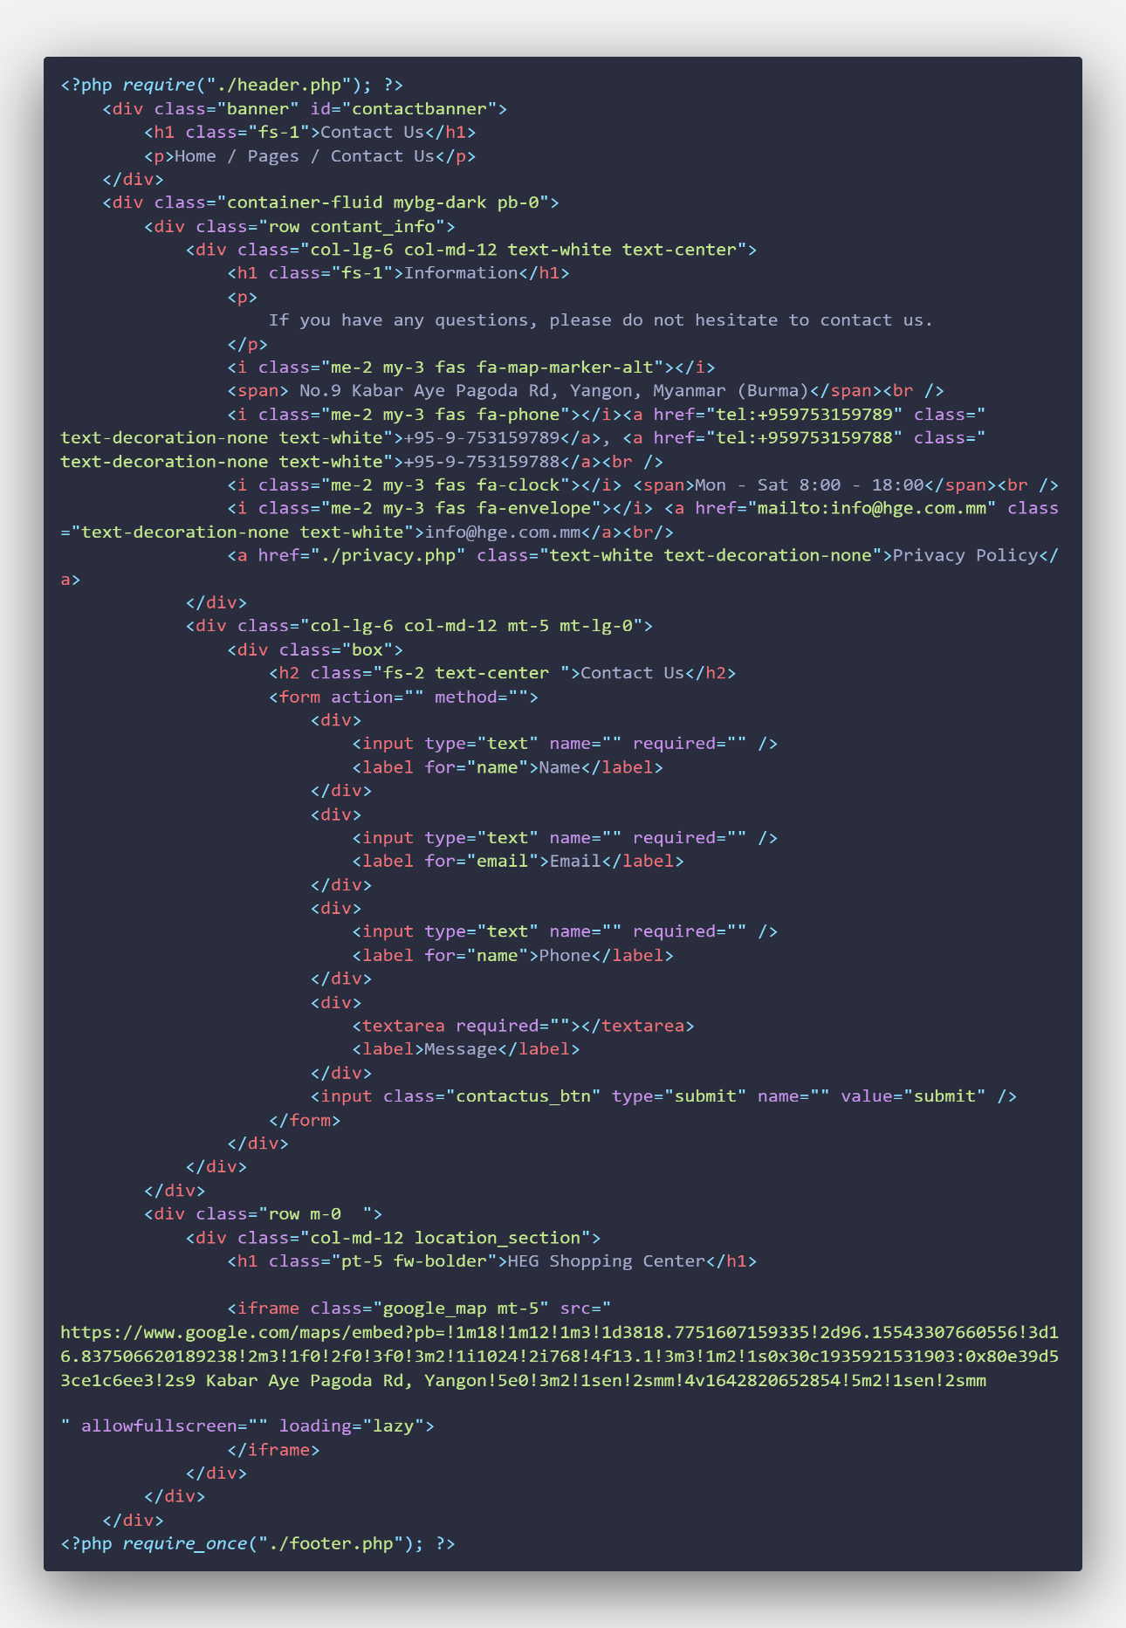

**FAQ page code**

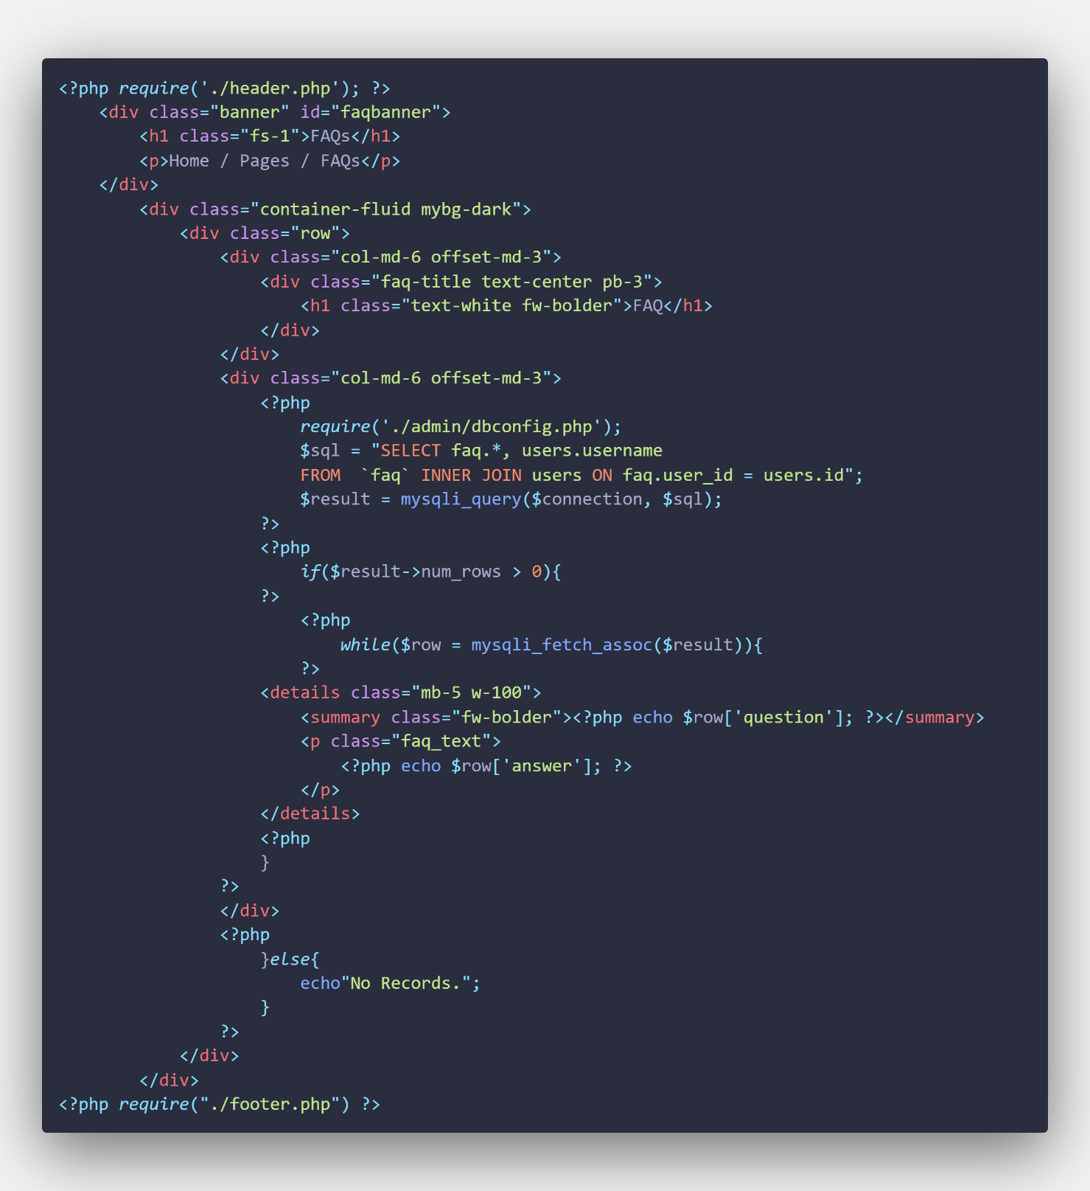

**Sign Up page code**

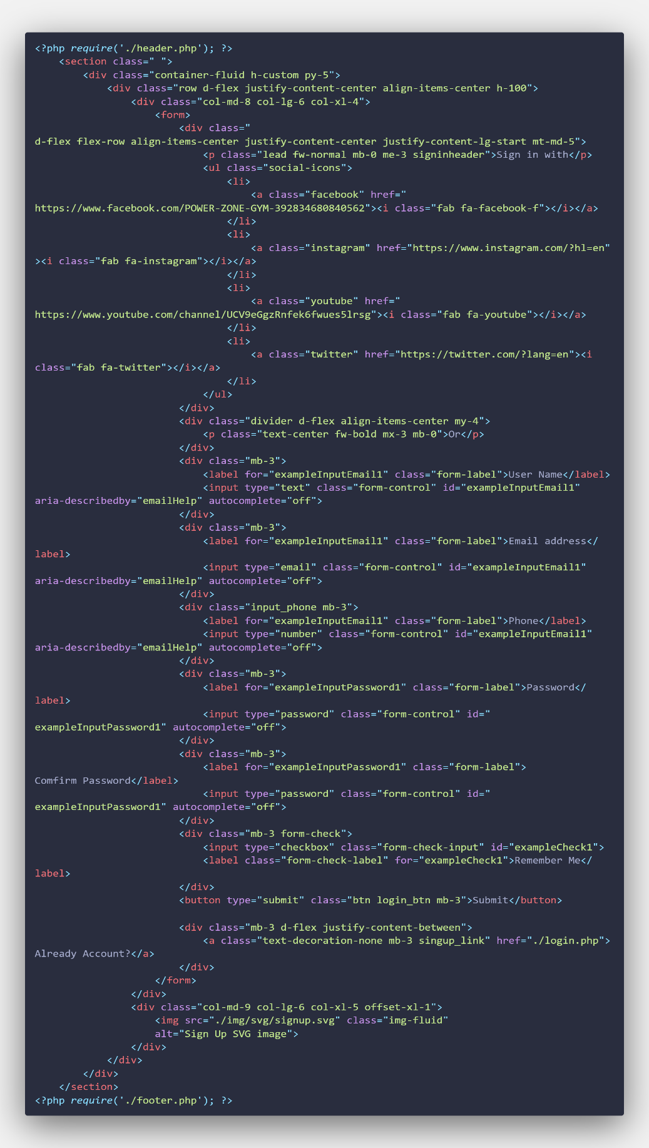

**Log in page code**

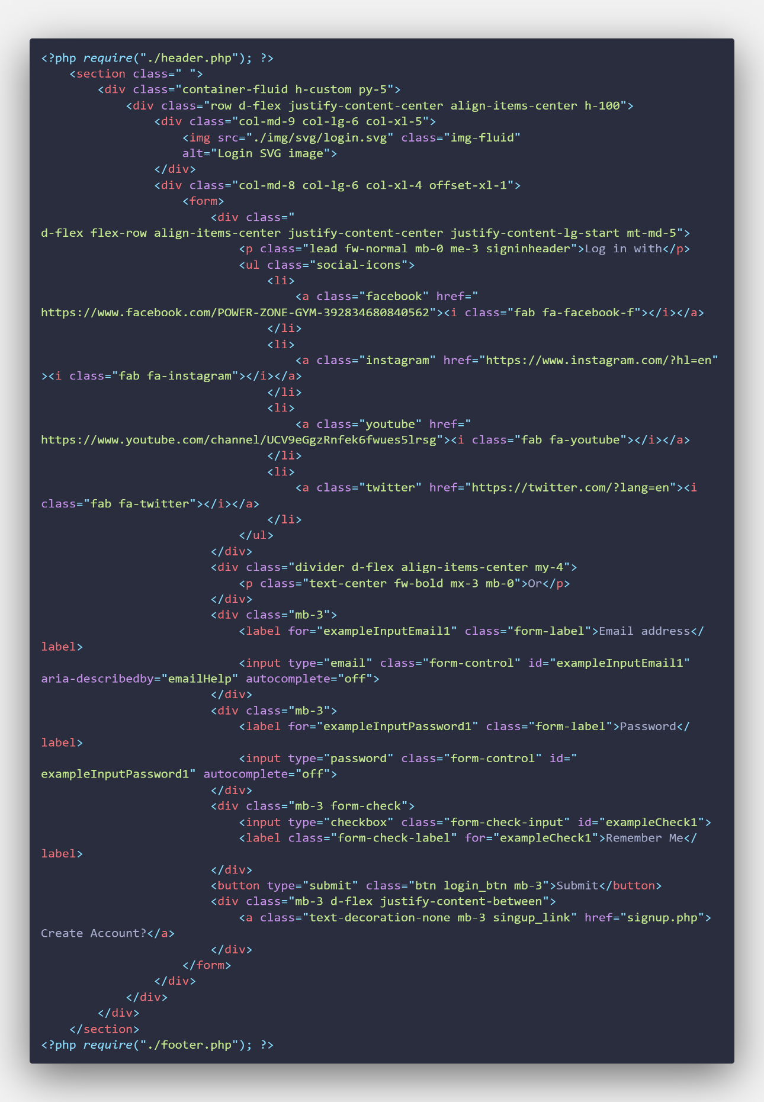

**Product Detail page code**

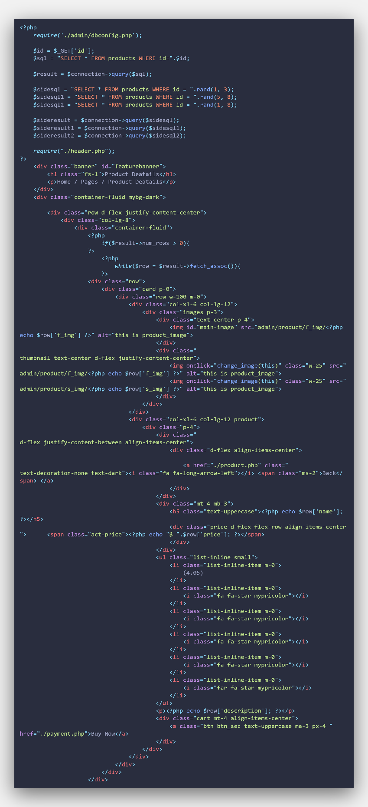

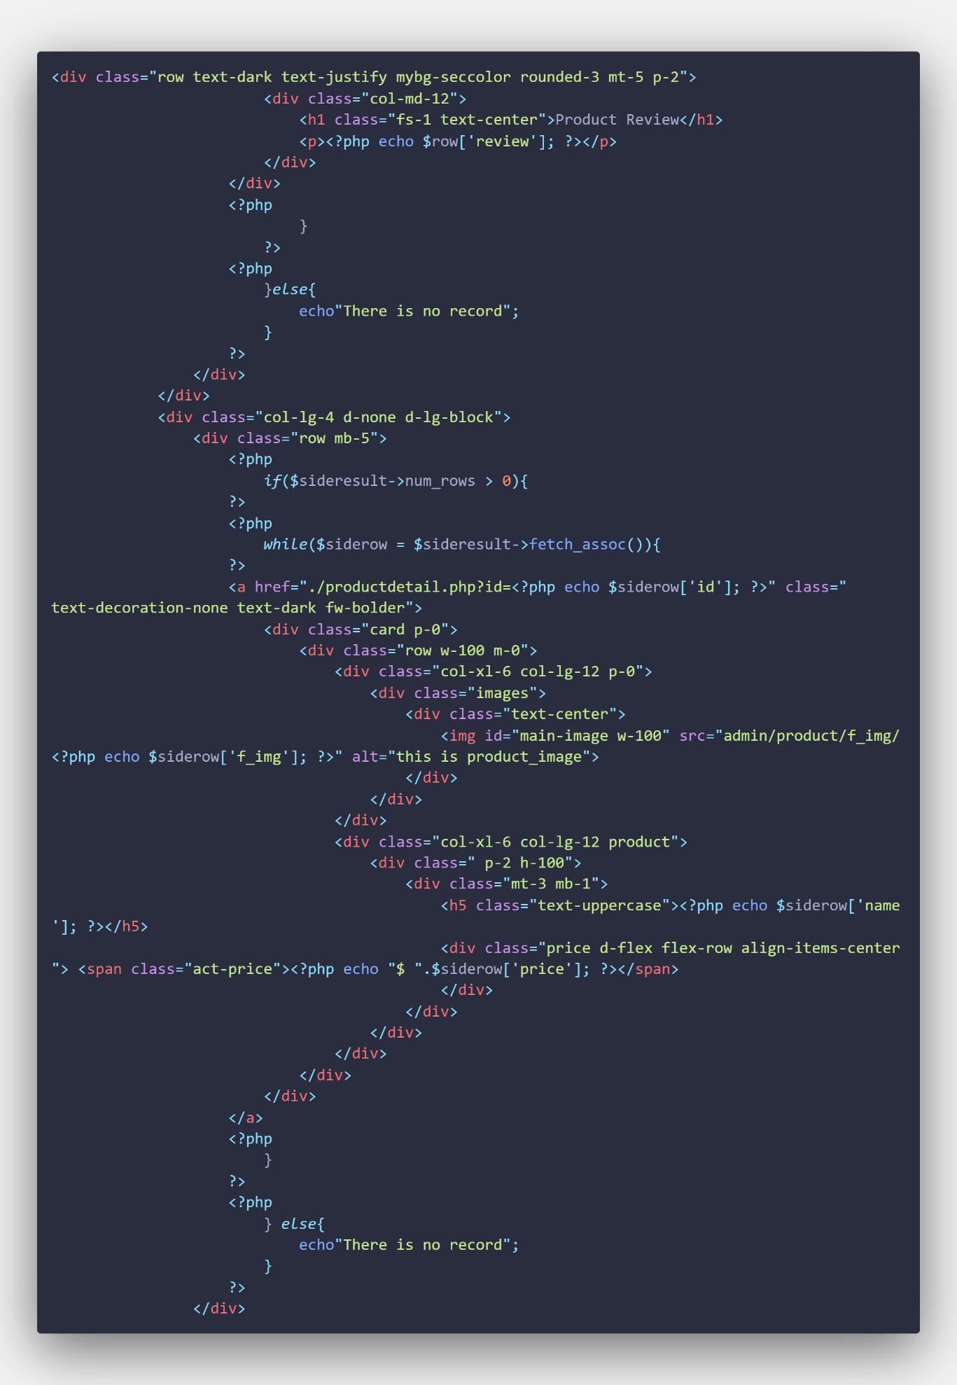

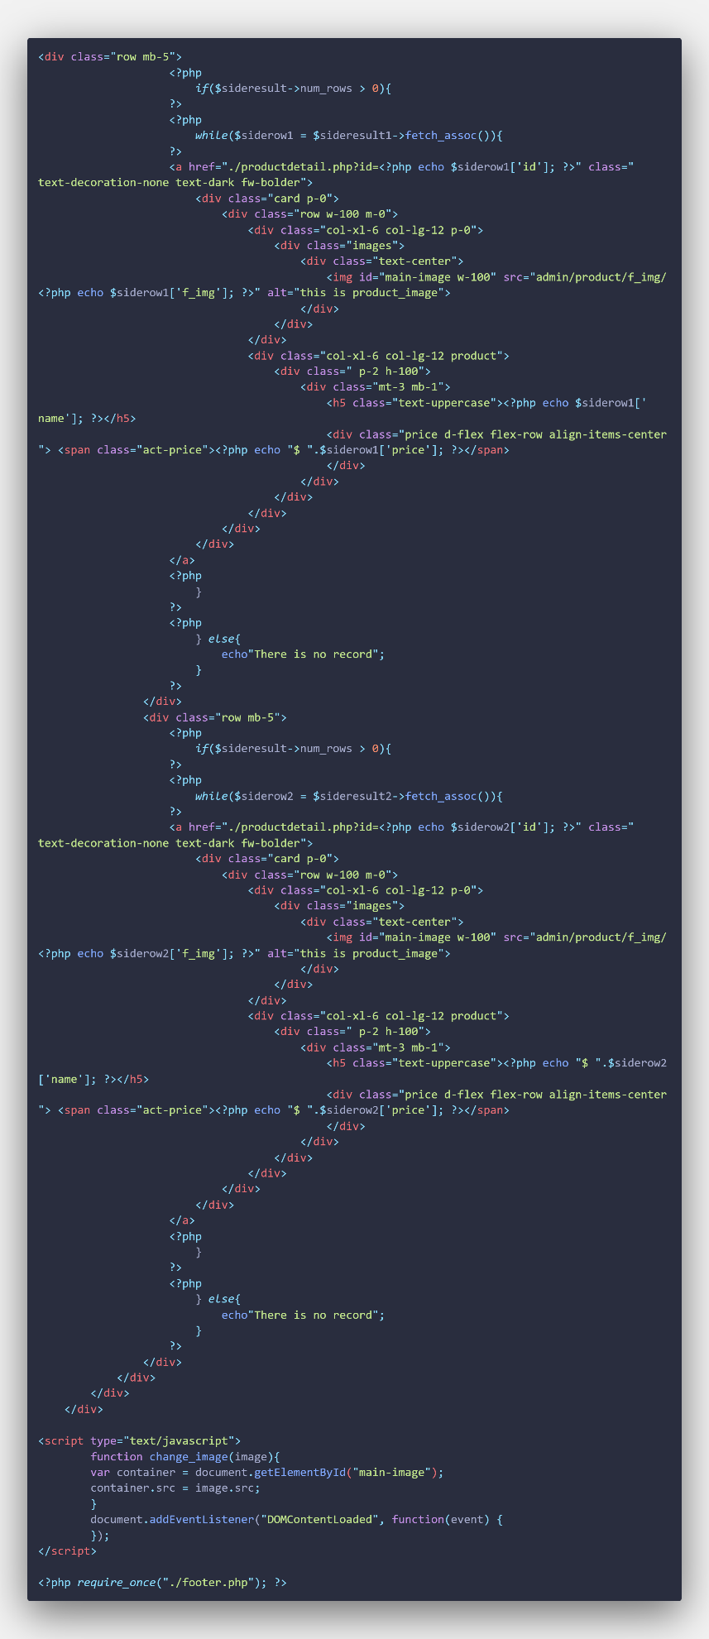

**Privacy page code**

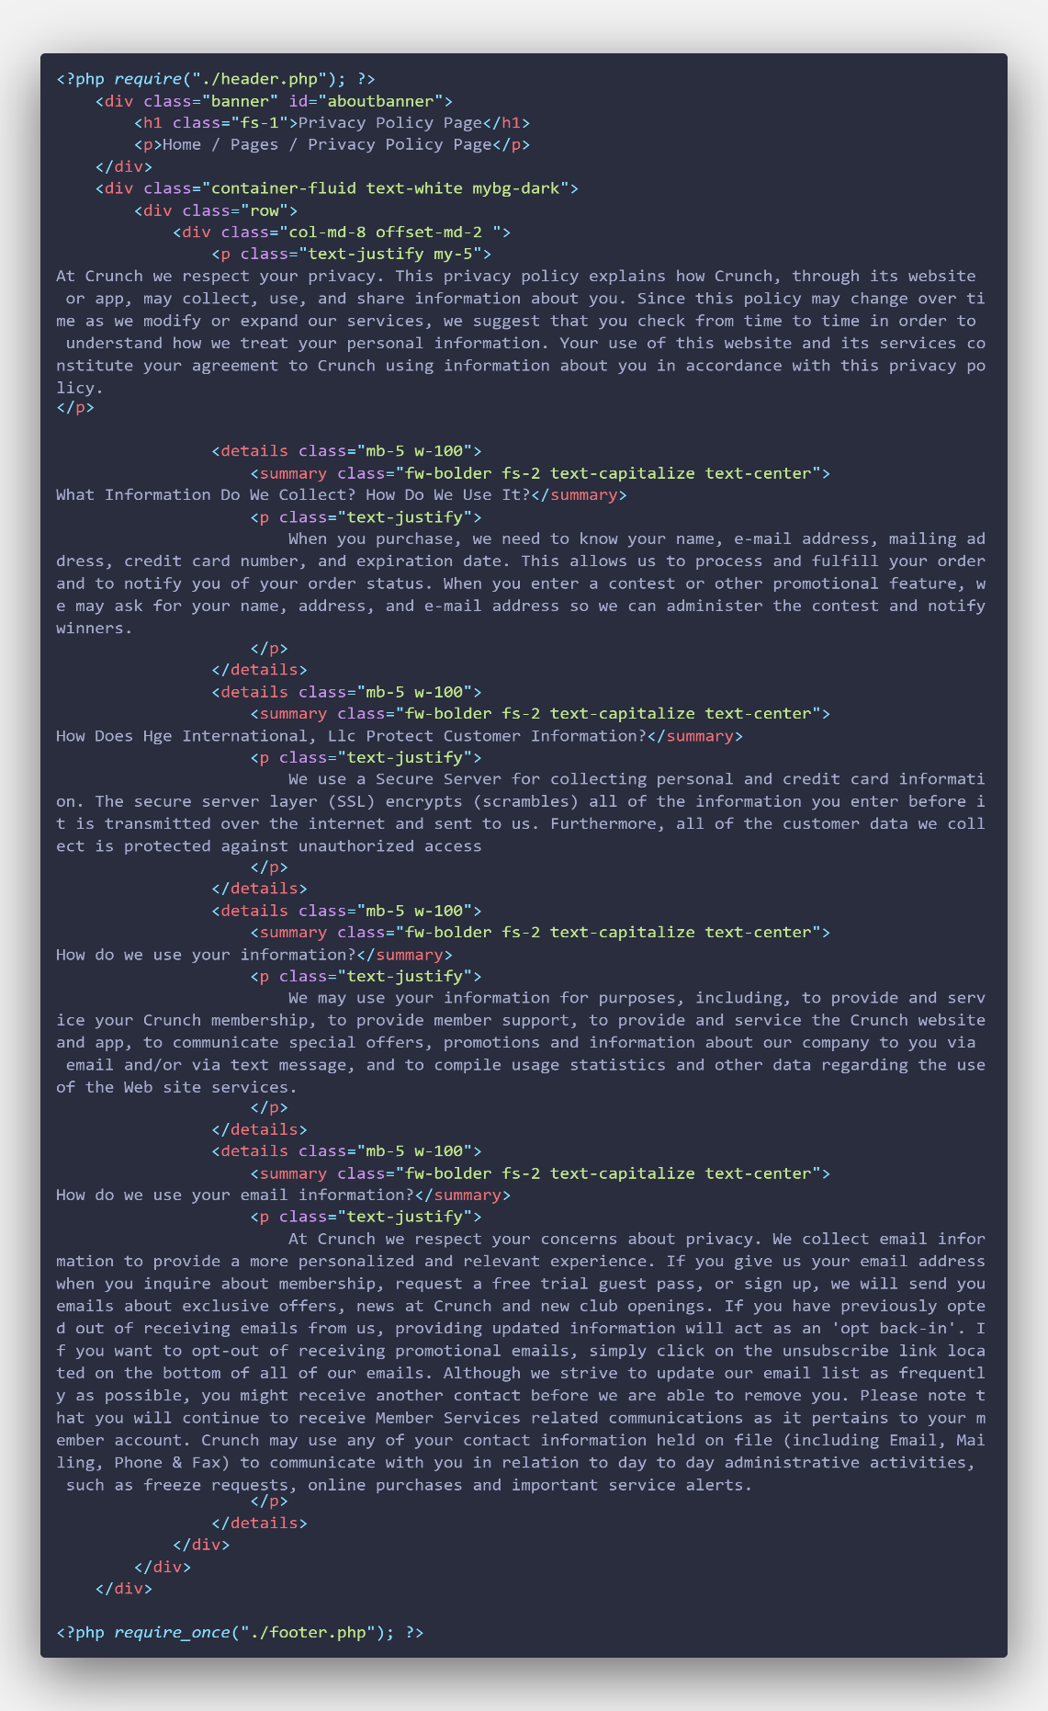

**Cookie page code**

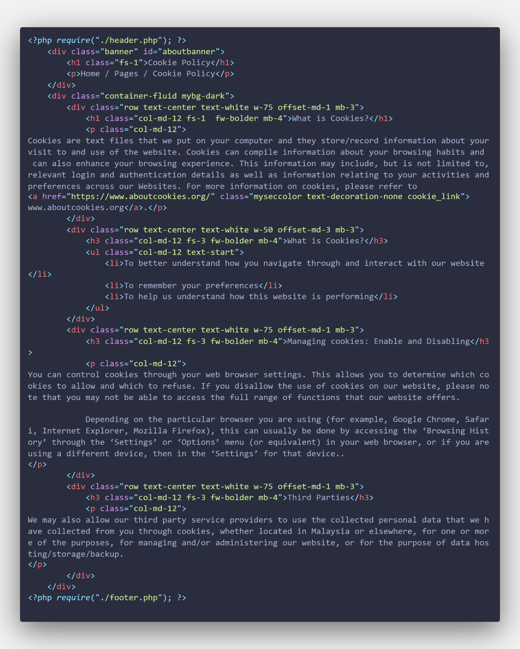

**Payment page code**

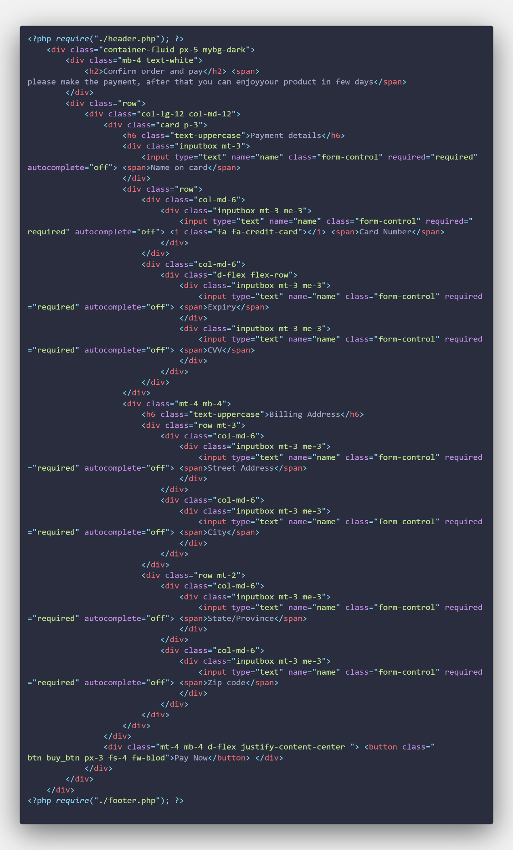

**Web Service page code**

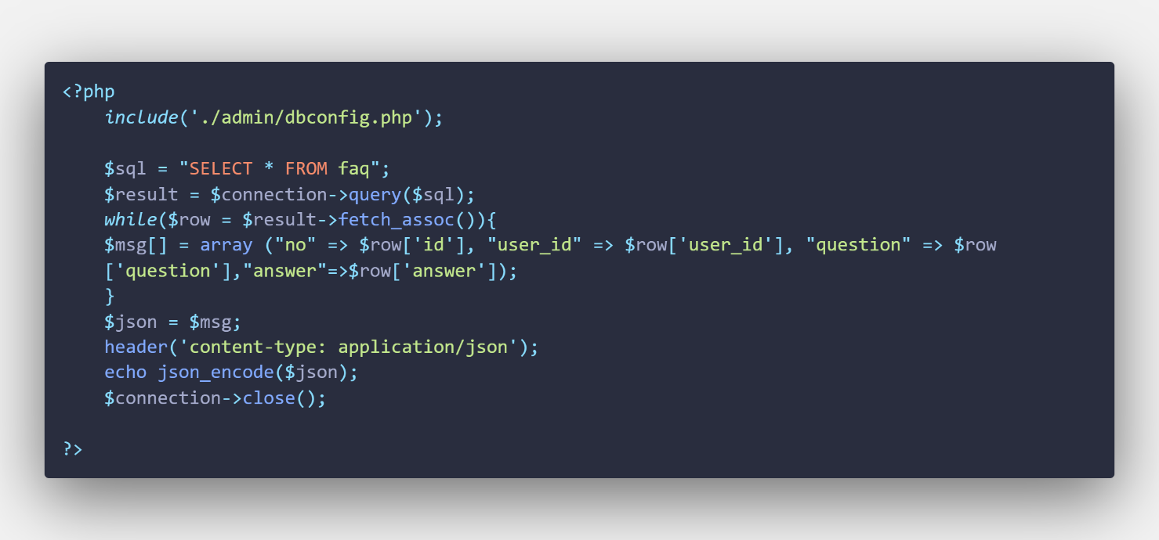

**Footer page code**

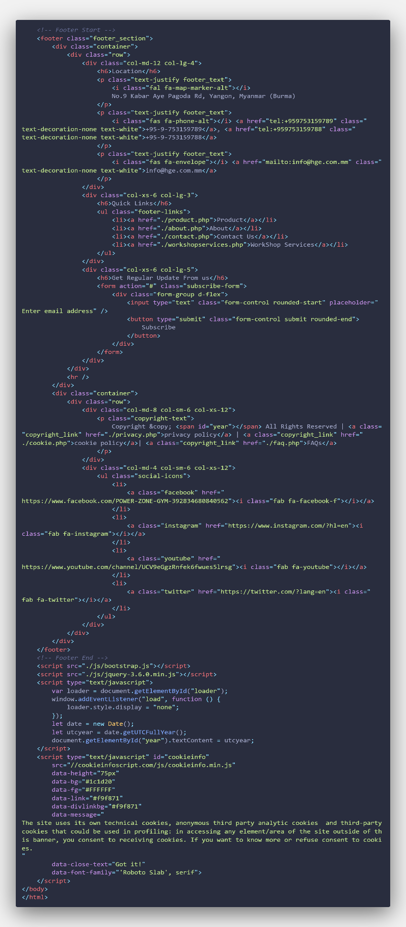

**Style CSS page code**

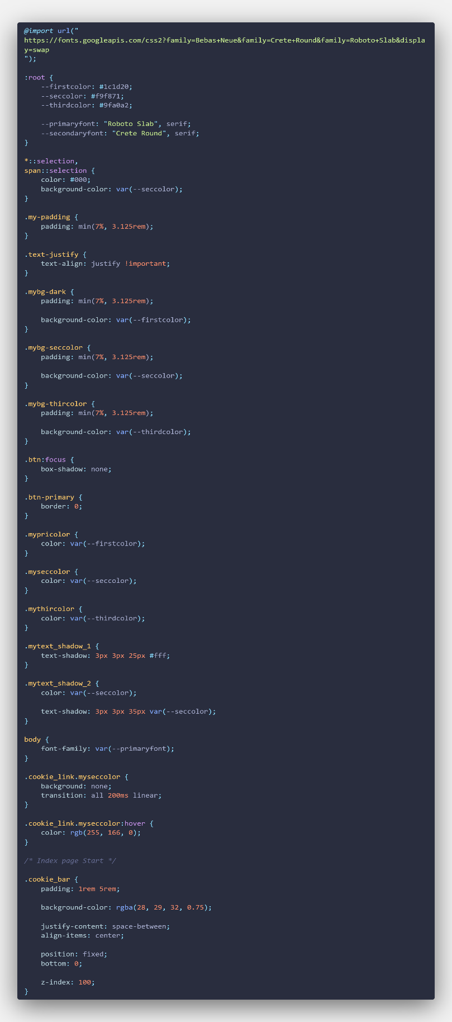

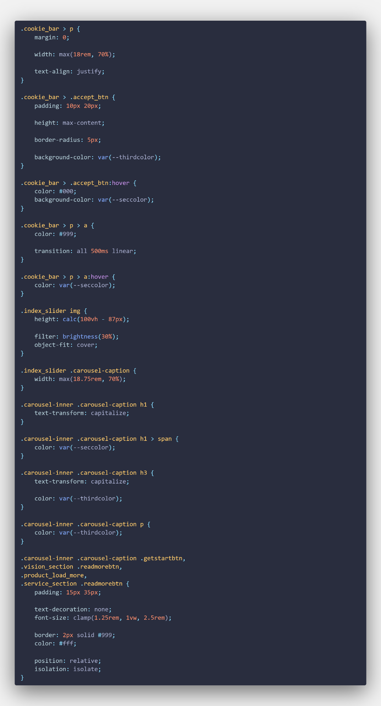

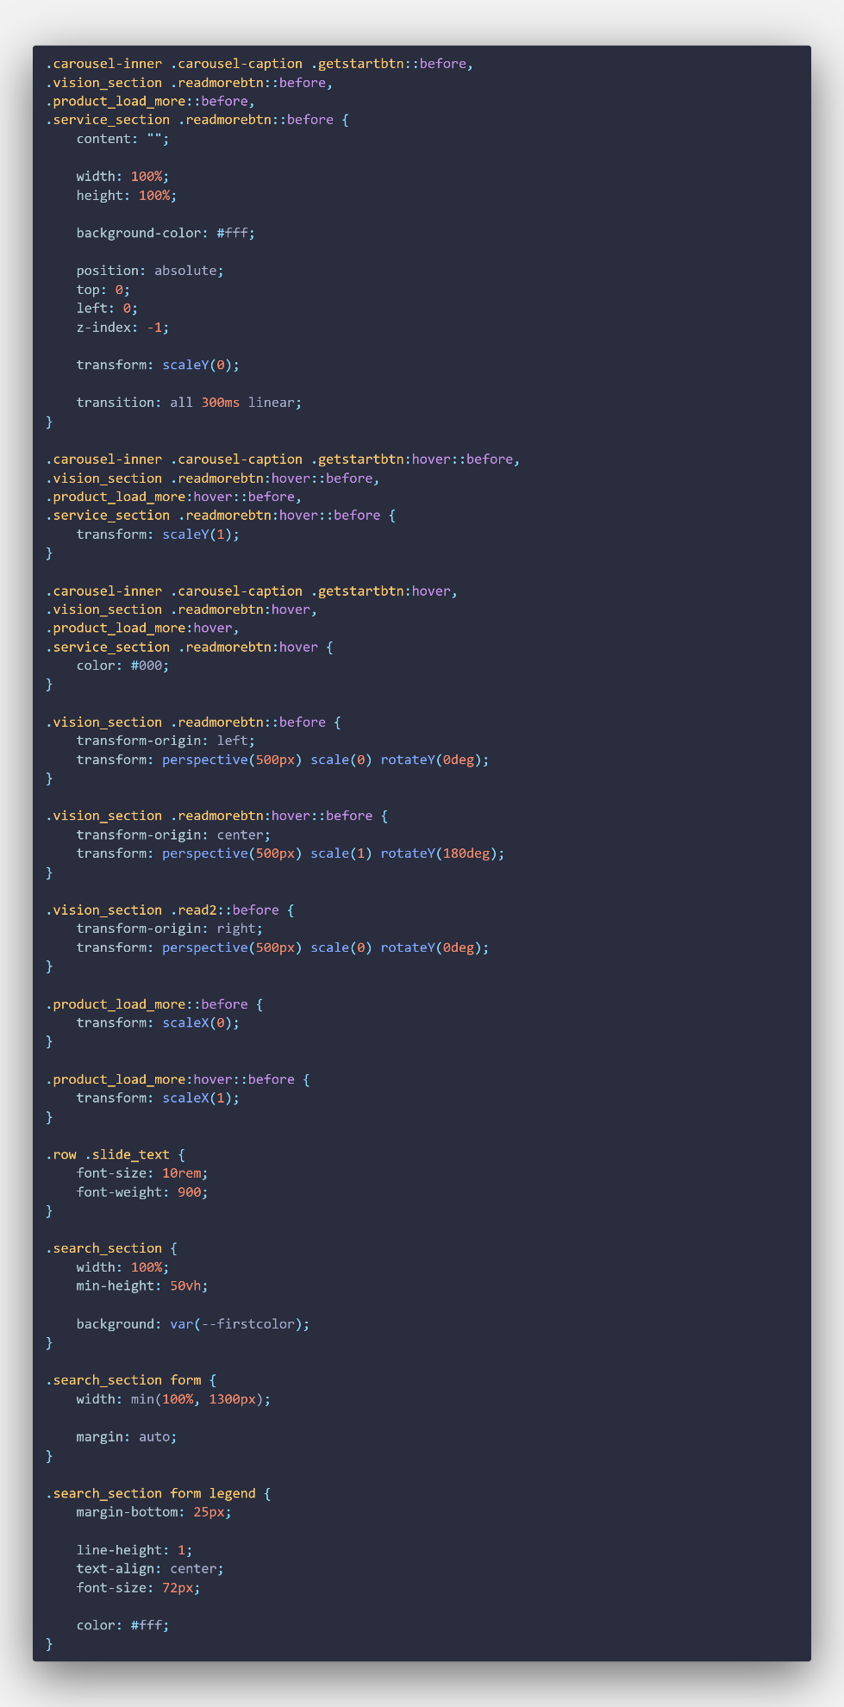

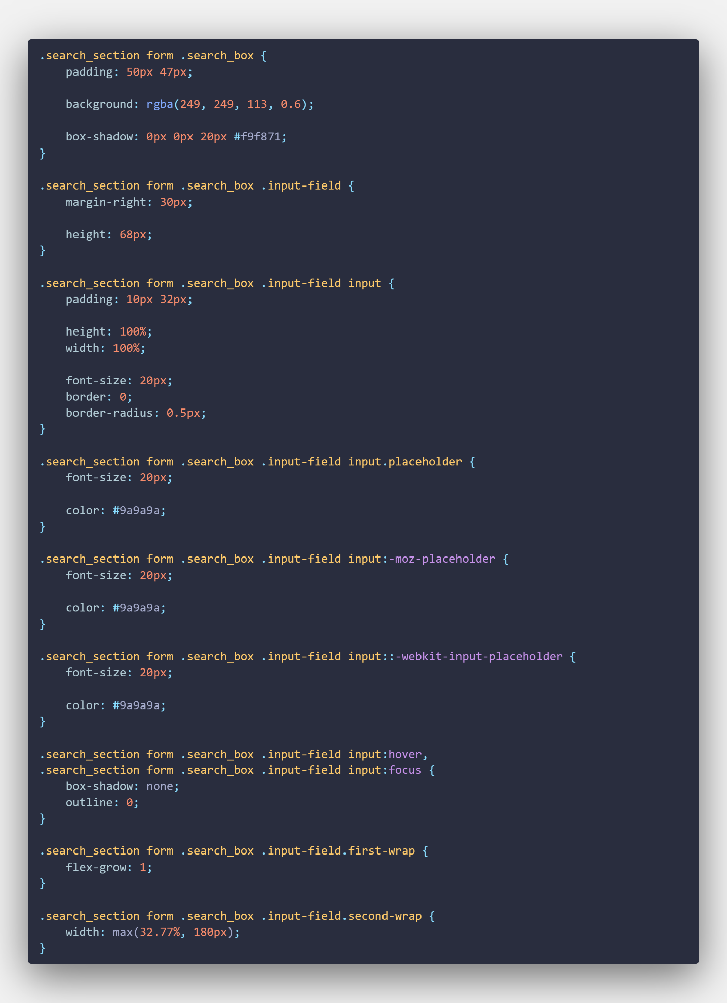

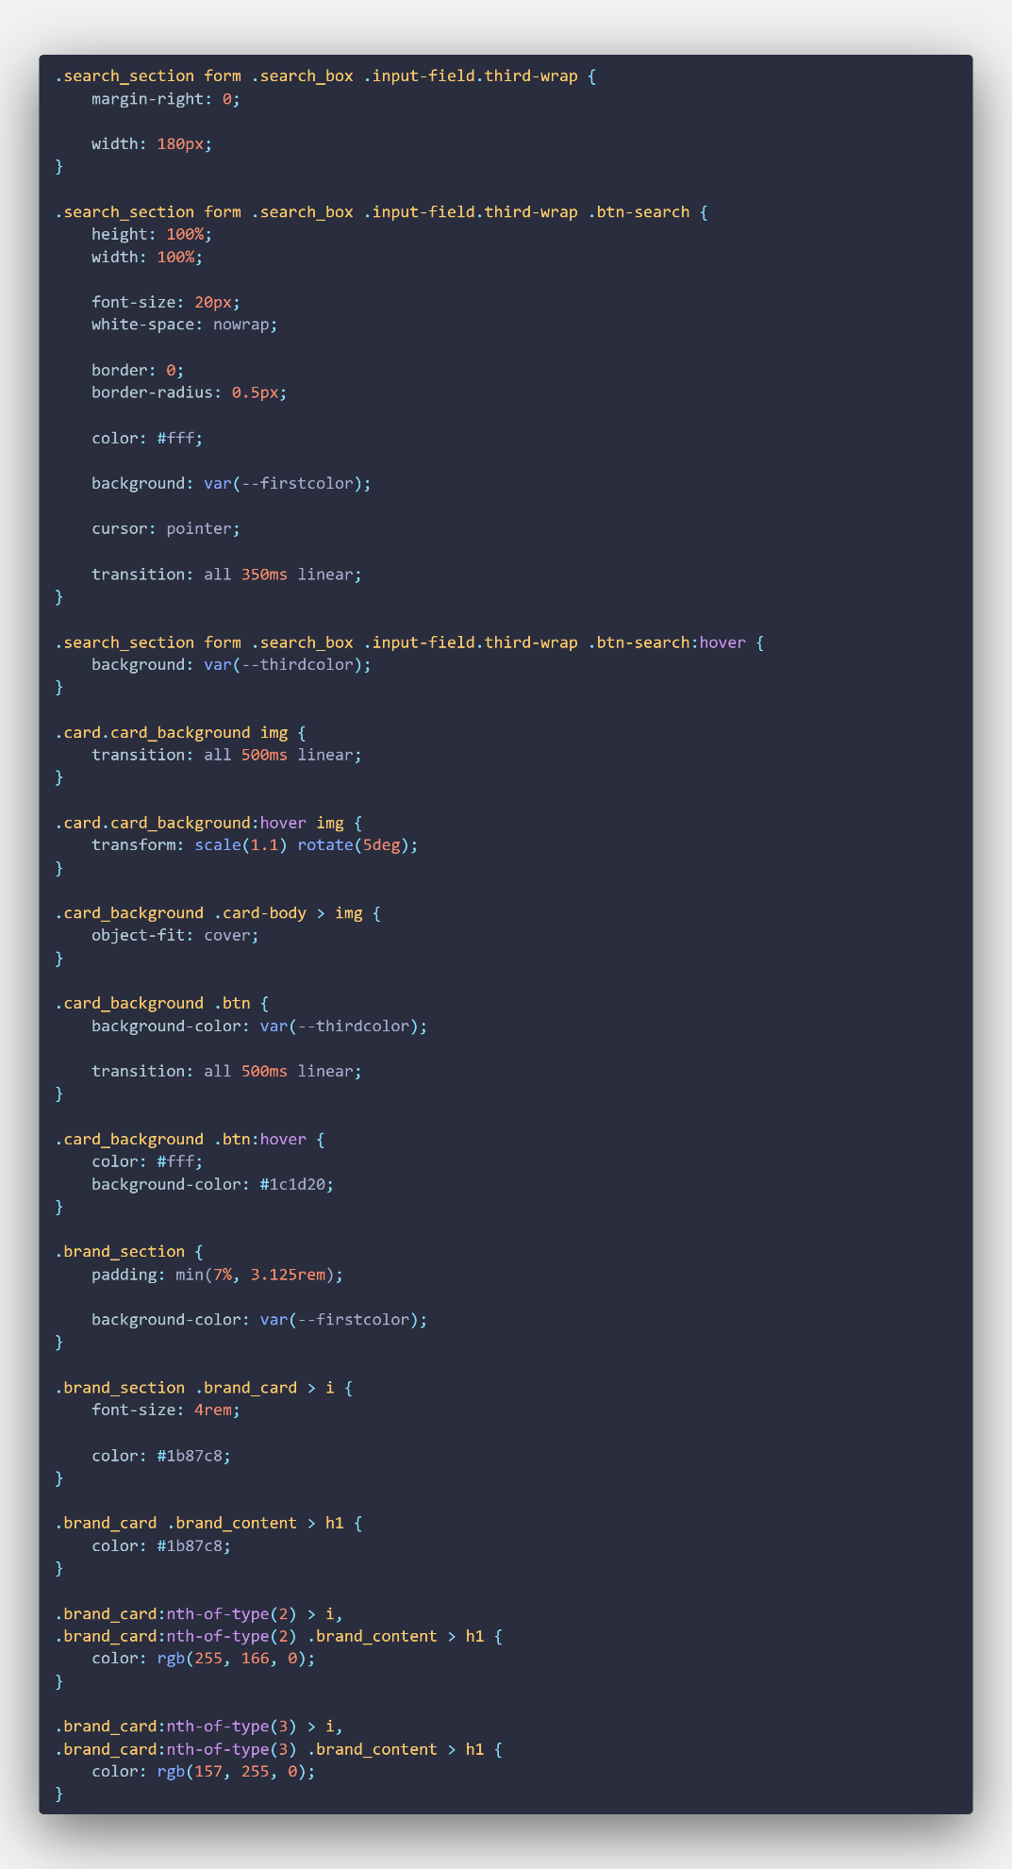

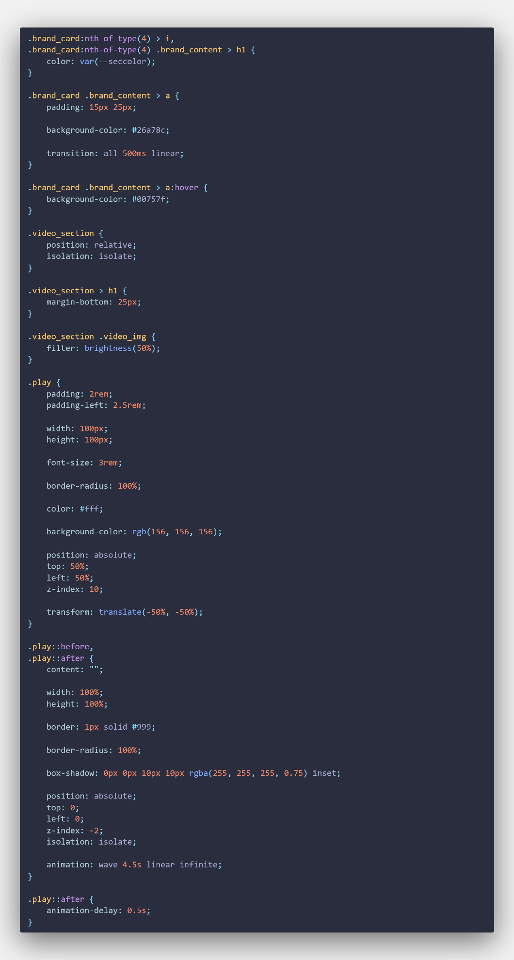

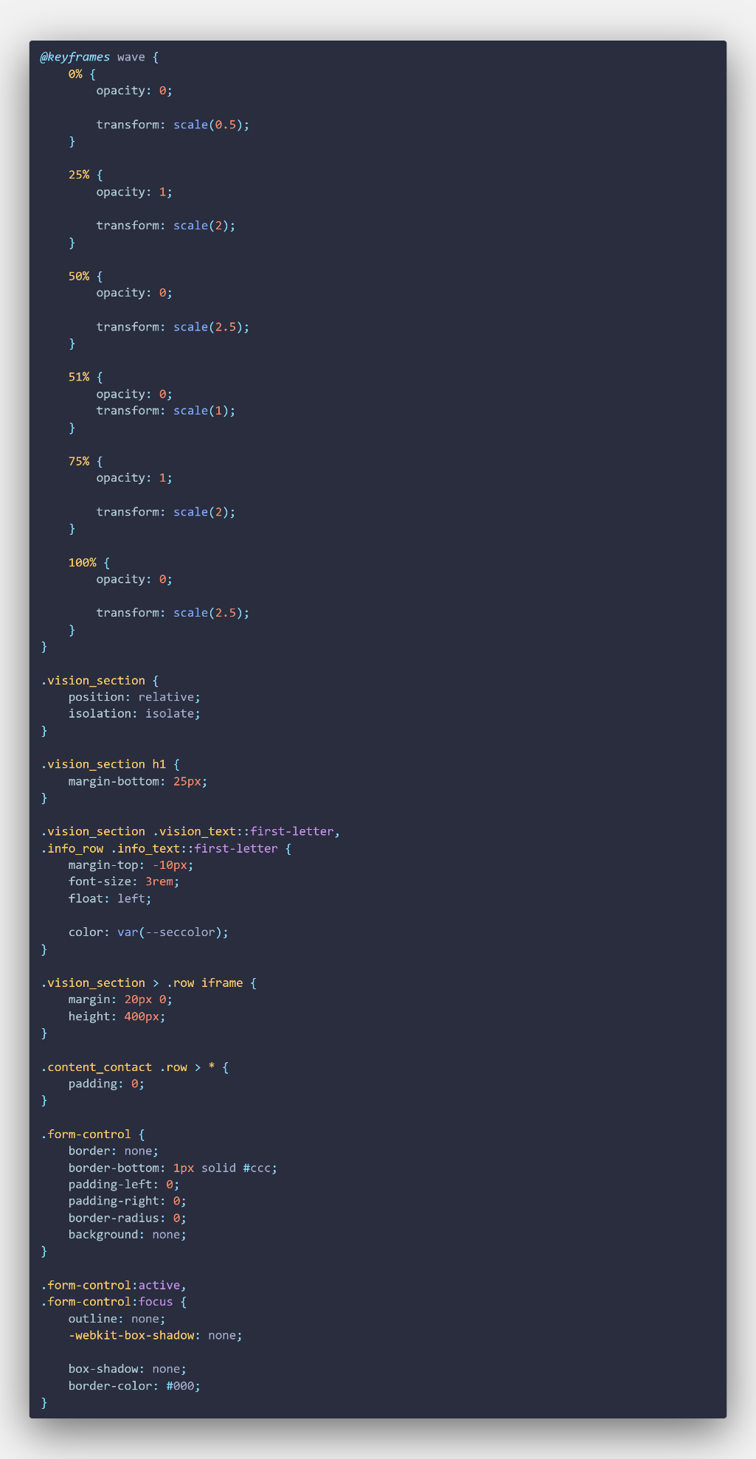

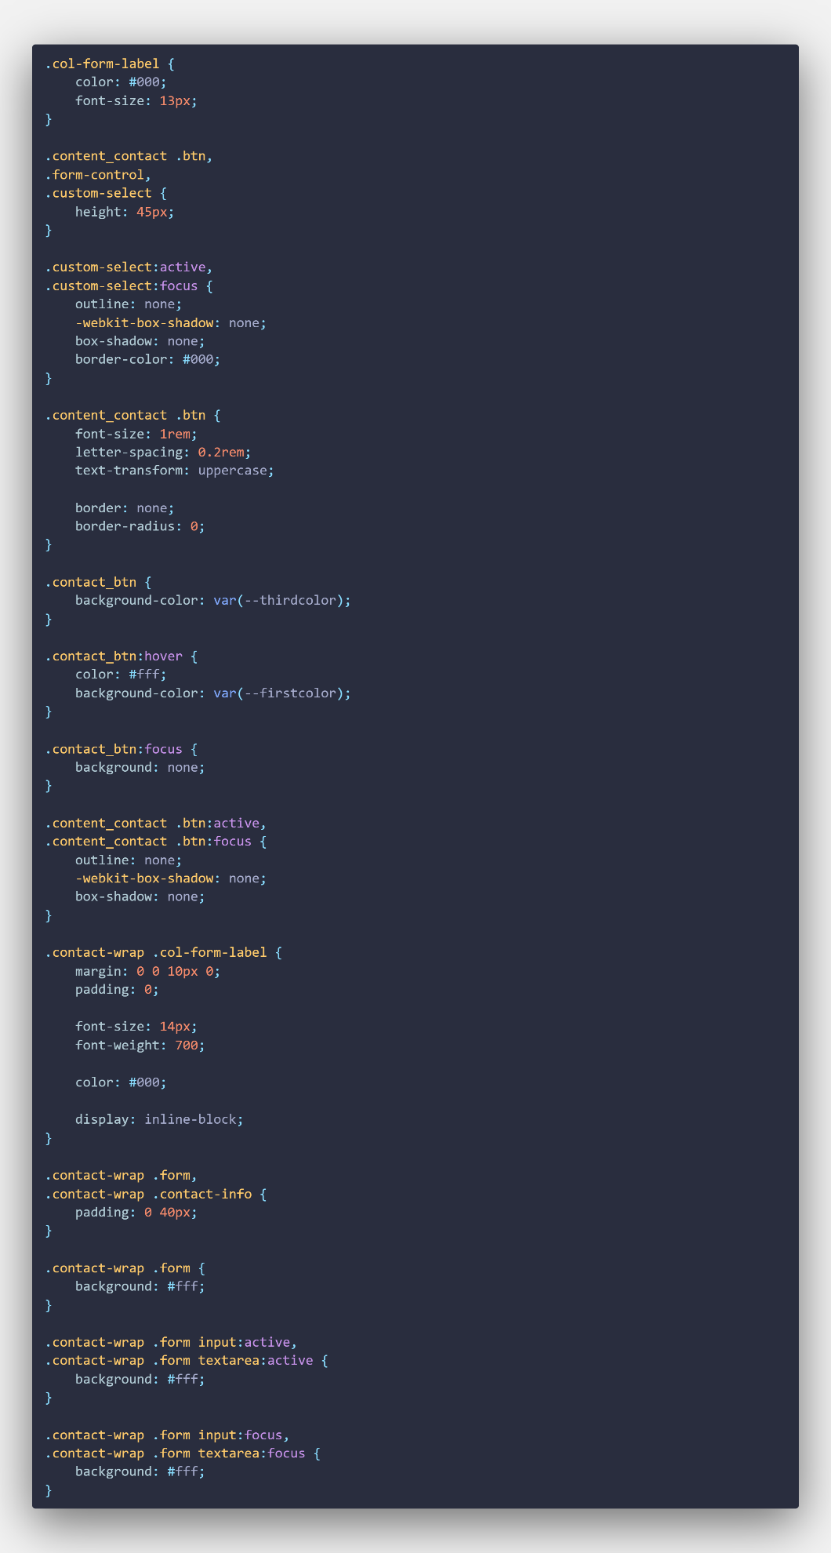

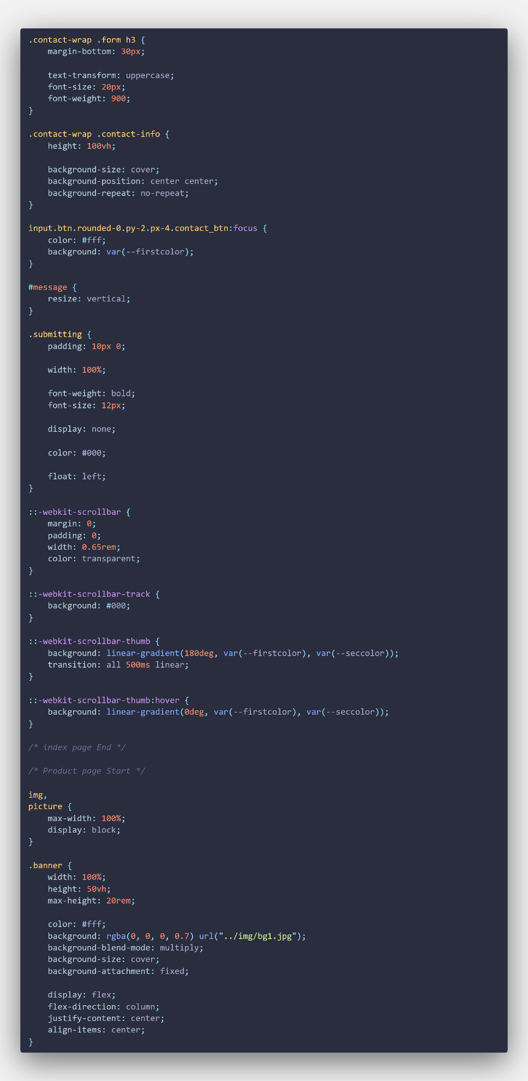

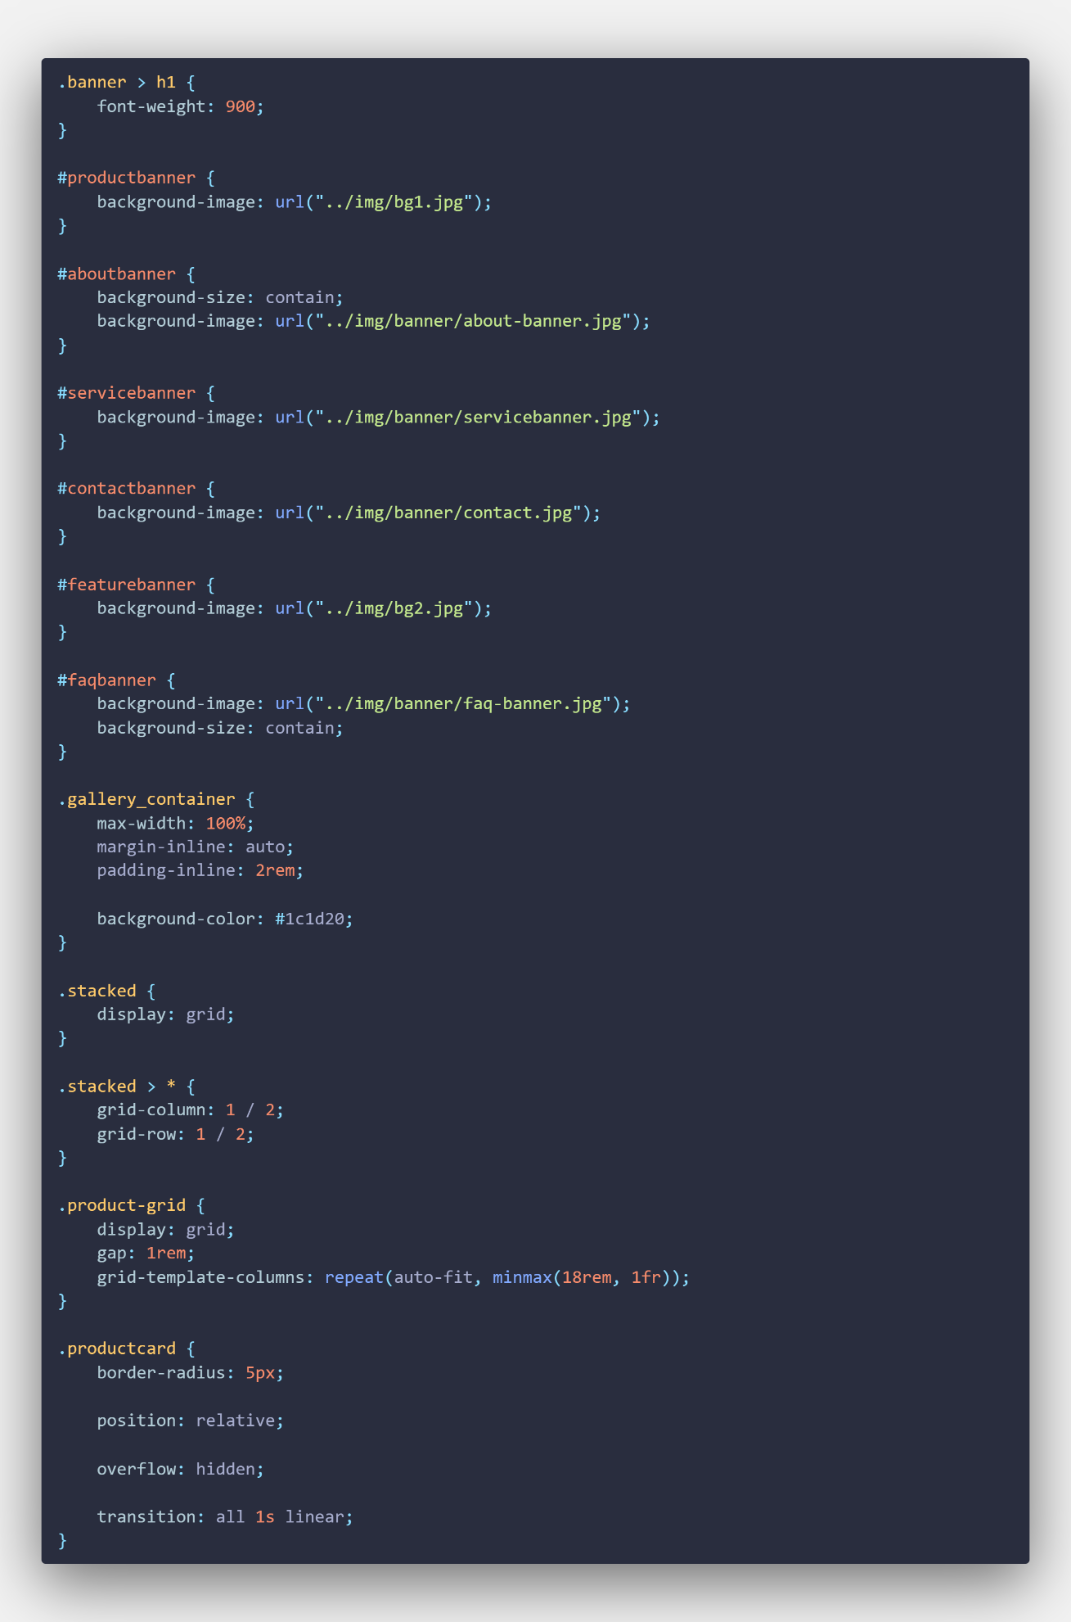

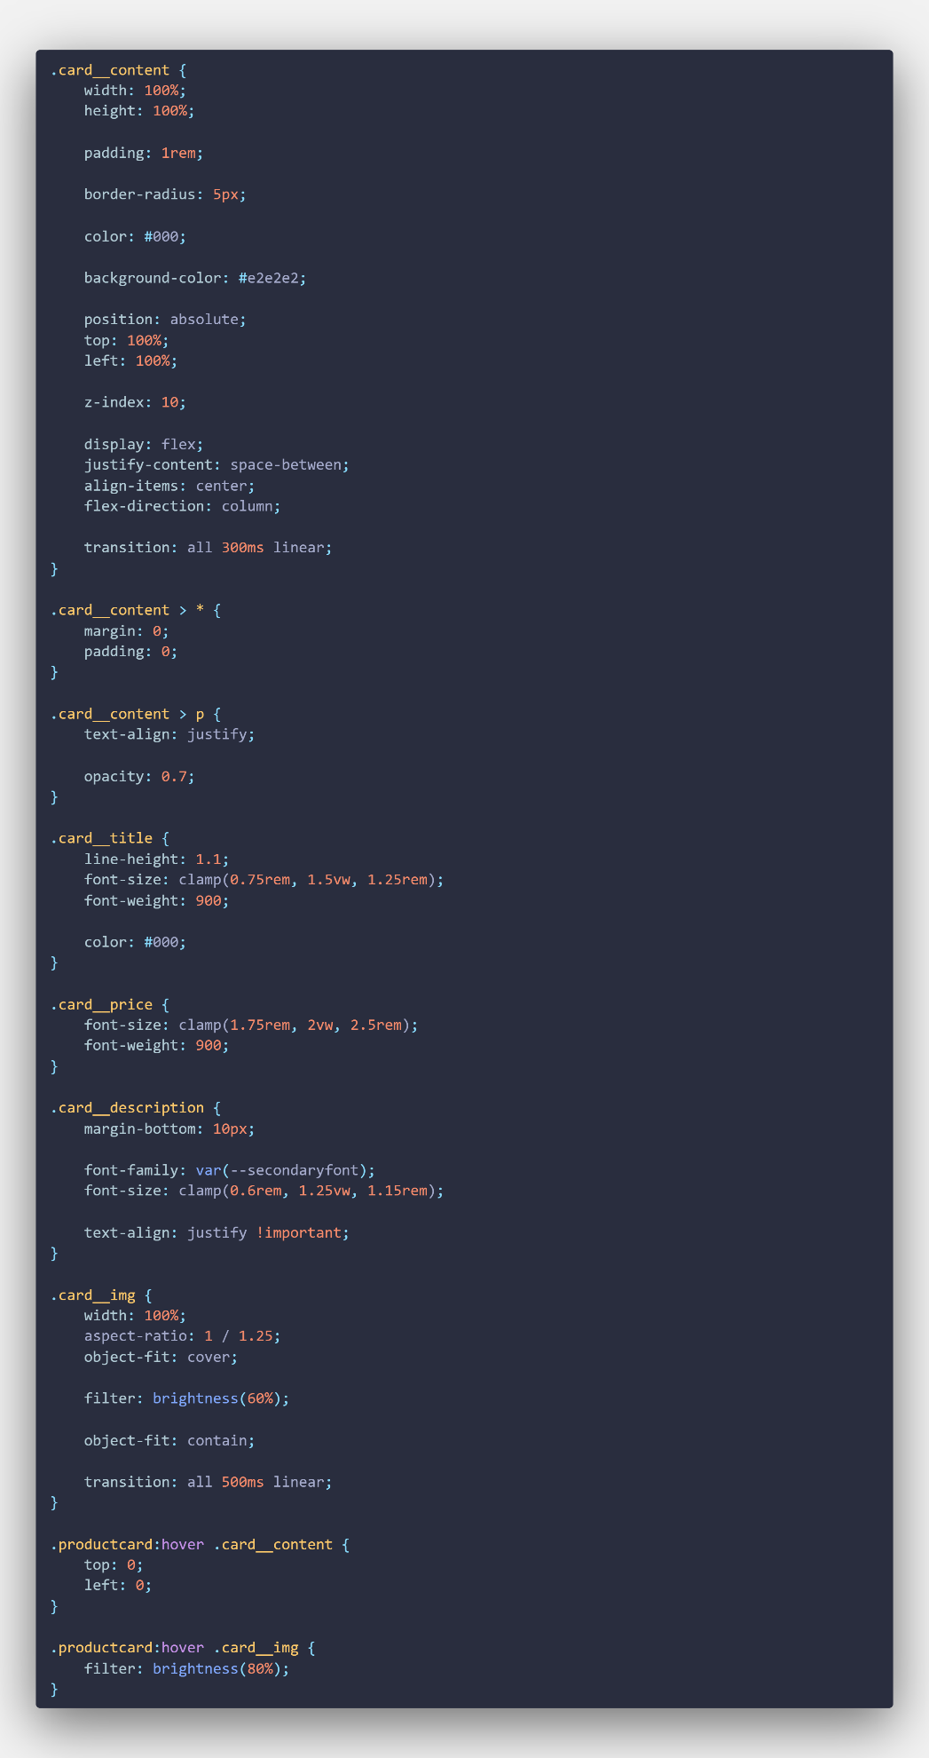

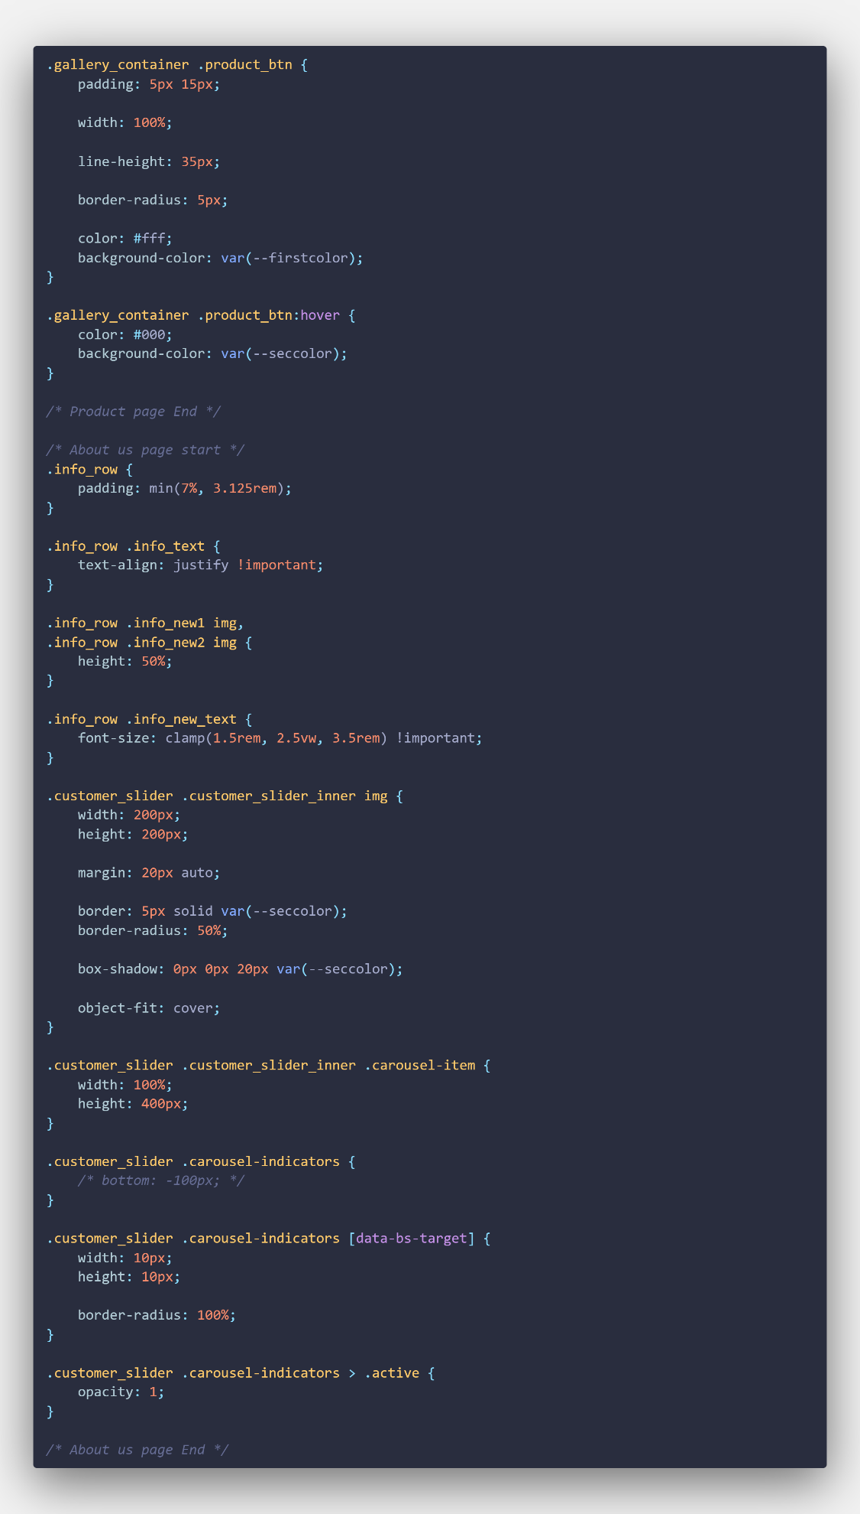

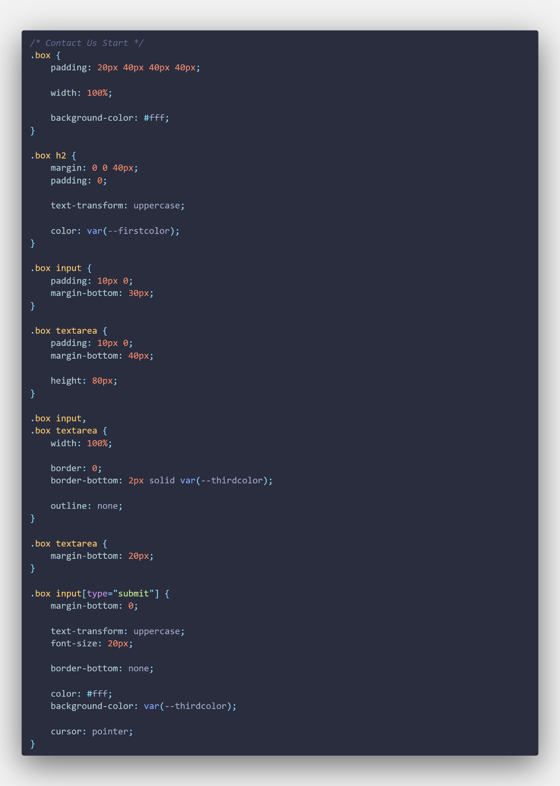

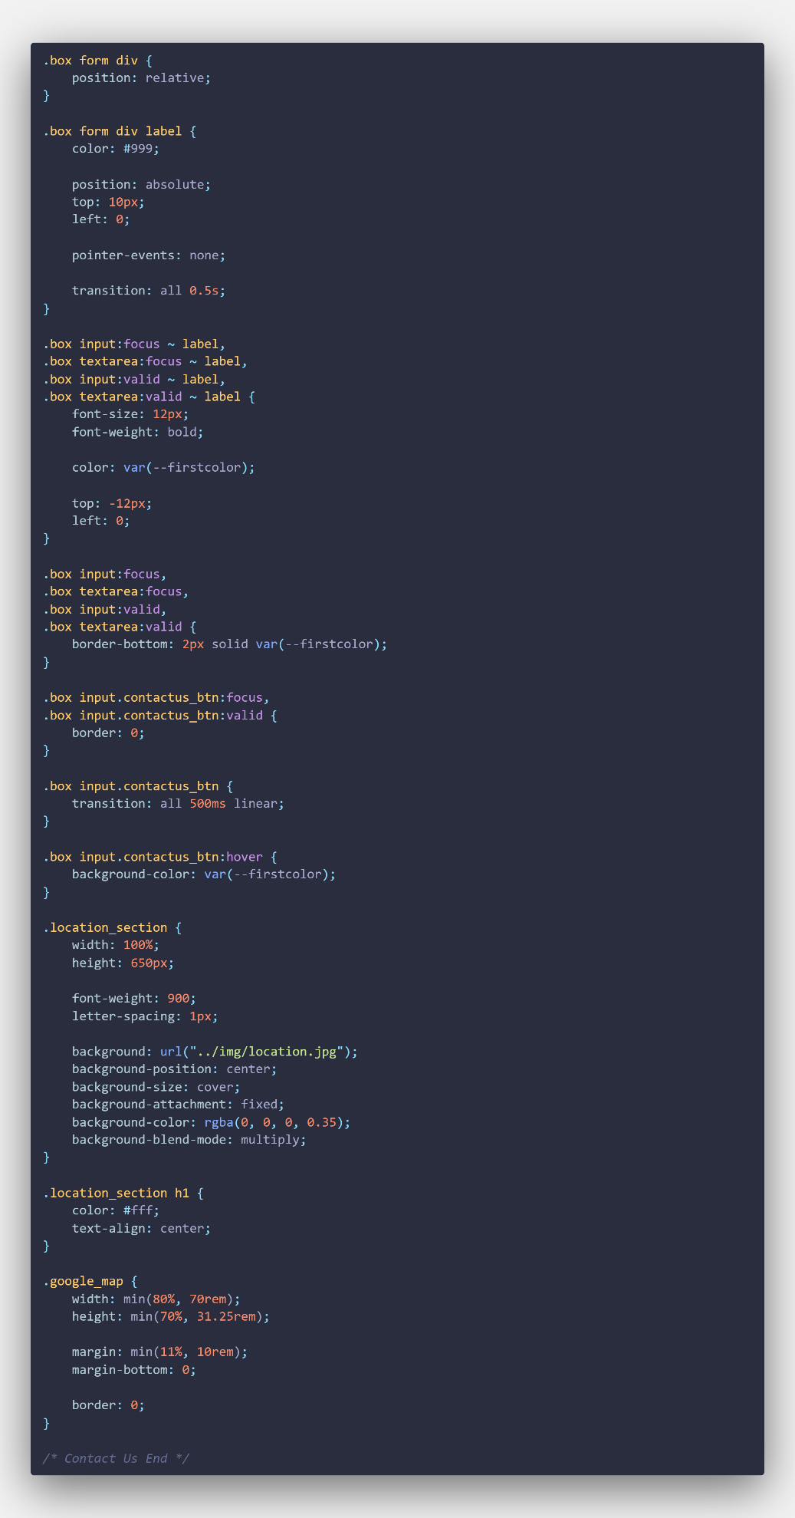

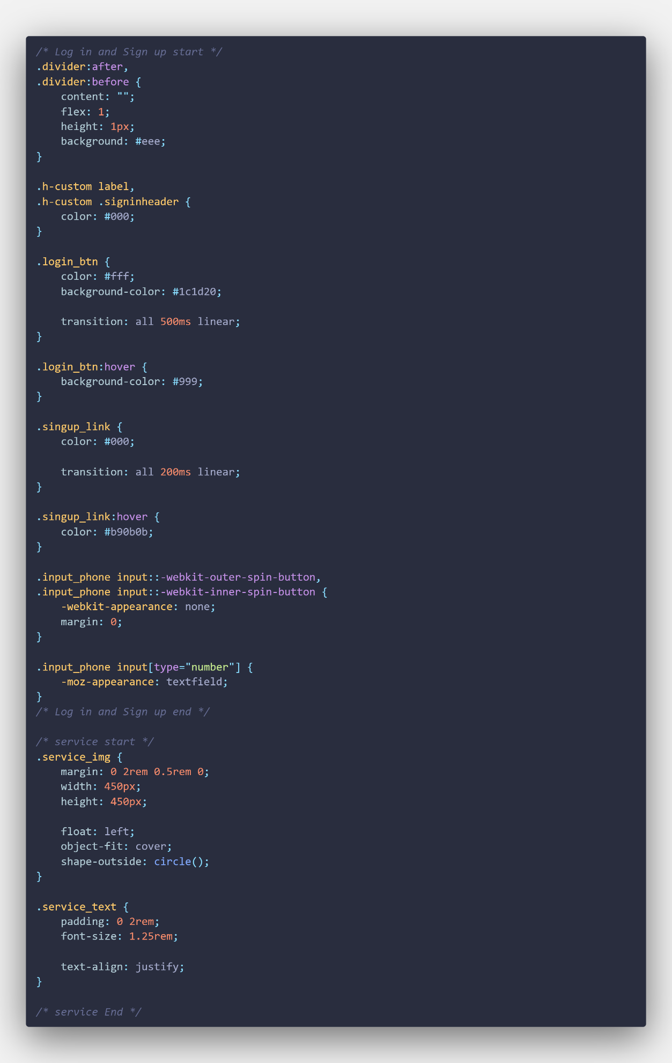

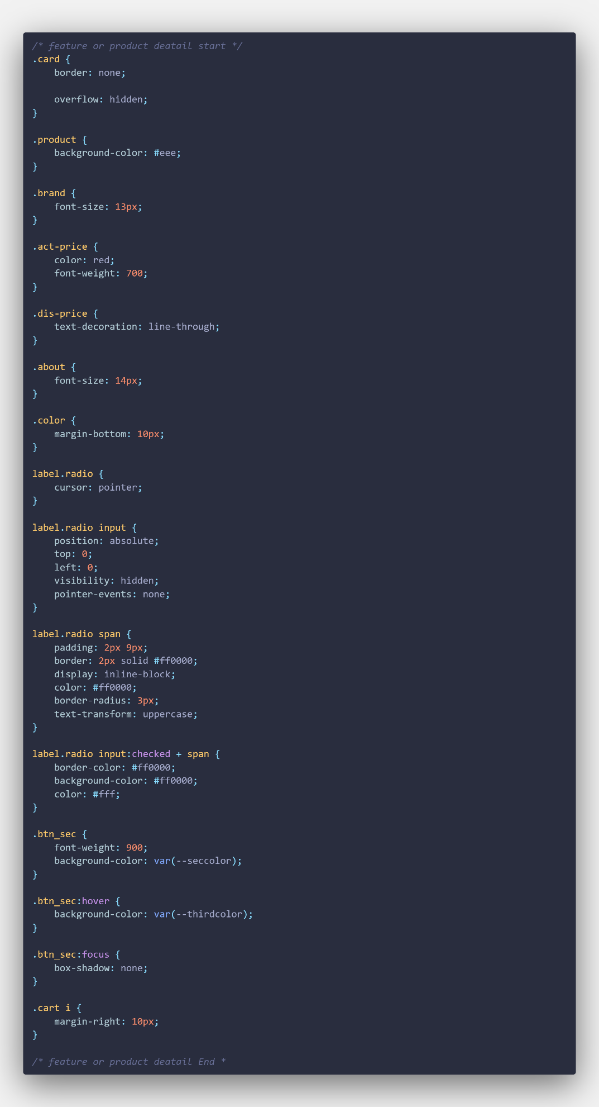

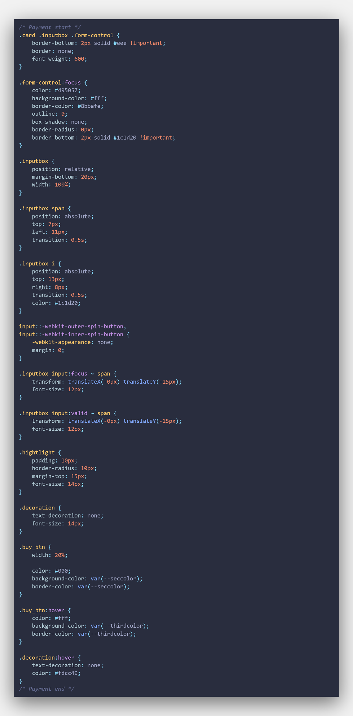

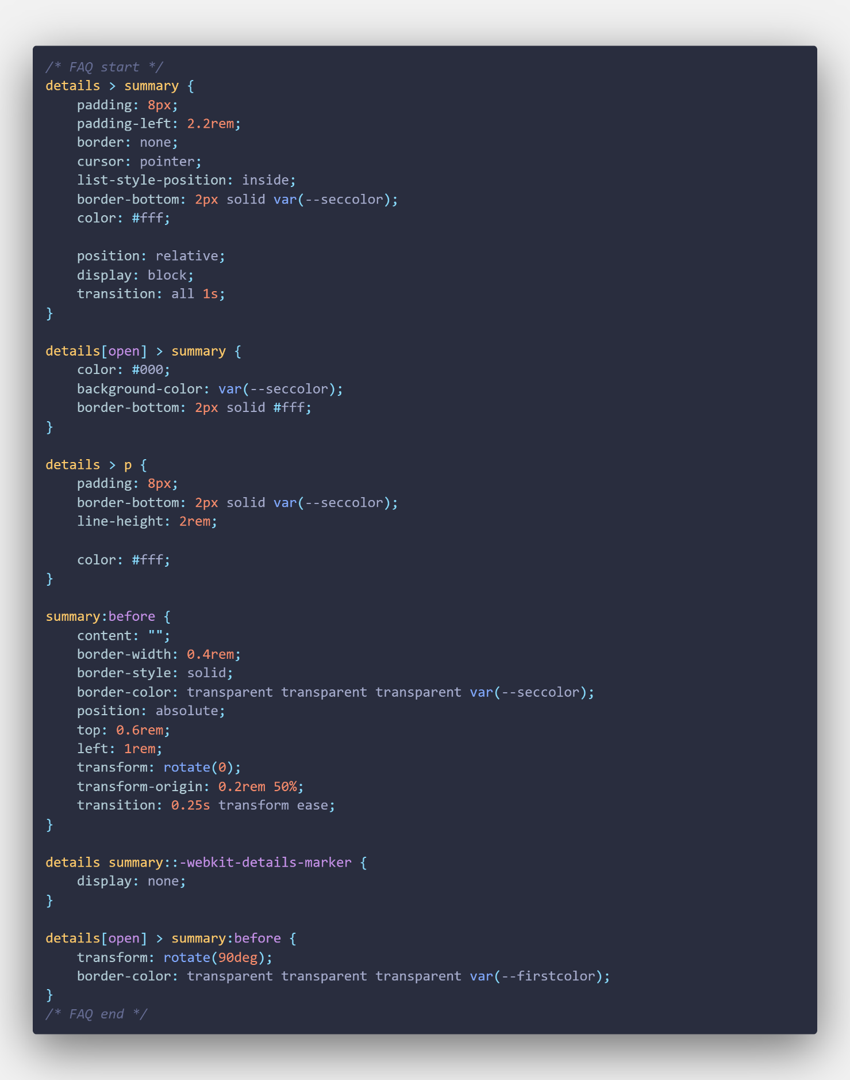

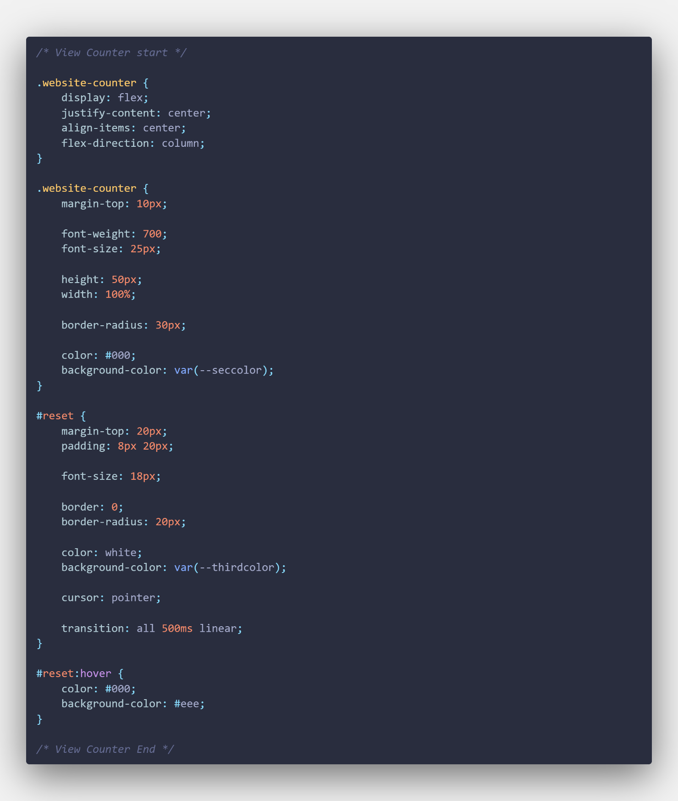

**Media query CSS page code**

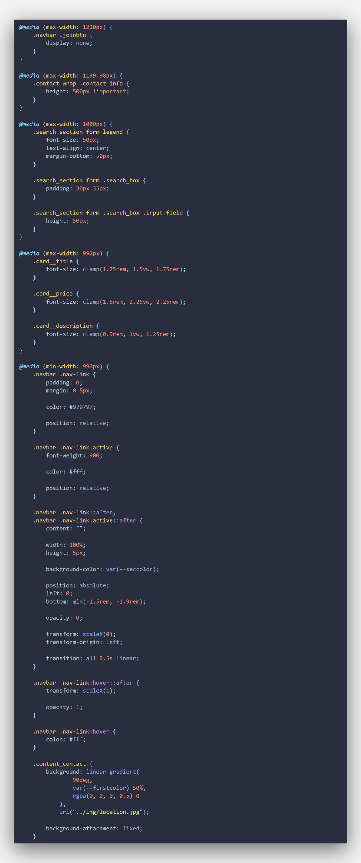

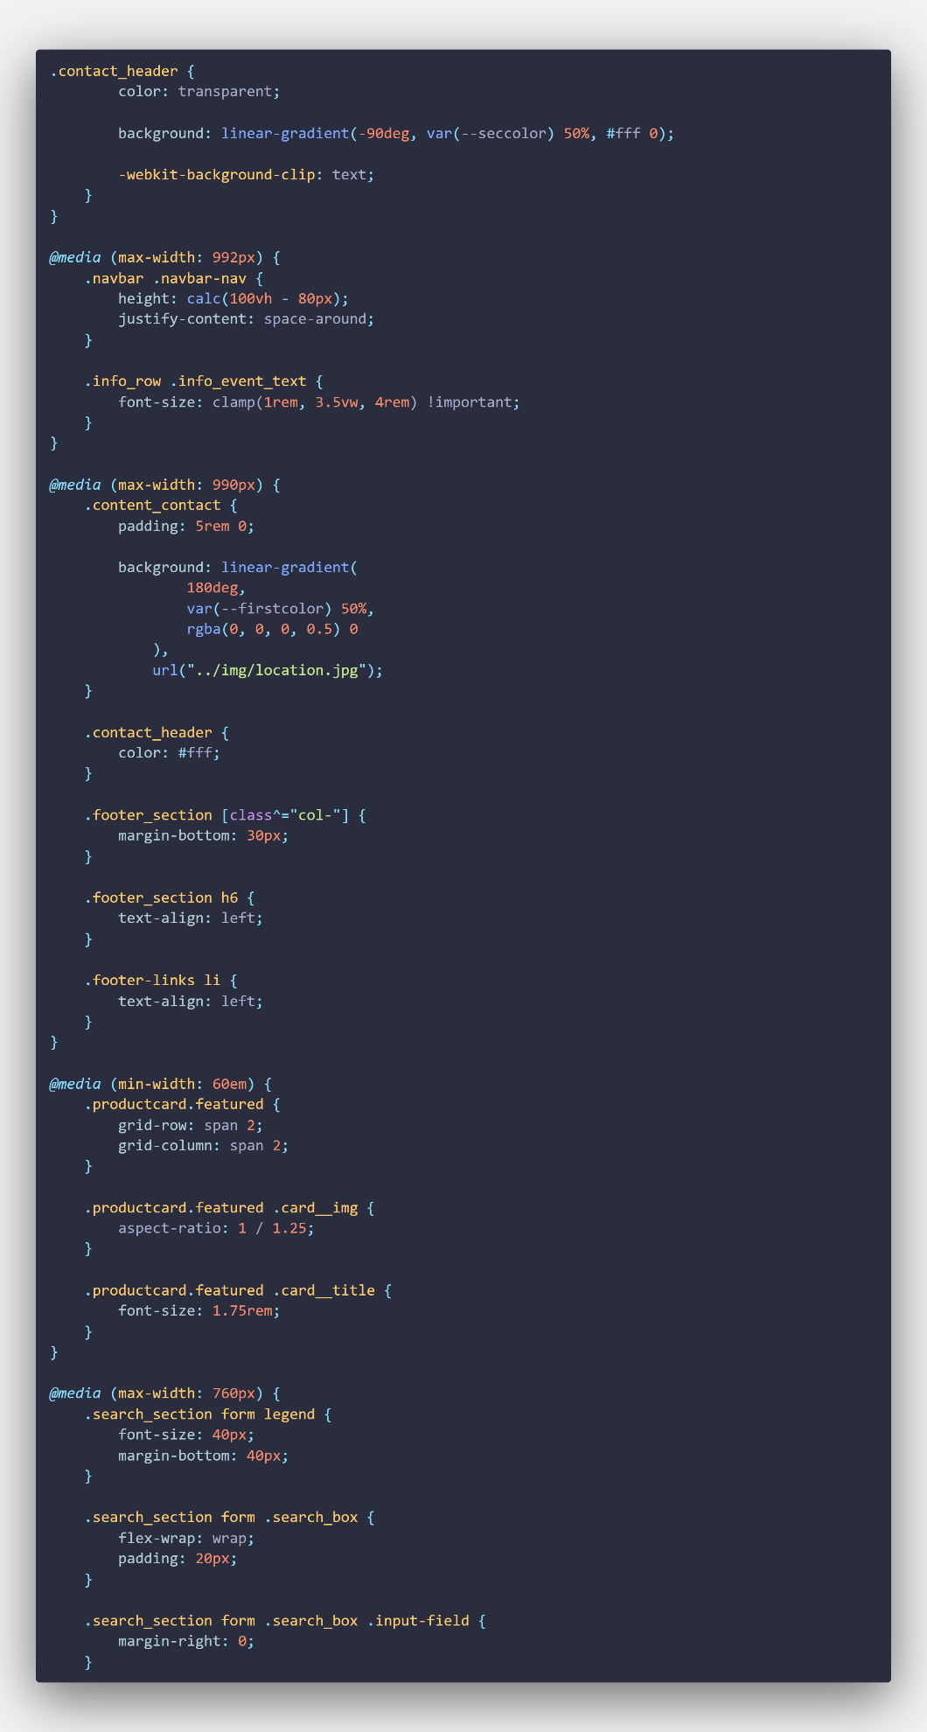

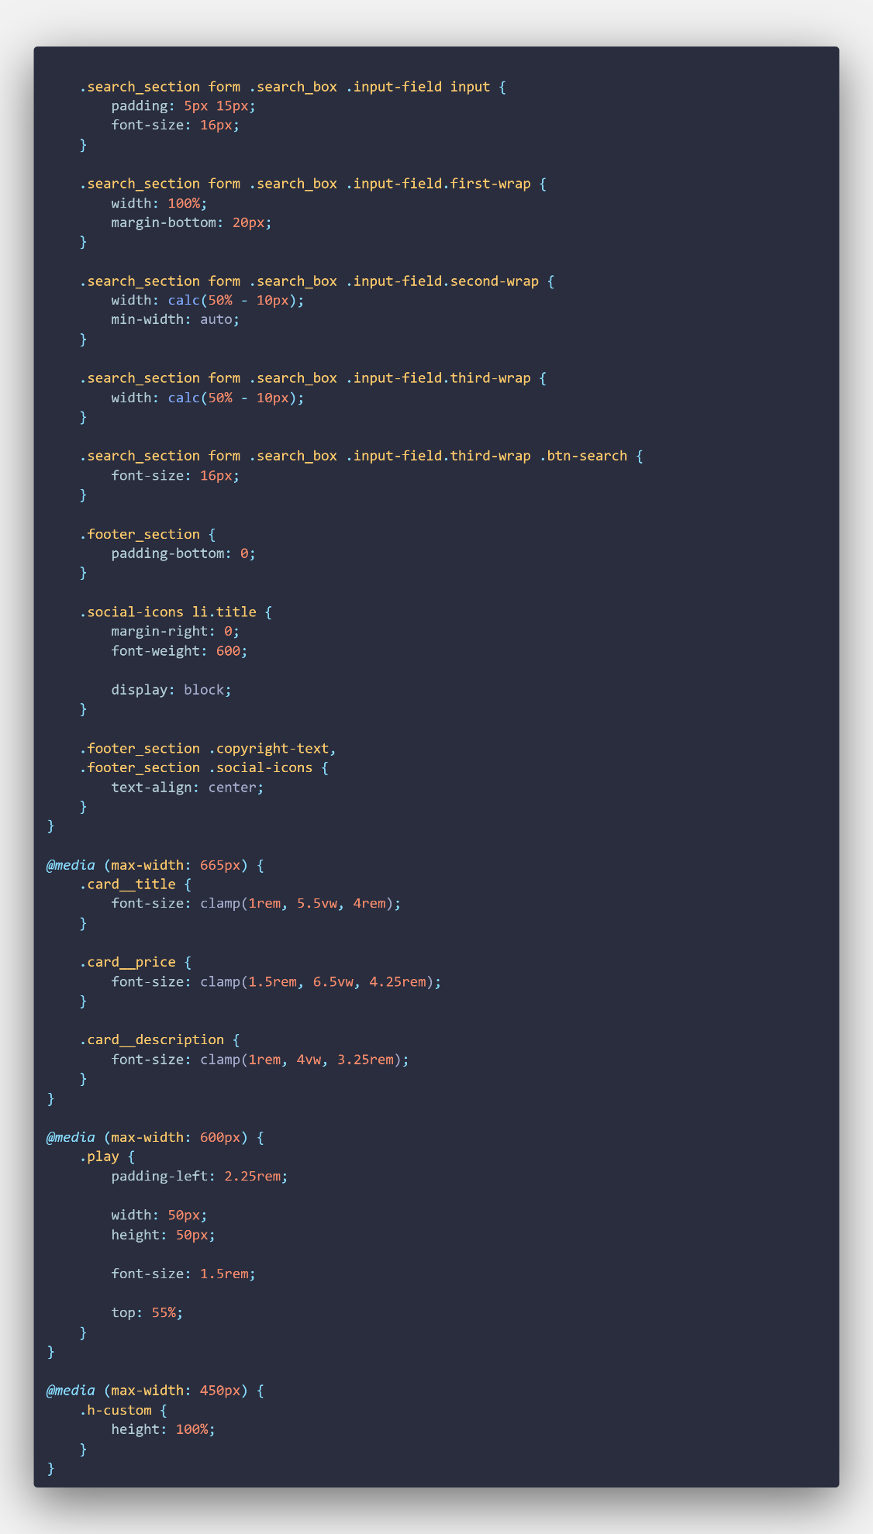

**Header Footer Loader CSS page code**

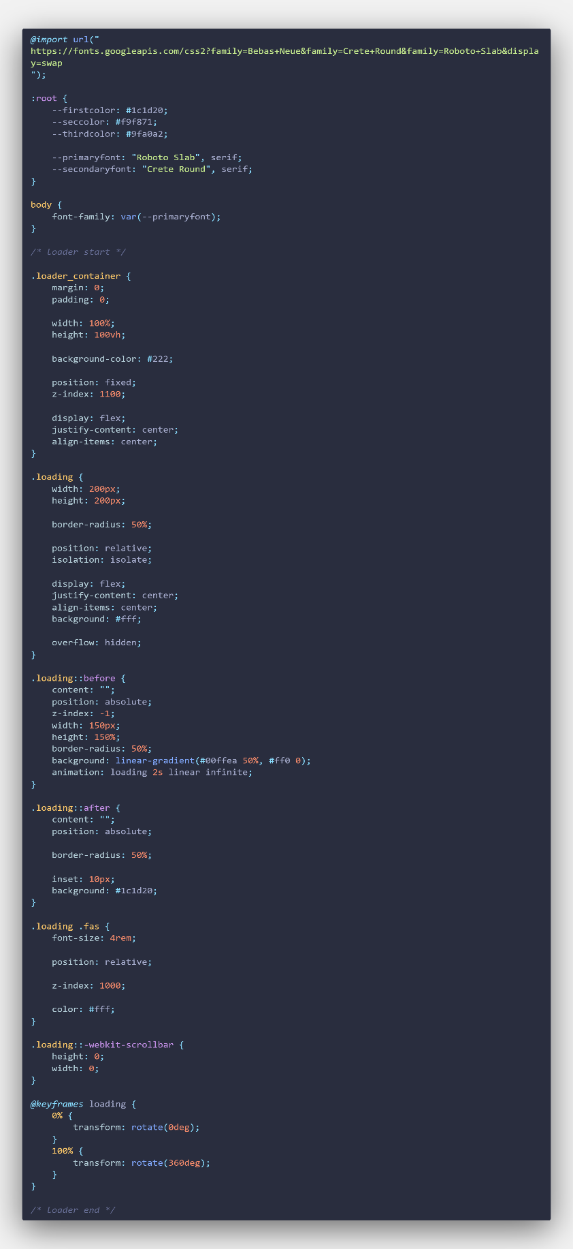

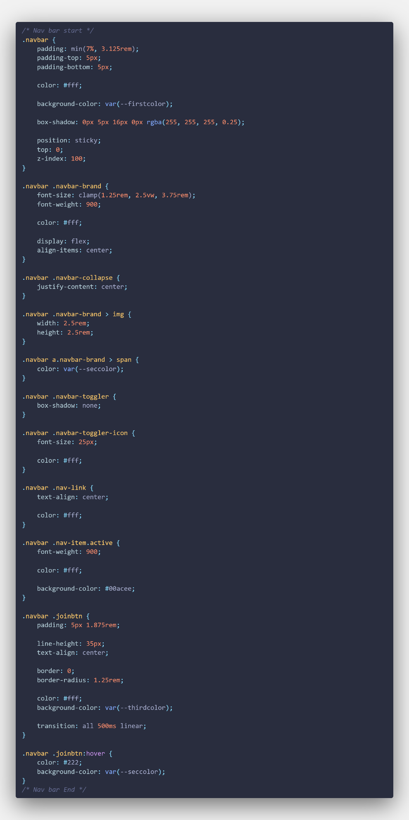

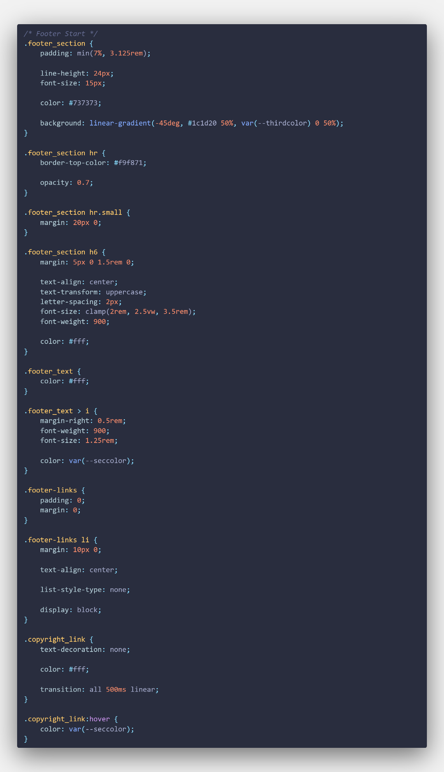

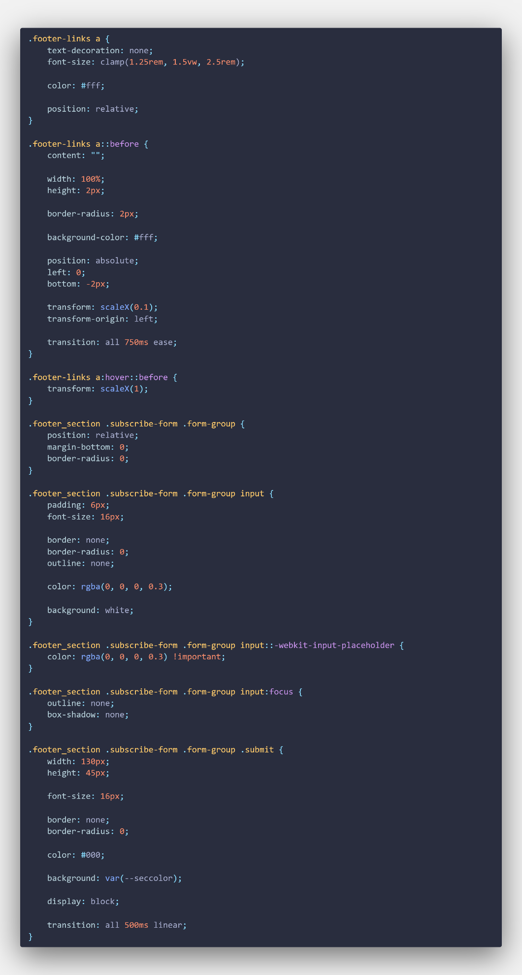

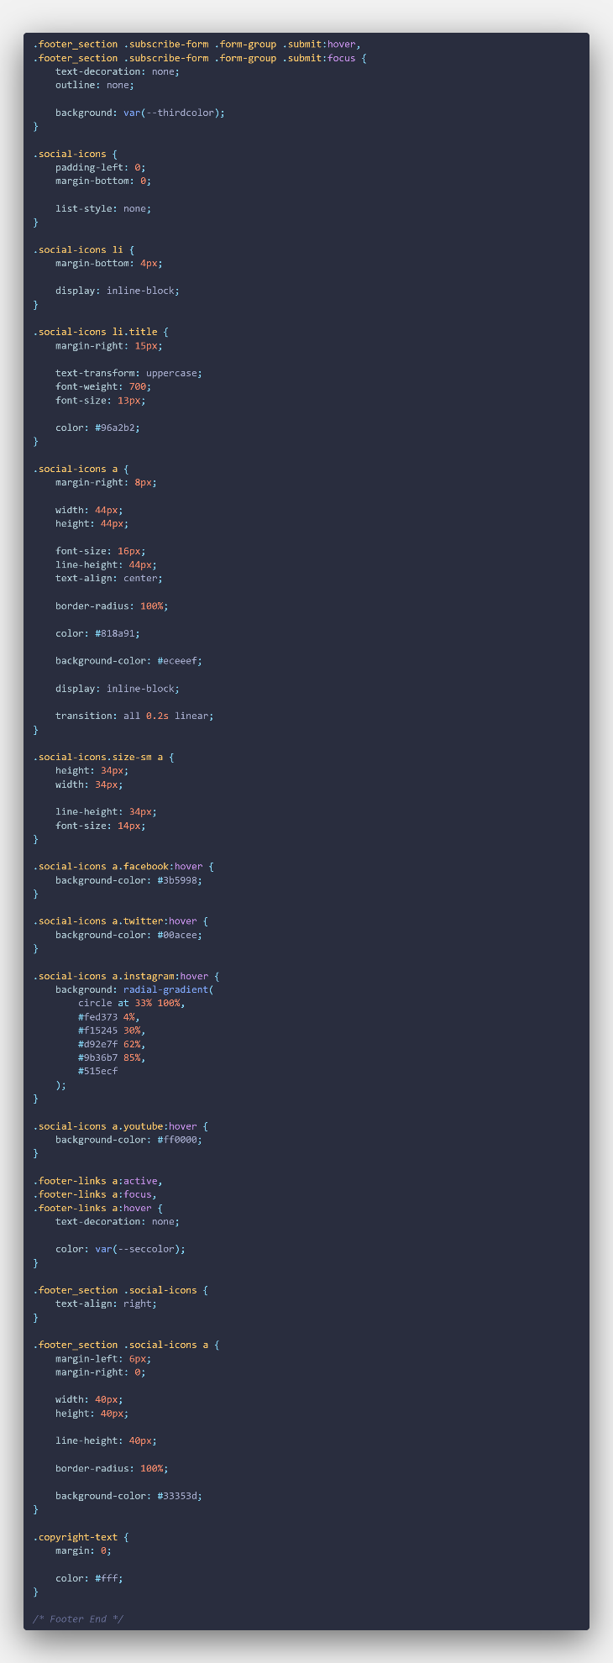

# Running the project admin code

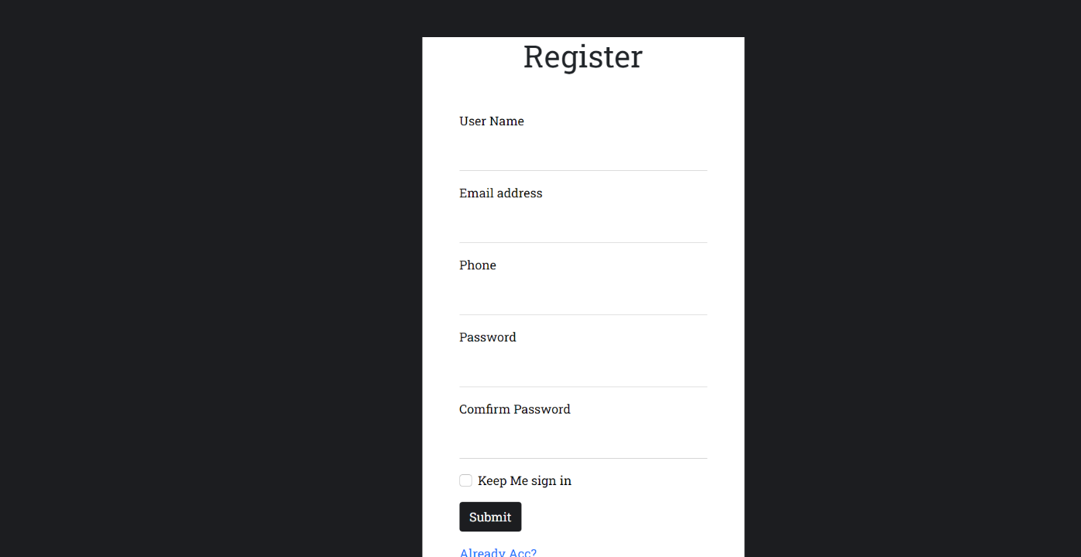

Fig 3.1 Running the New Admin User Page

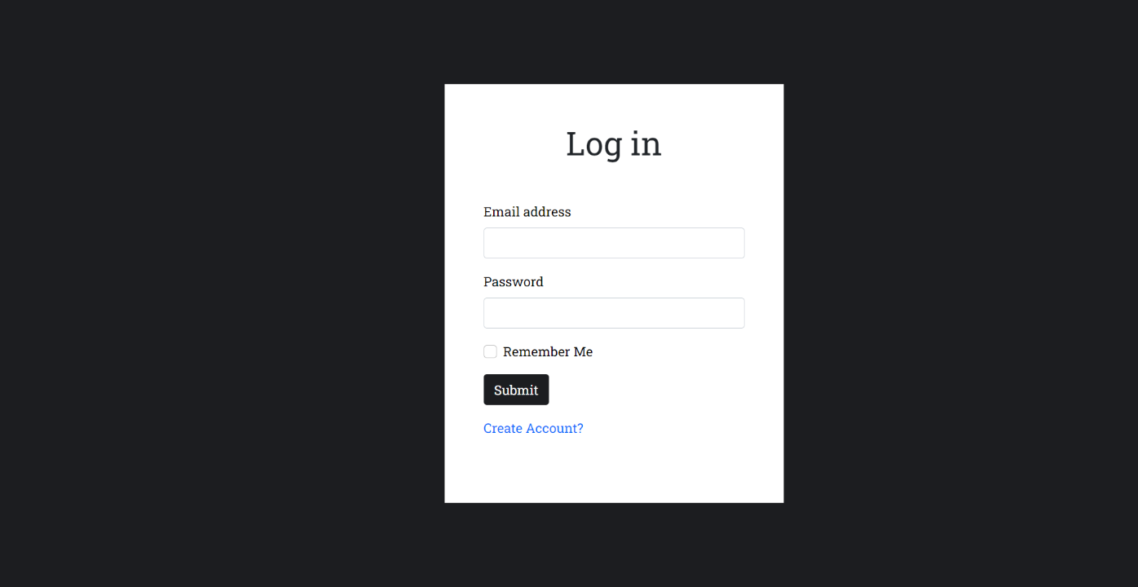

Fig 3.2 Running the Admin Log in Index Page

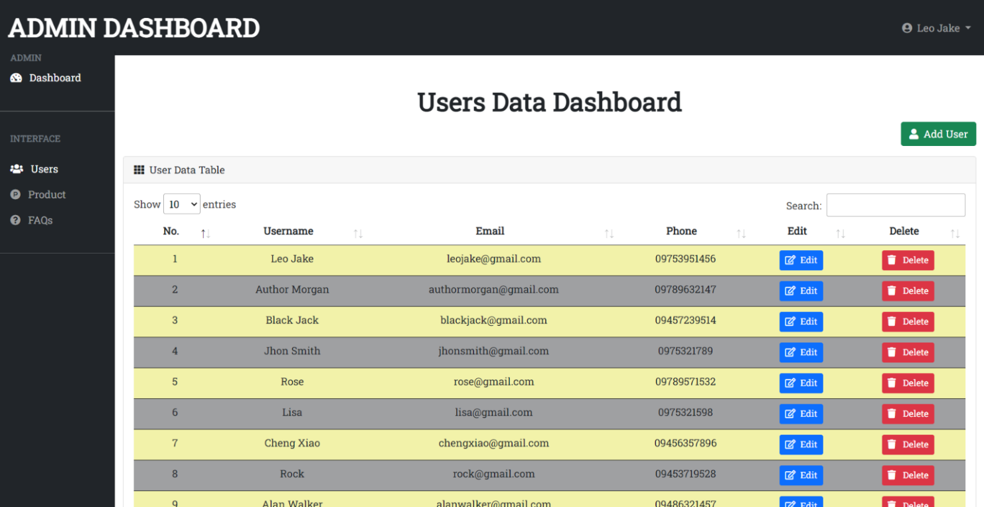

Fig 3.3 Running the Admin User Index Page part 1

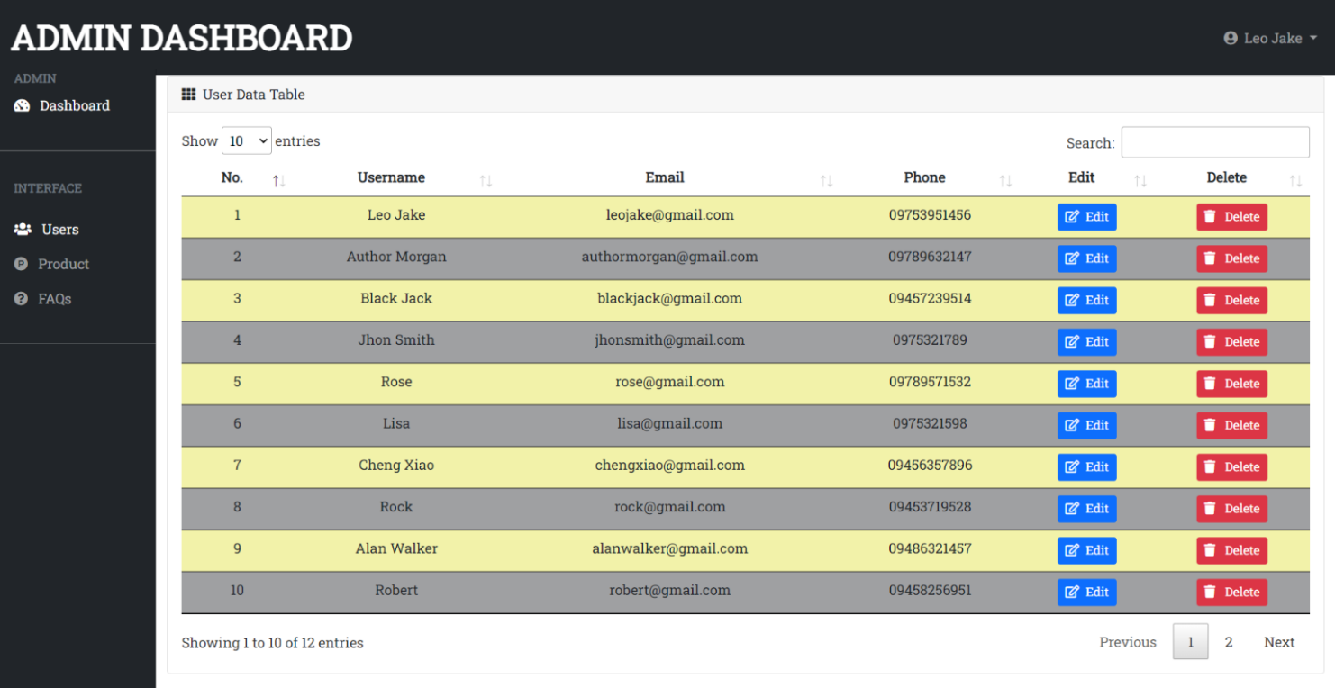

Fig 3.4 Running the Admin User Index Page part 2

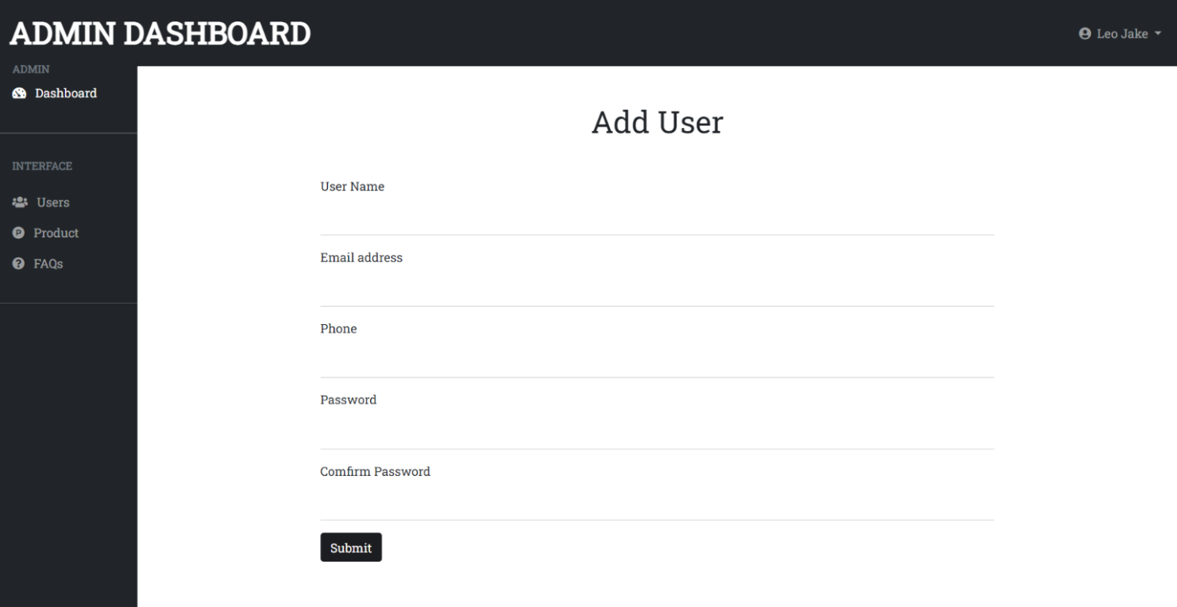

Fig 3.5 Running the New Admin User Page from Admin Dashboard

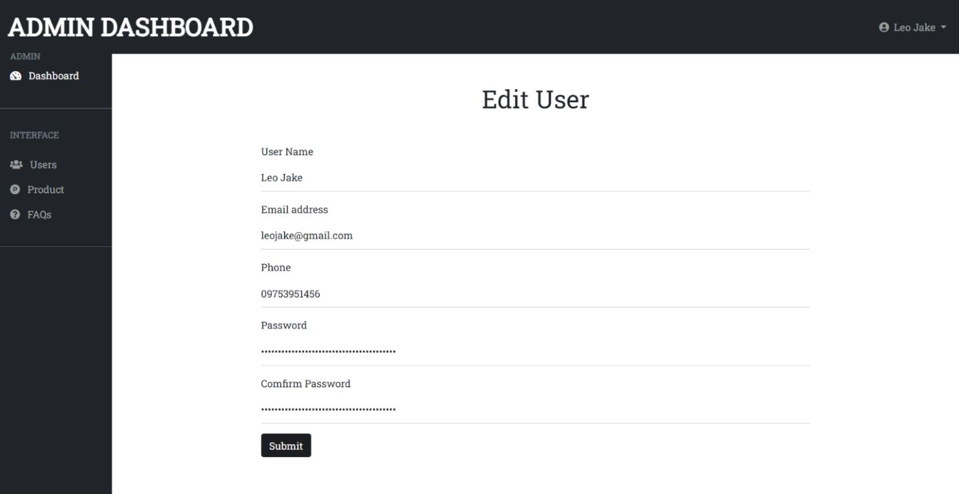

Fig 3.6 Running the Edit Admin Data Page

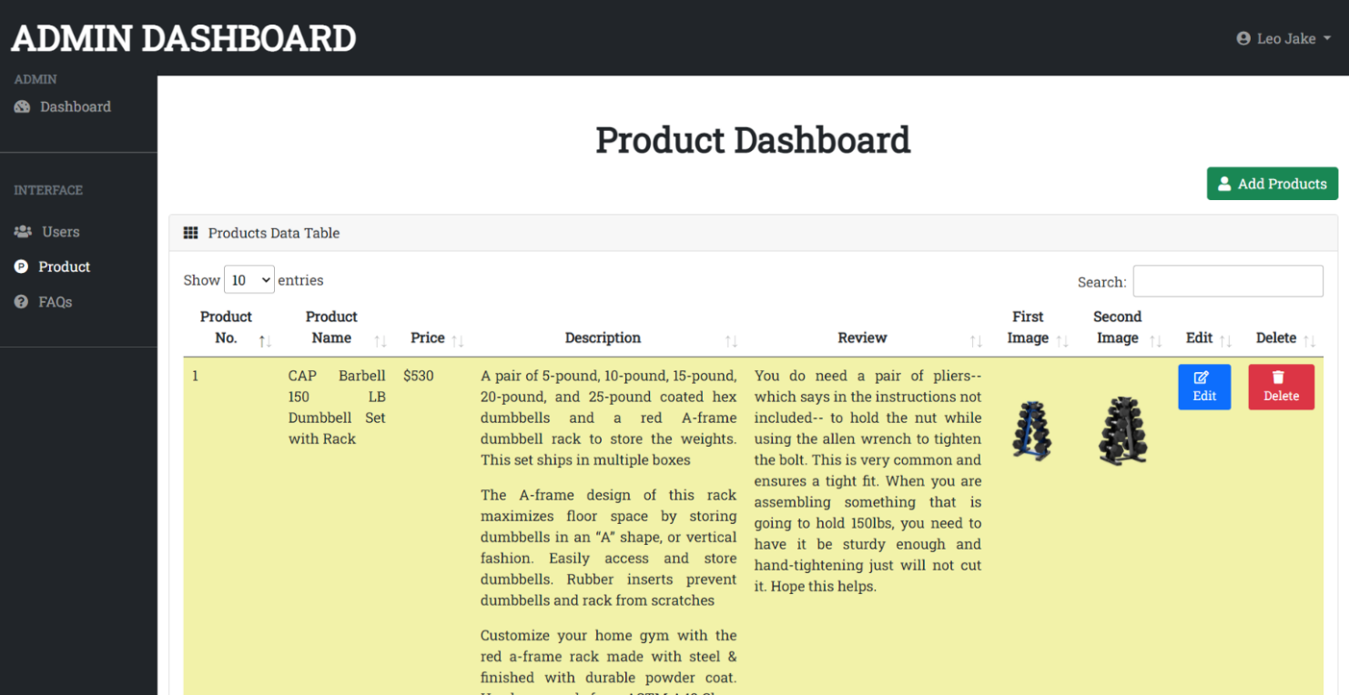

Fig 3.7 Running the Admin Product Index Page part 1

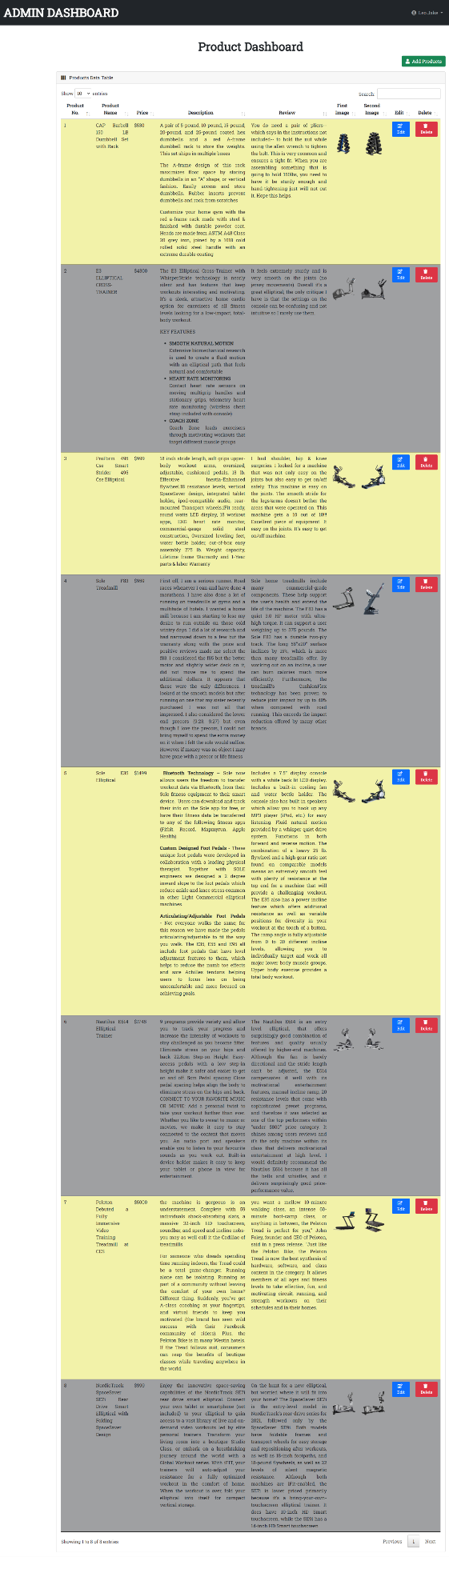

Fig 3.8 Running the Admin Product Index Page part 2

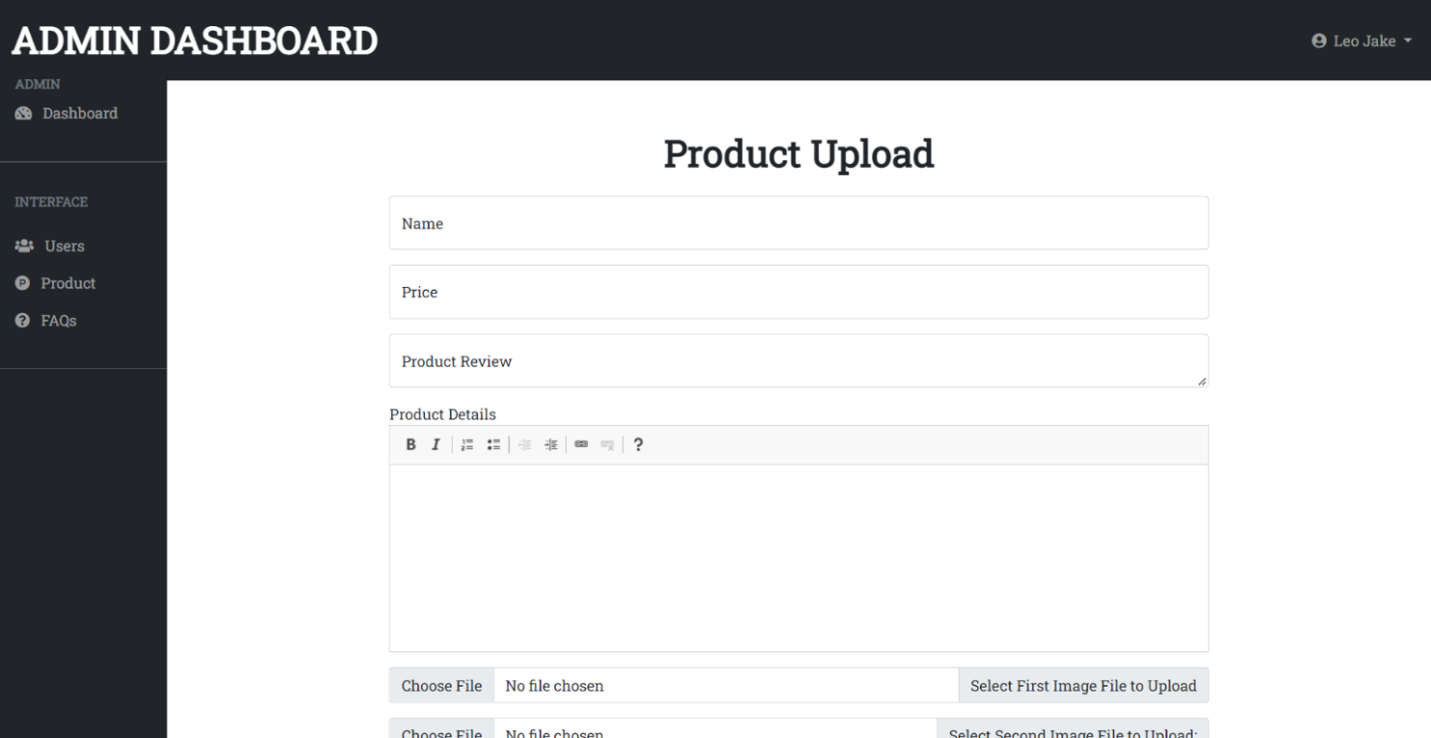

Fig 3.9 Running the Product Upload Page part 1

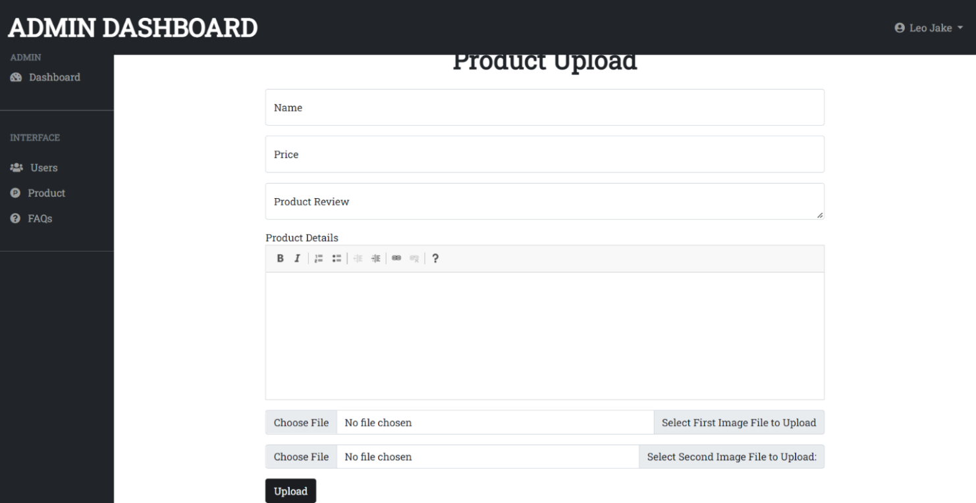

Fig 3.10 Running the Product Upload Page part 2

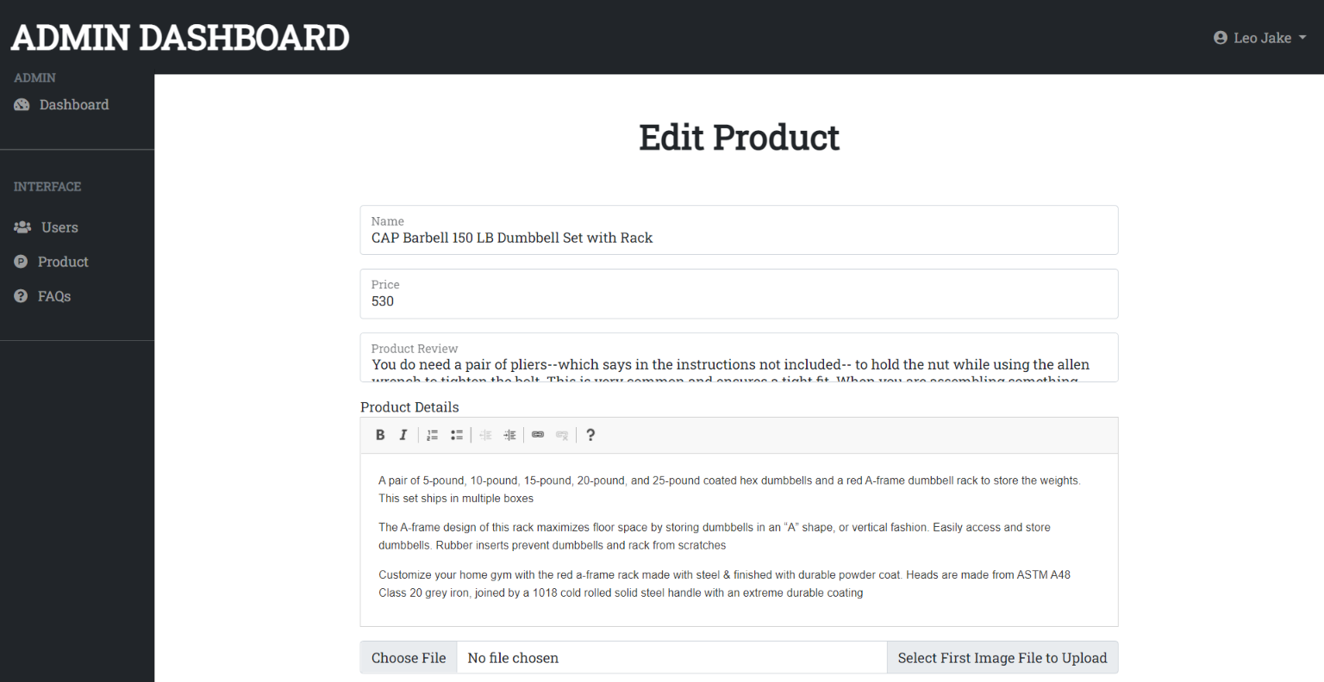

Fig 3.11 Running the Edit Product Data Page part 1

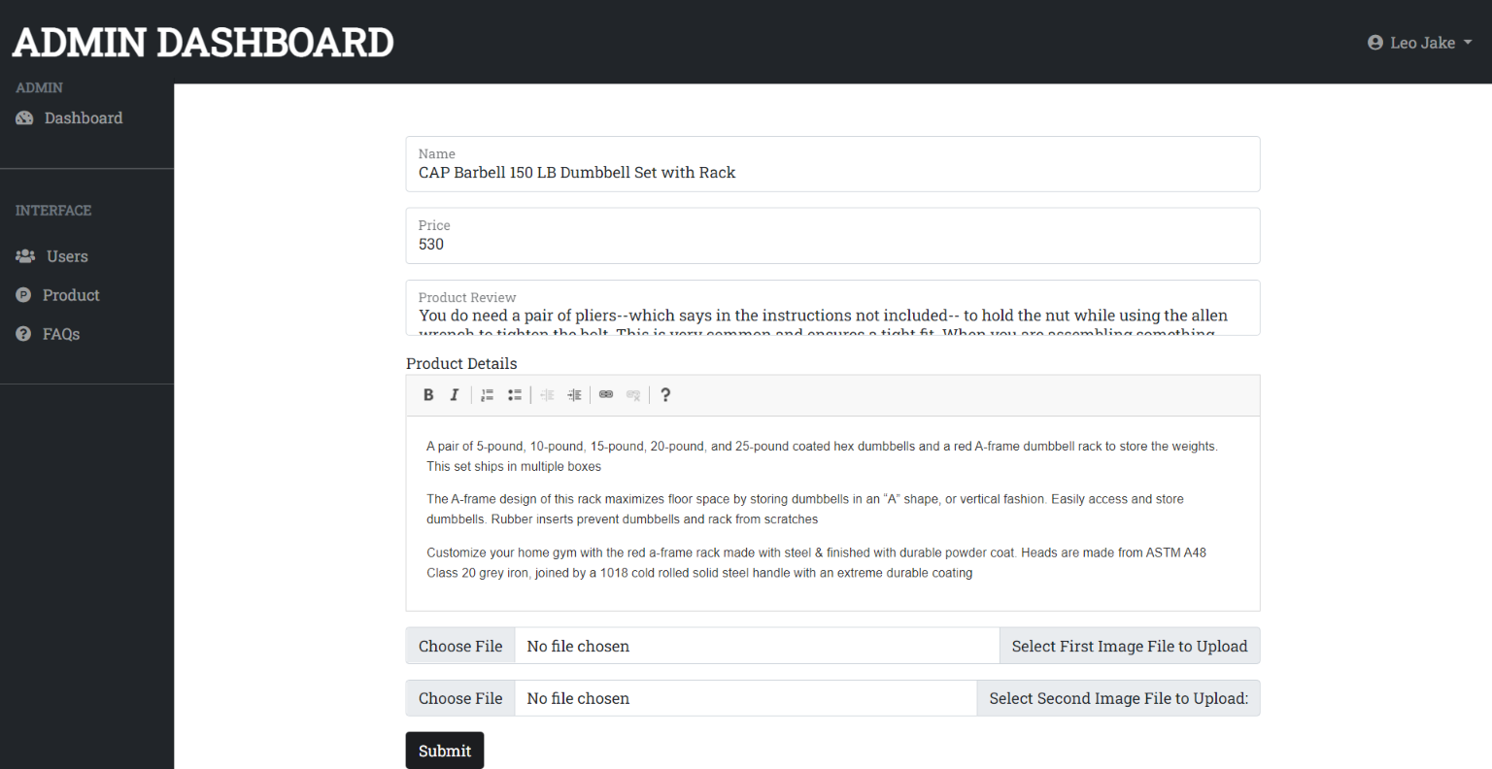

Fig 3.12 Running the Edit Product Data Page part 2

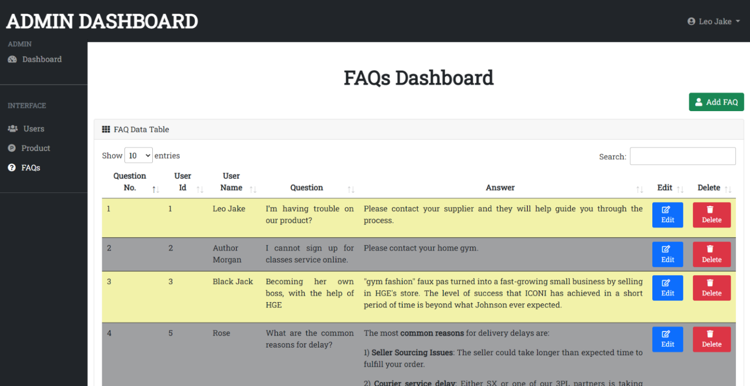

Fig 3.13 Running the FAQ Index Page part 1

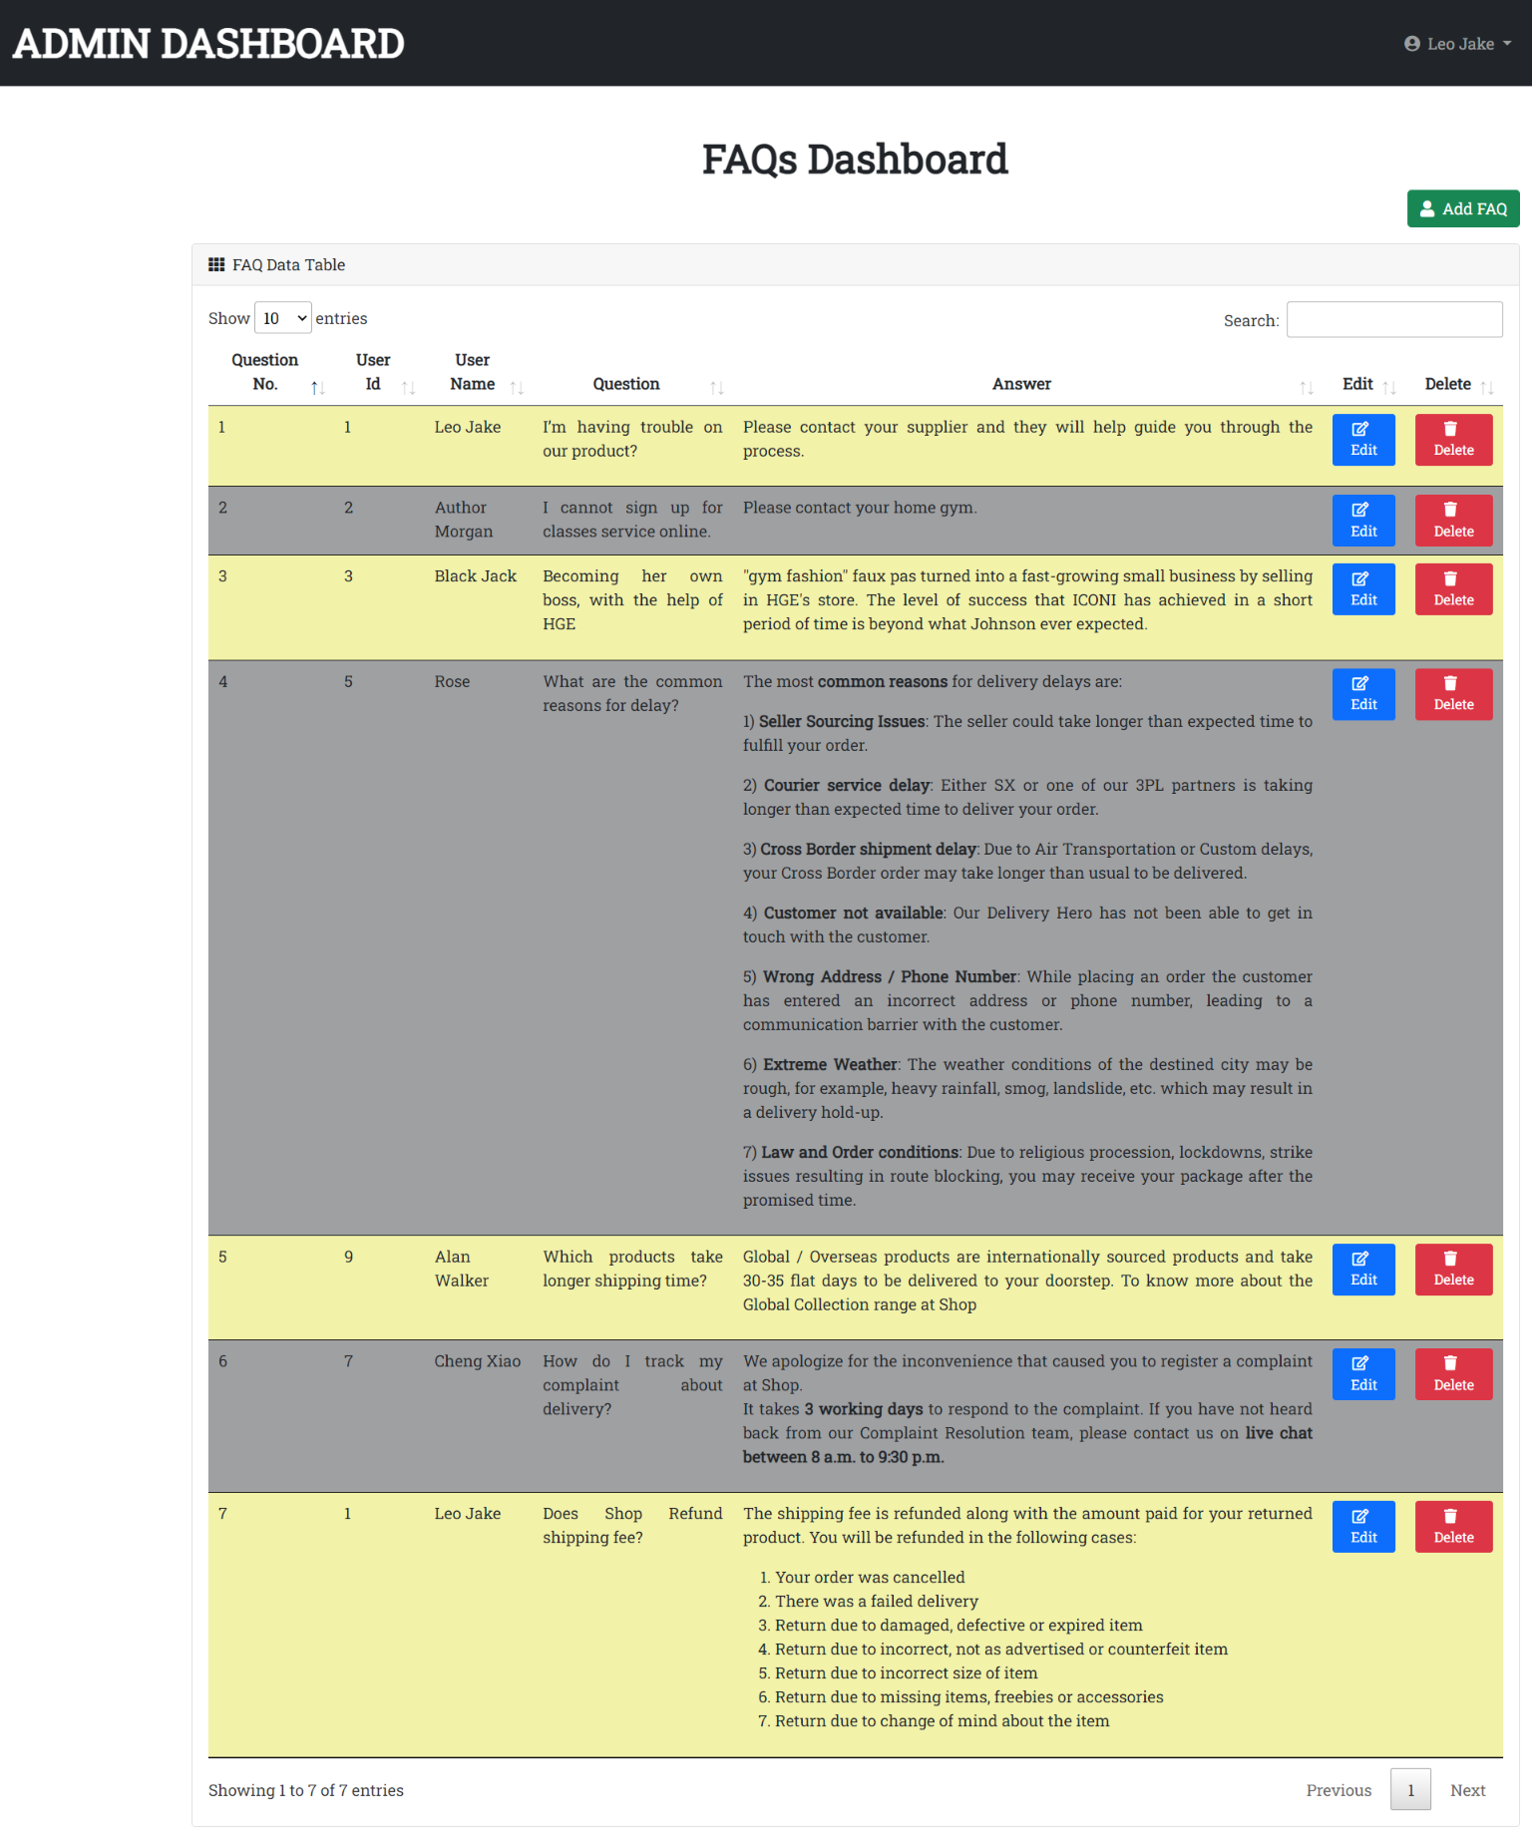

Fig 3.14 Running the FAQ Index Page part 2

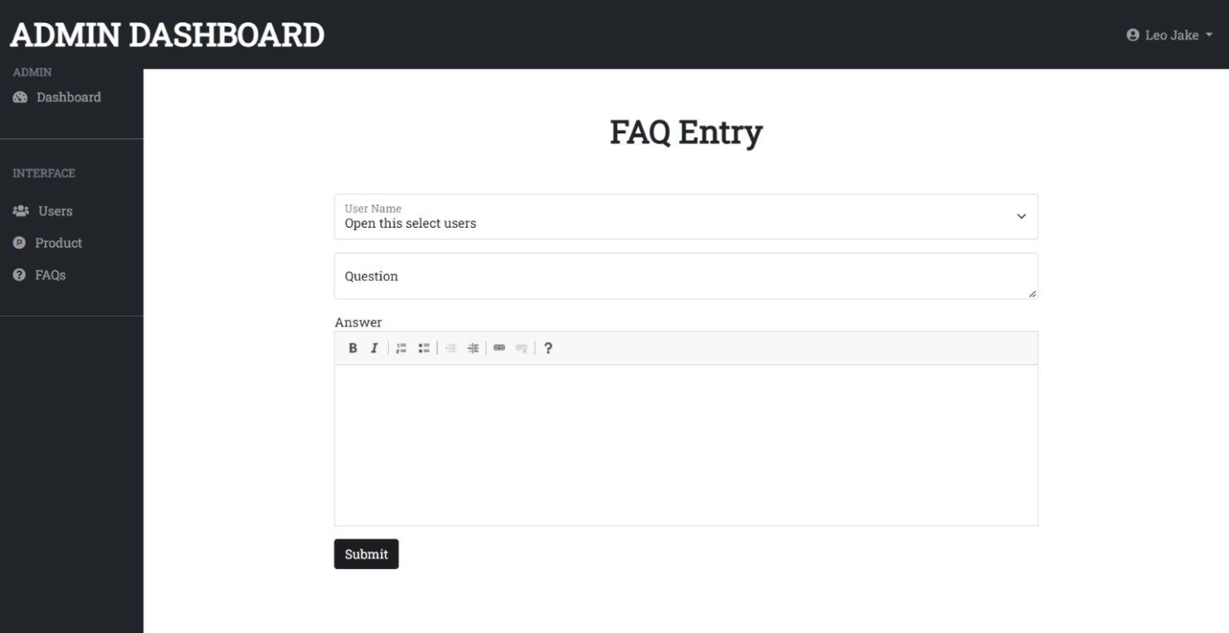

Fig 3.15 Running the FAQ Entry Page

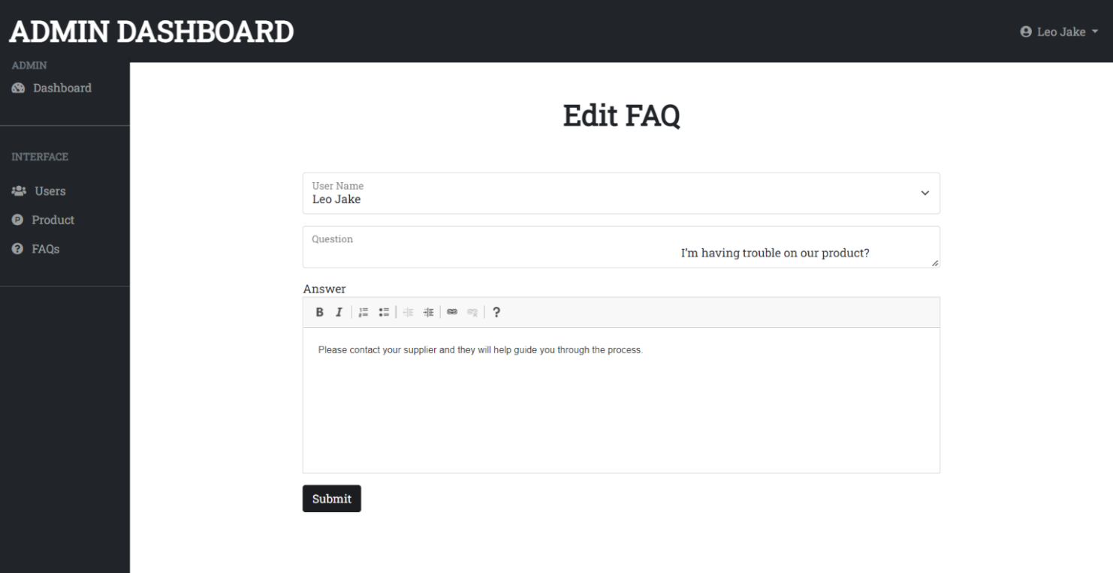

Fig 3.16 Running the Edit FAQ Page

# Describe the Back-end code

**Dbconfig Page Code (connect to the database)**

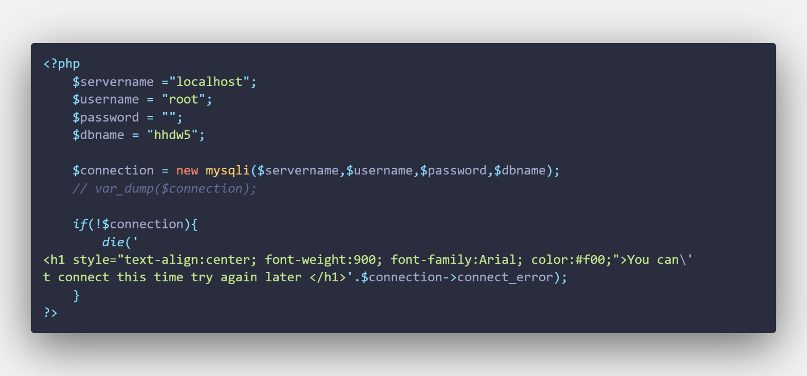

**Header page For Admin Log in and Register Pages Code**

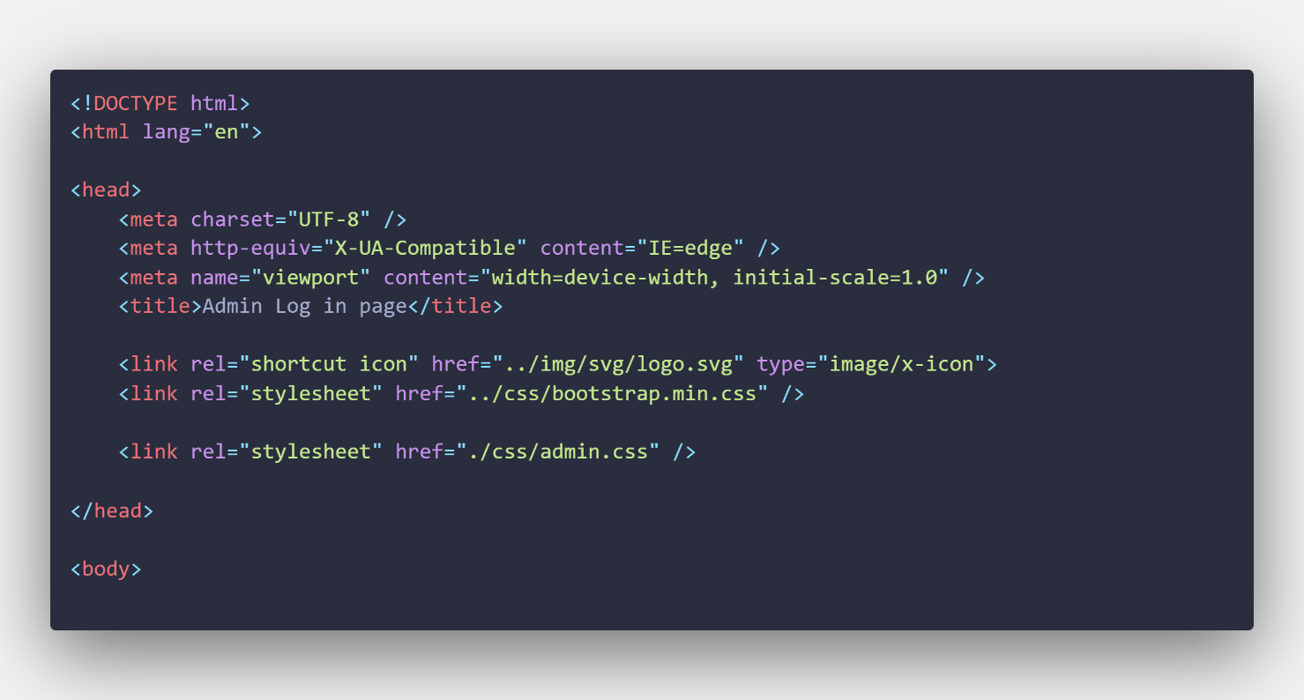

**Log in Page Code**

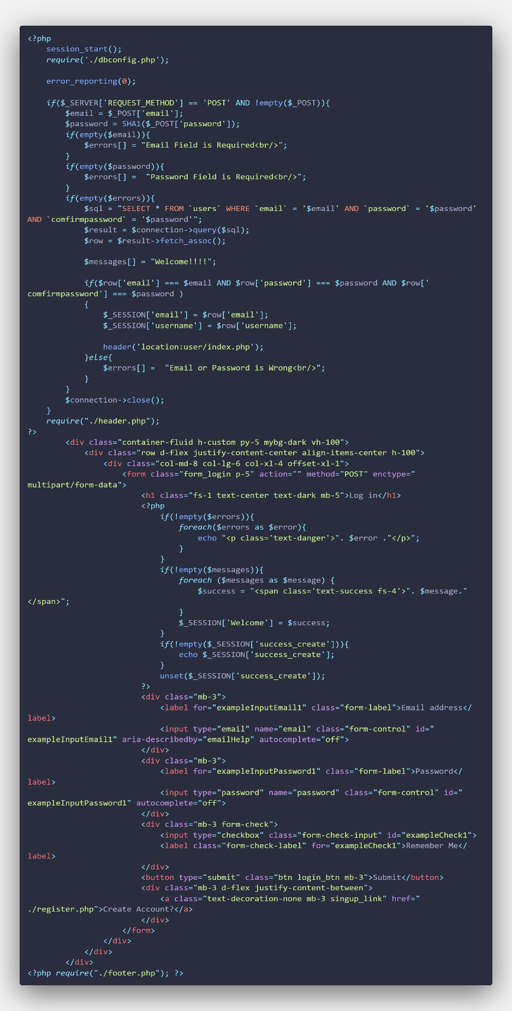

**Register Page Code**

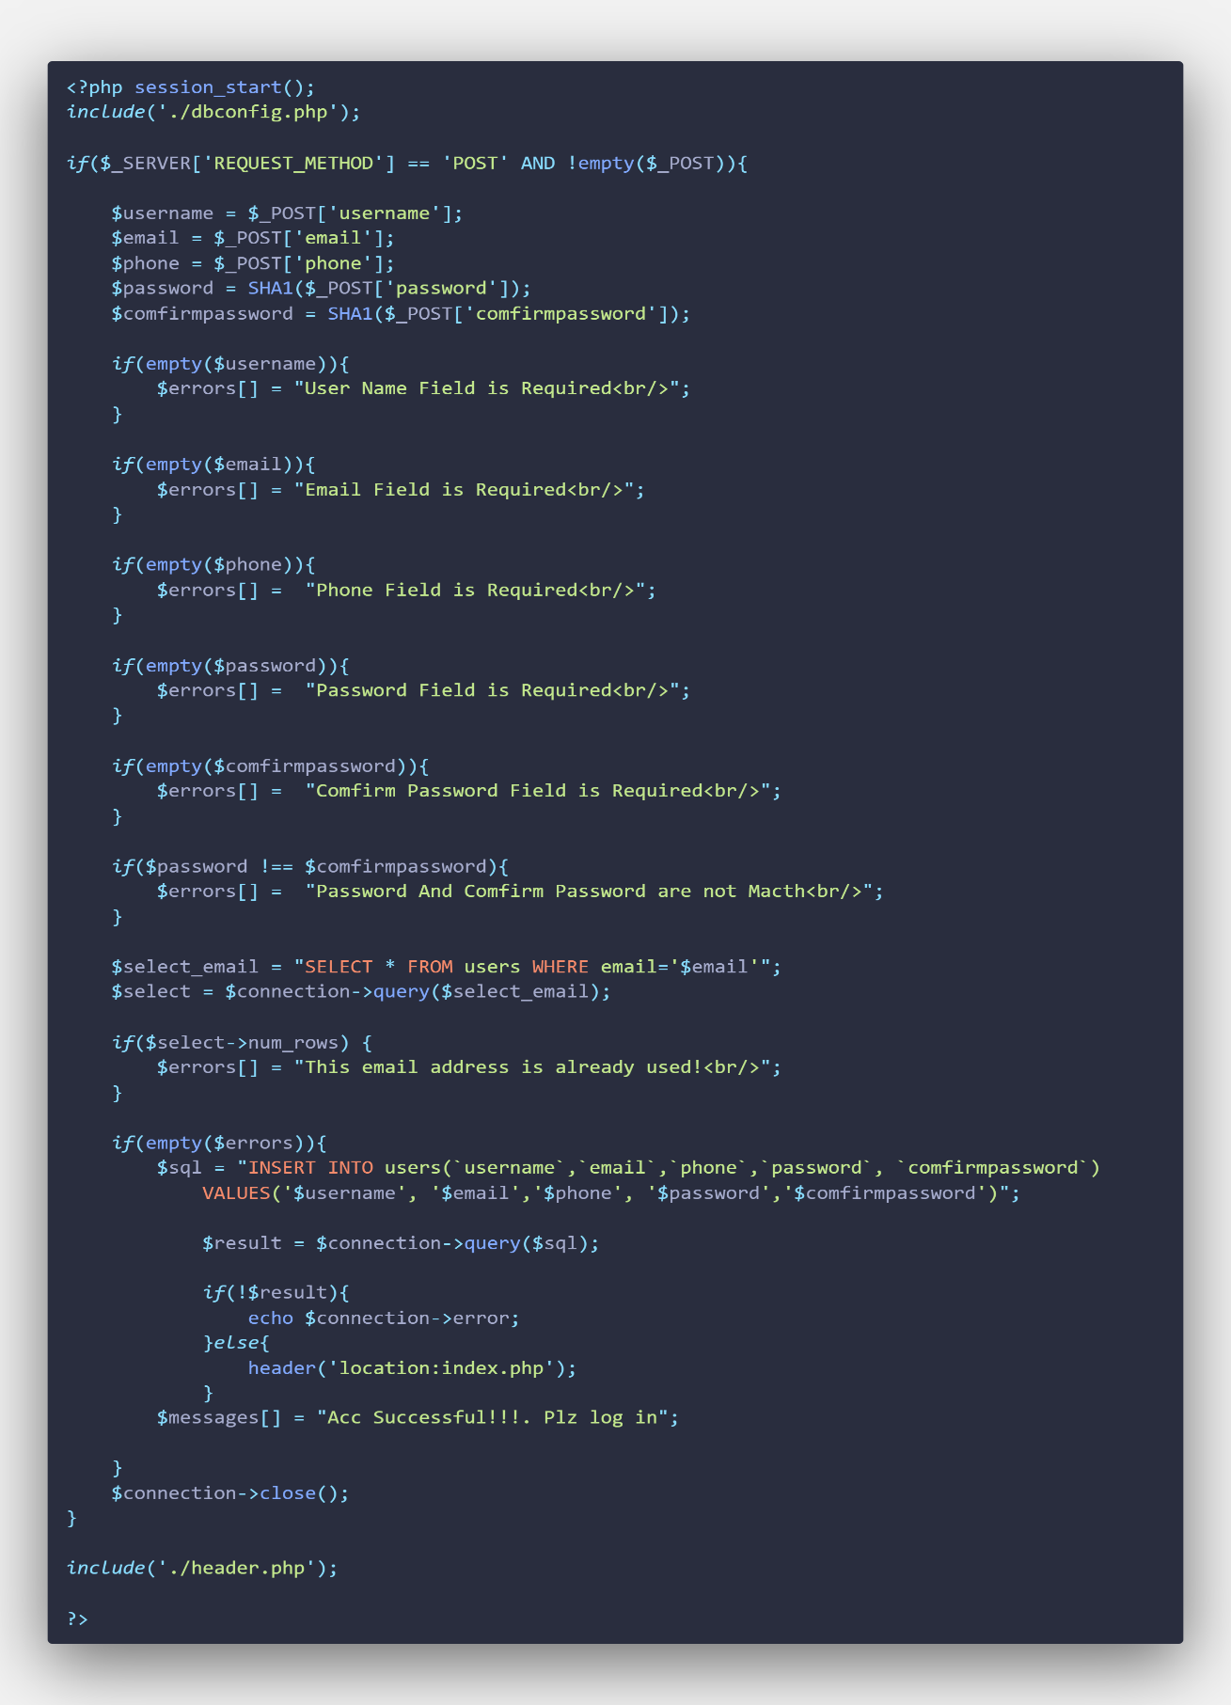

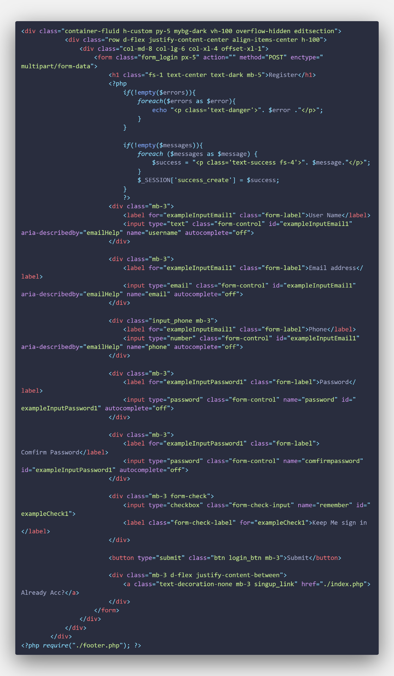

**Log Out Code**

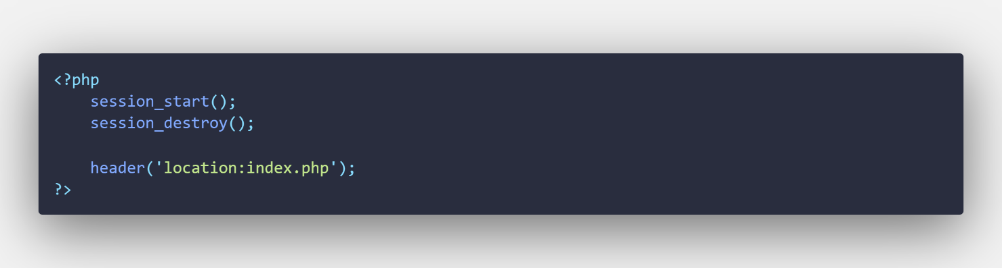

**Footer page Code For Admin Log in and Register Pages**

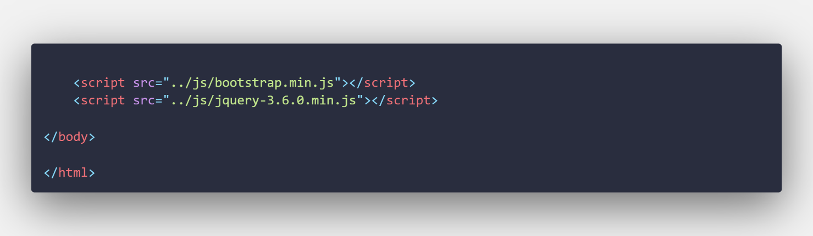

# Describe the Code in User Folder

**Header Page Code for User Folder**

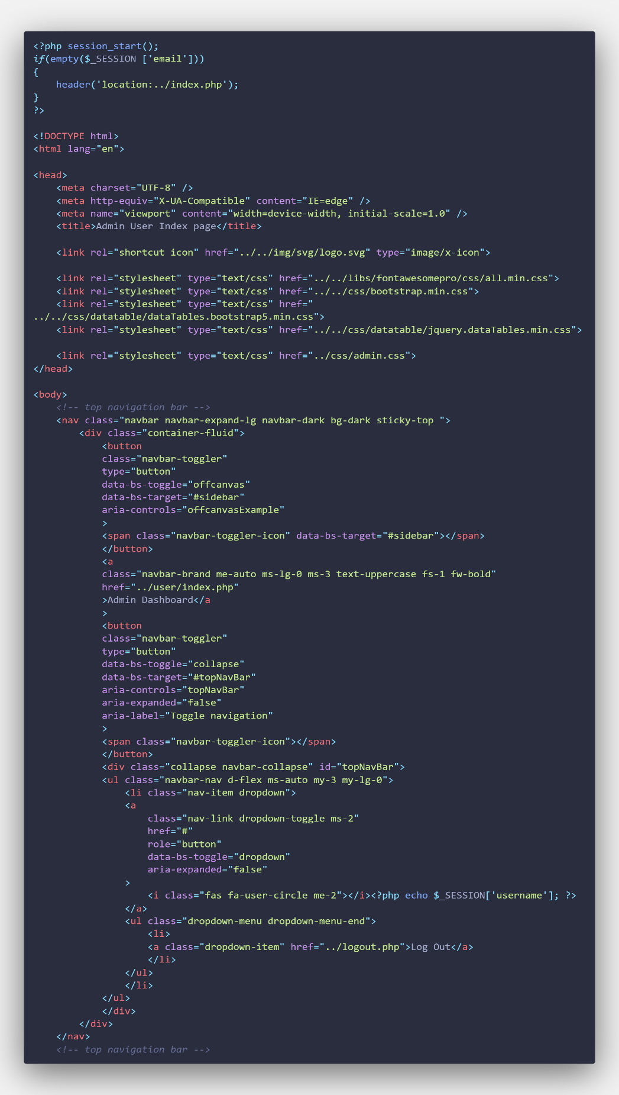

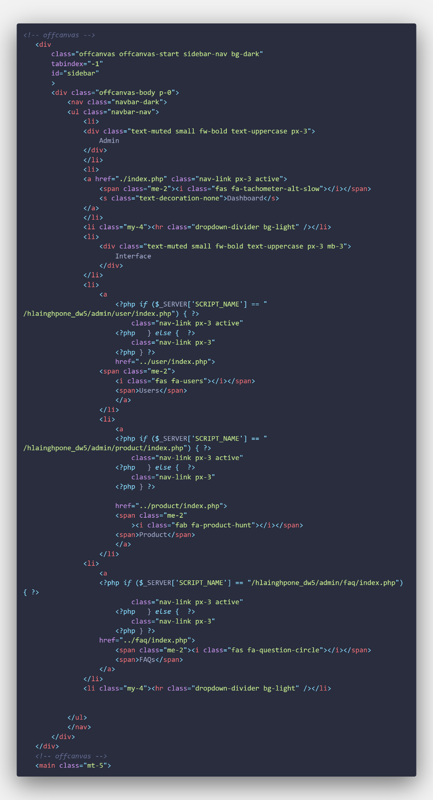

**User Index Page Code**

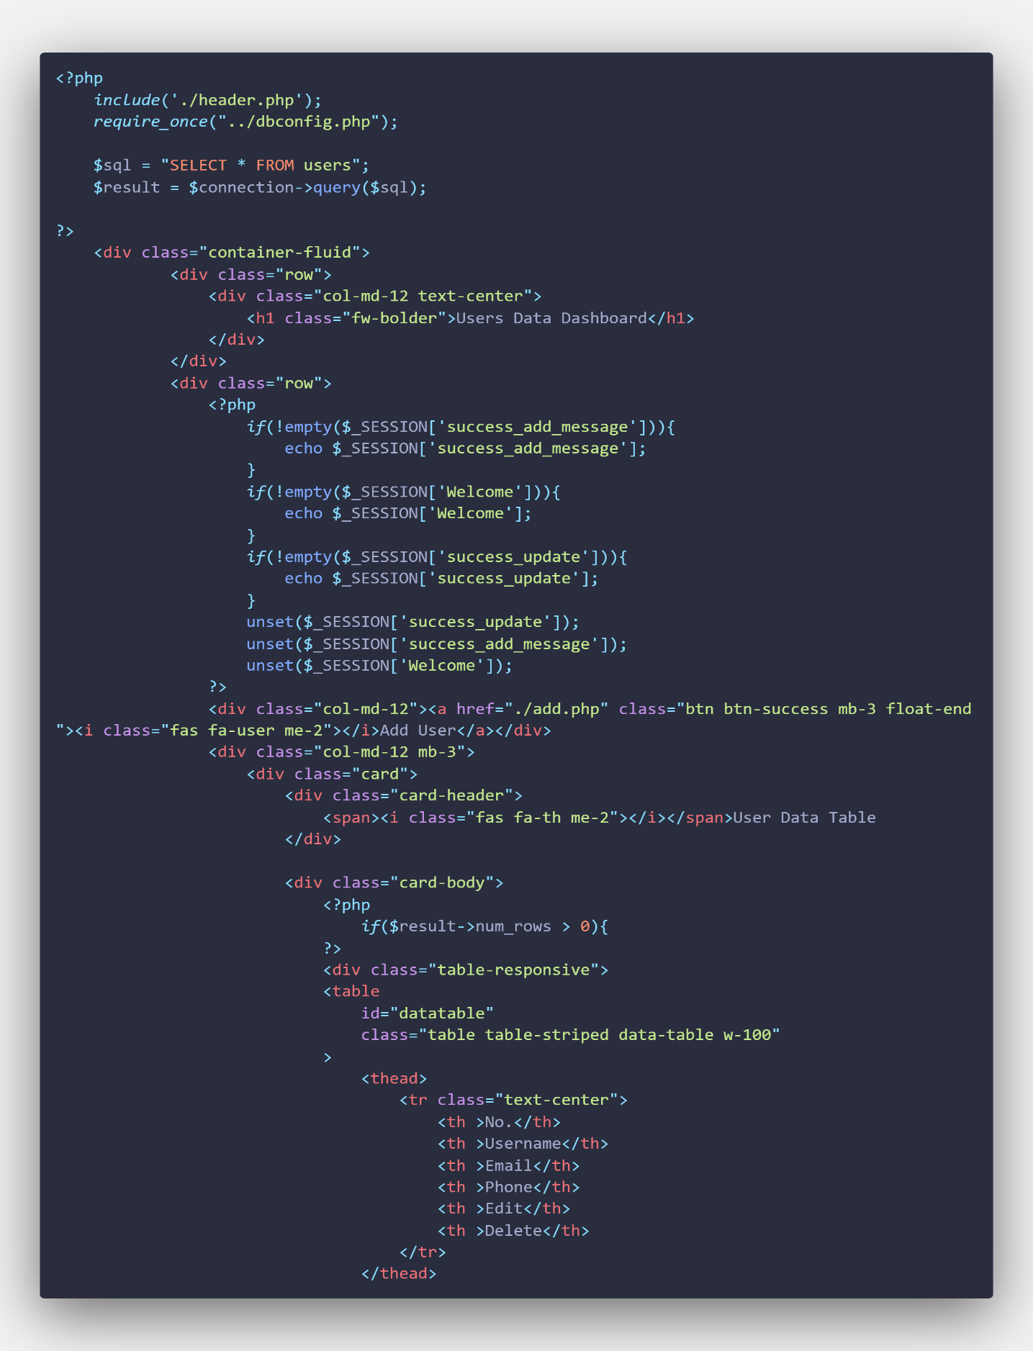

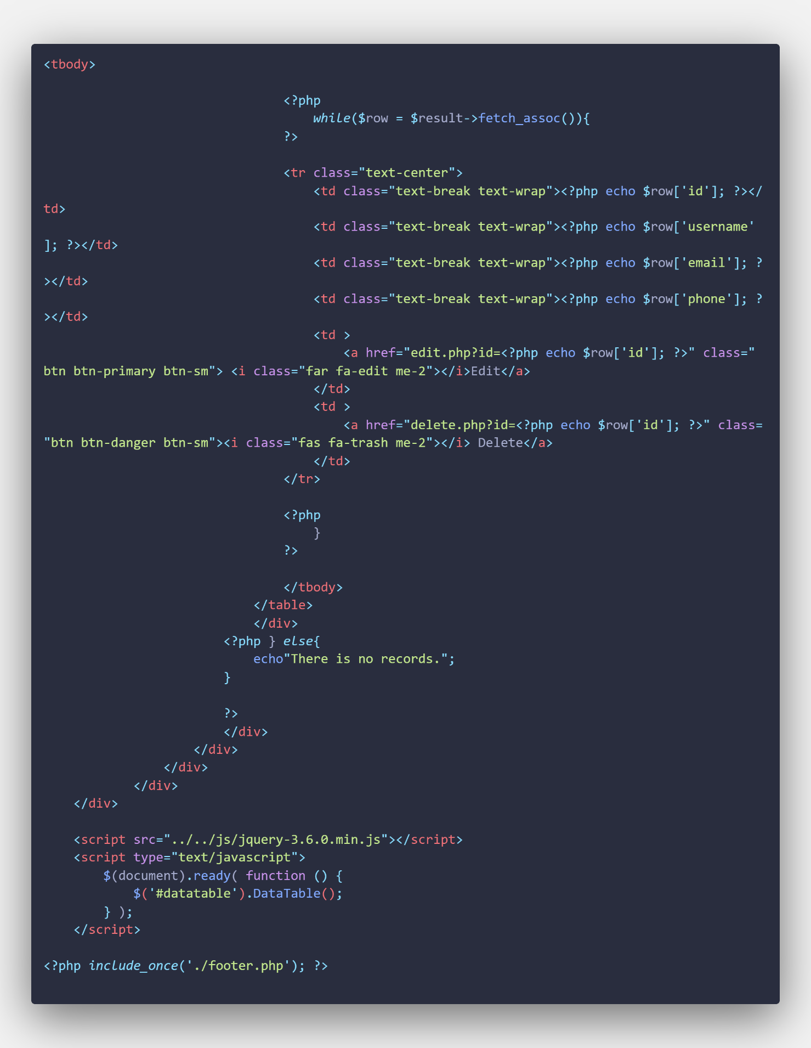

**Add User Page Code**

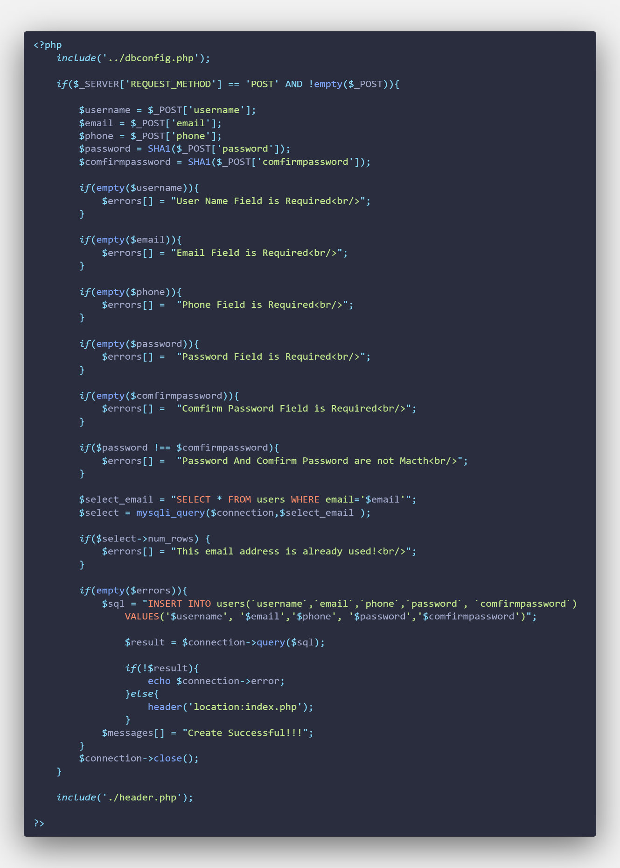

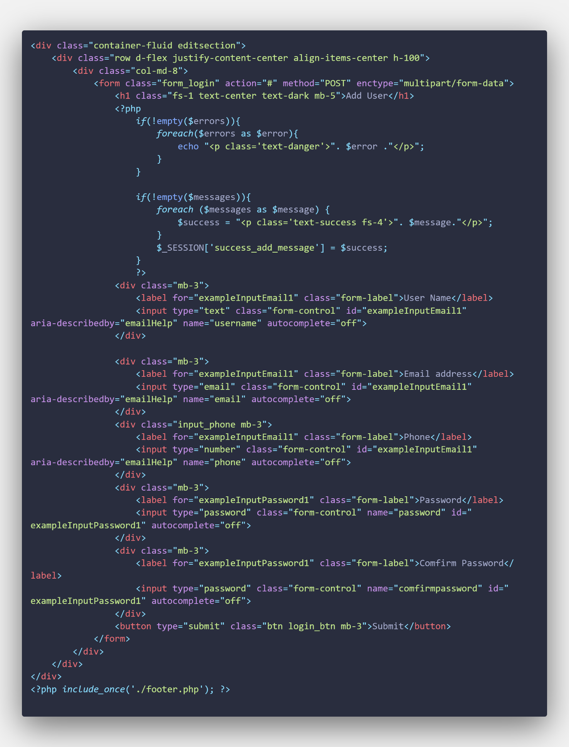

**Edit User Page**

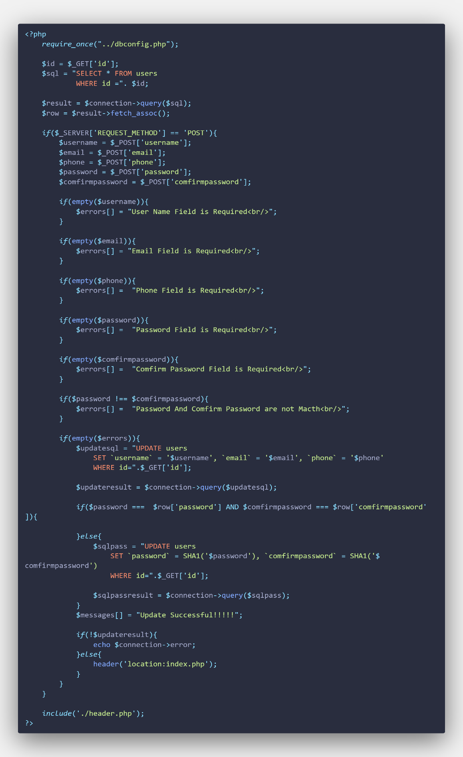

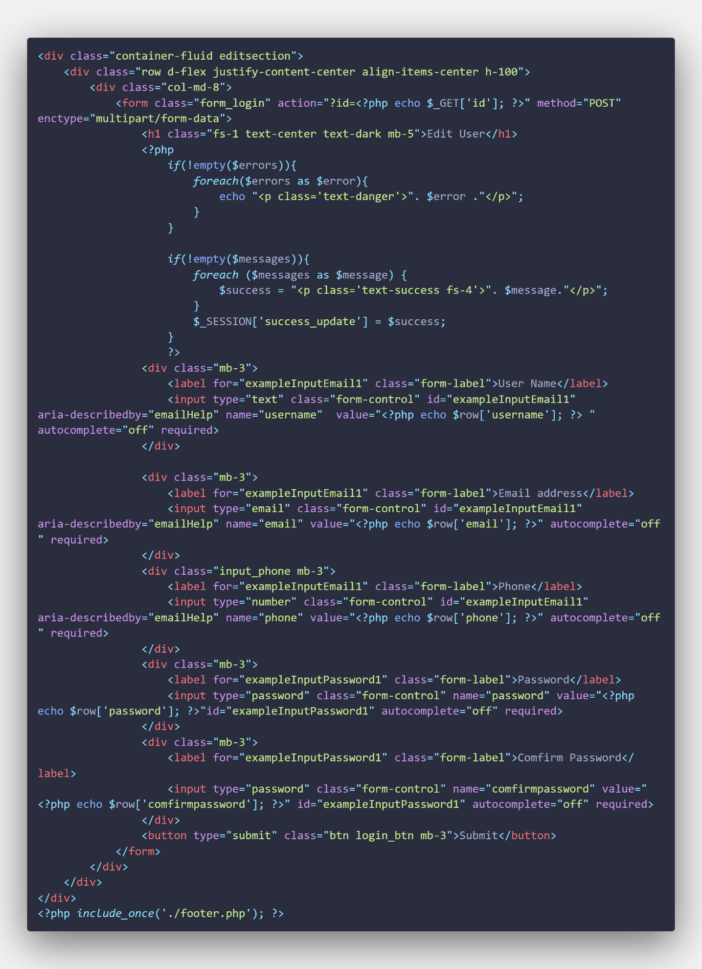

**Delete Page Code for User Folder**

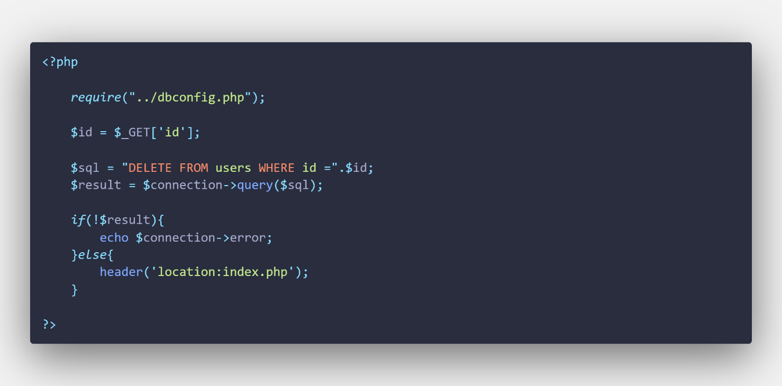

**Footer Page Code for User Folder**

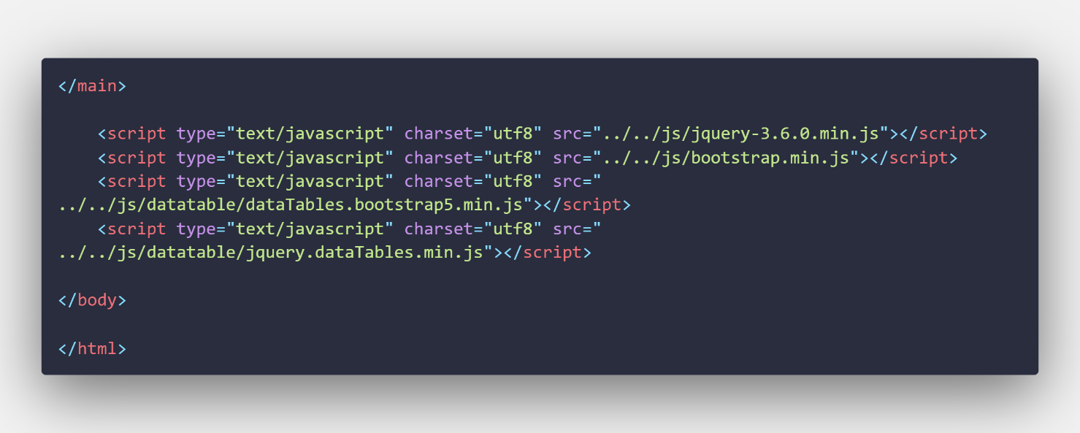

# Describe the Code in Product Folder

**Header Page Code for Product Folder**





**Product Index Page Code**

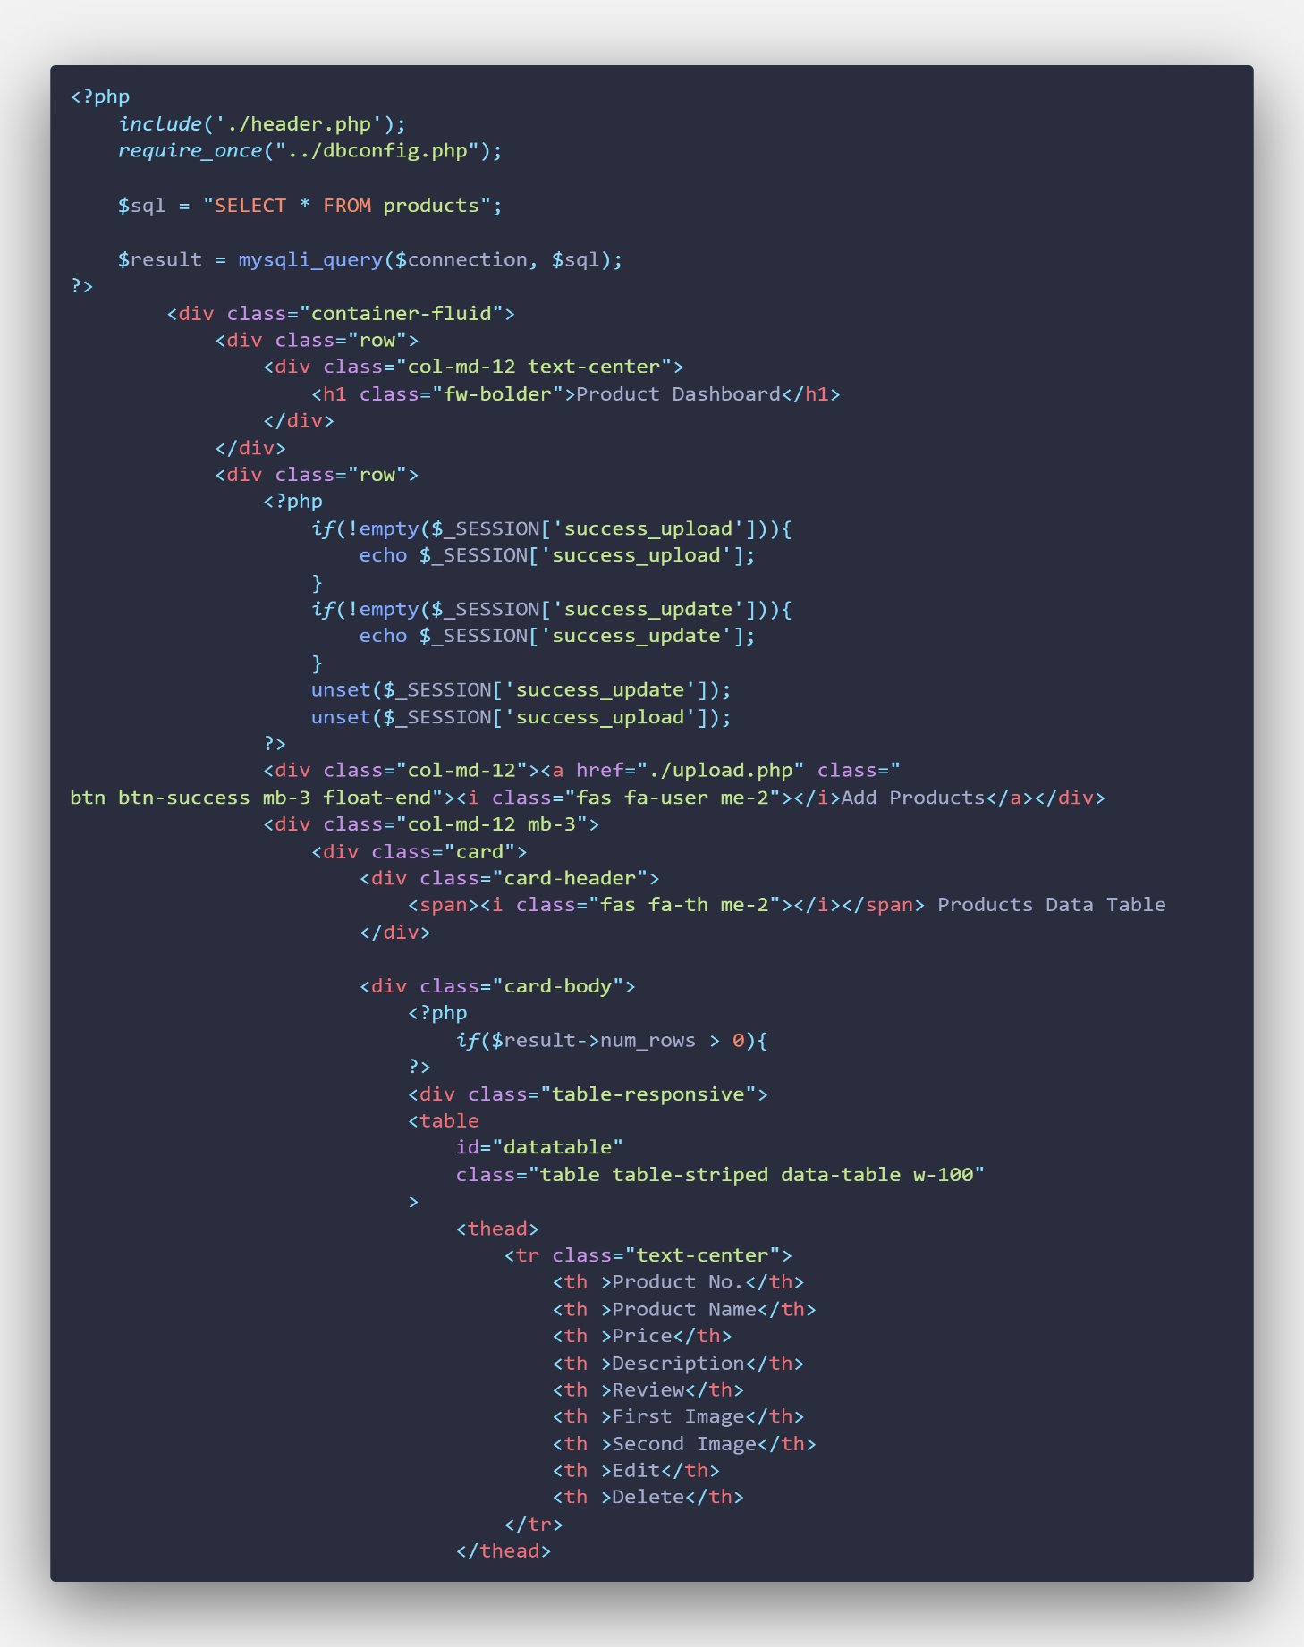

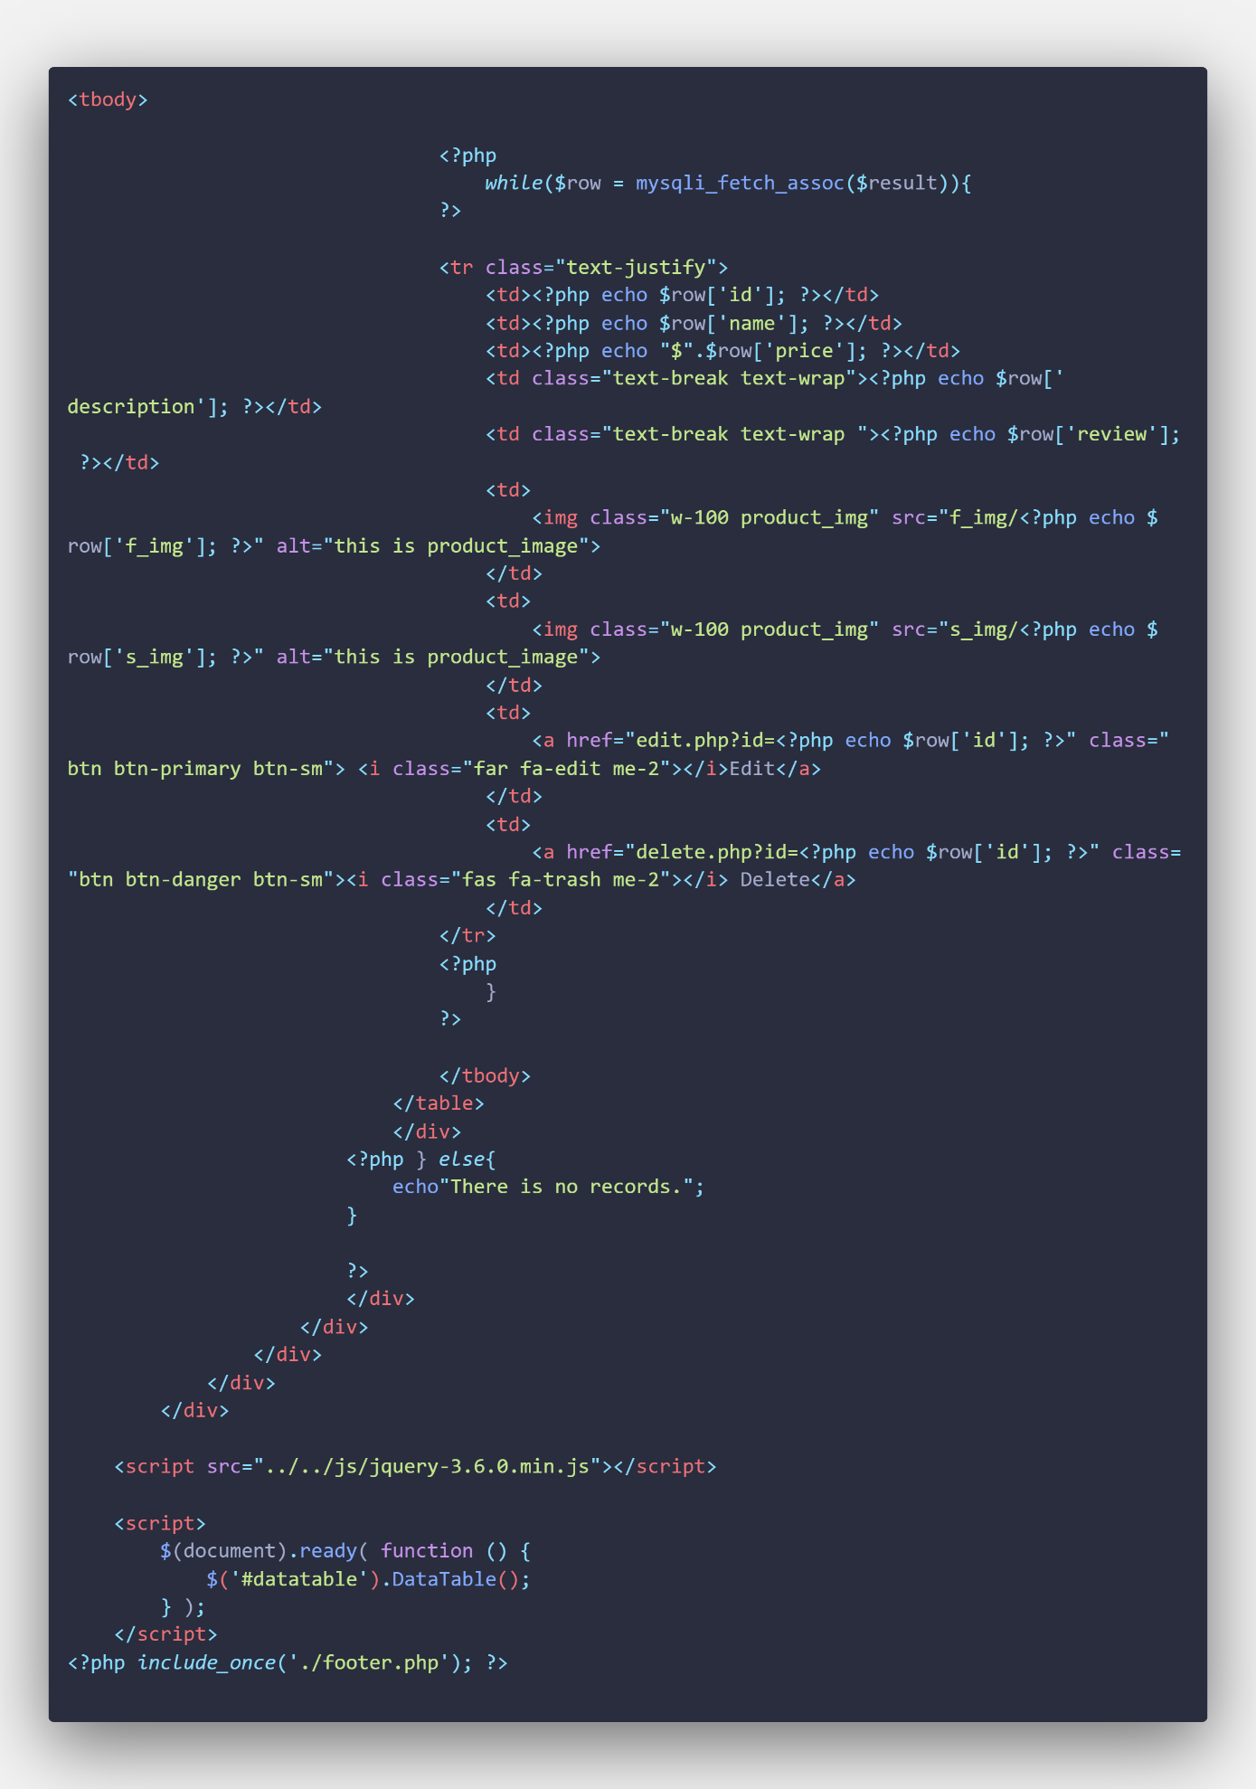

**Upload Page Code**

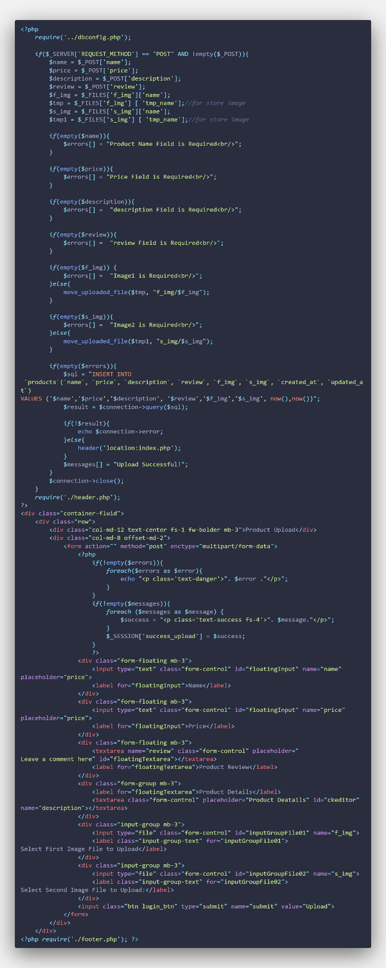

**Edit Page Code**

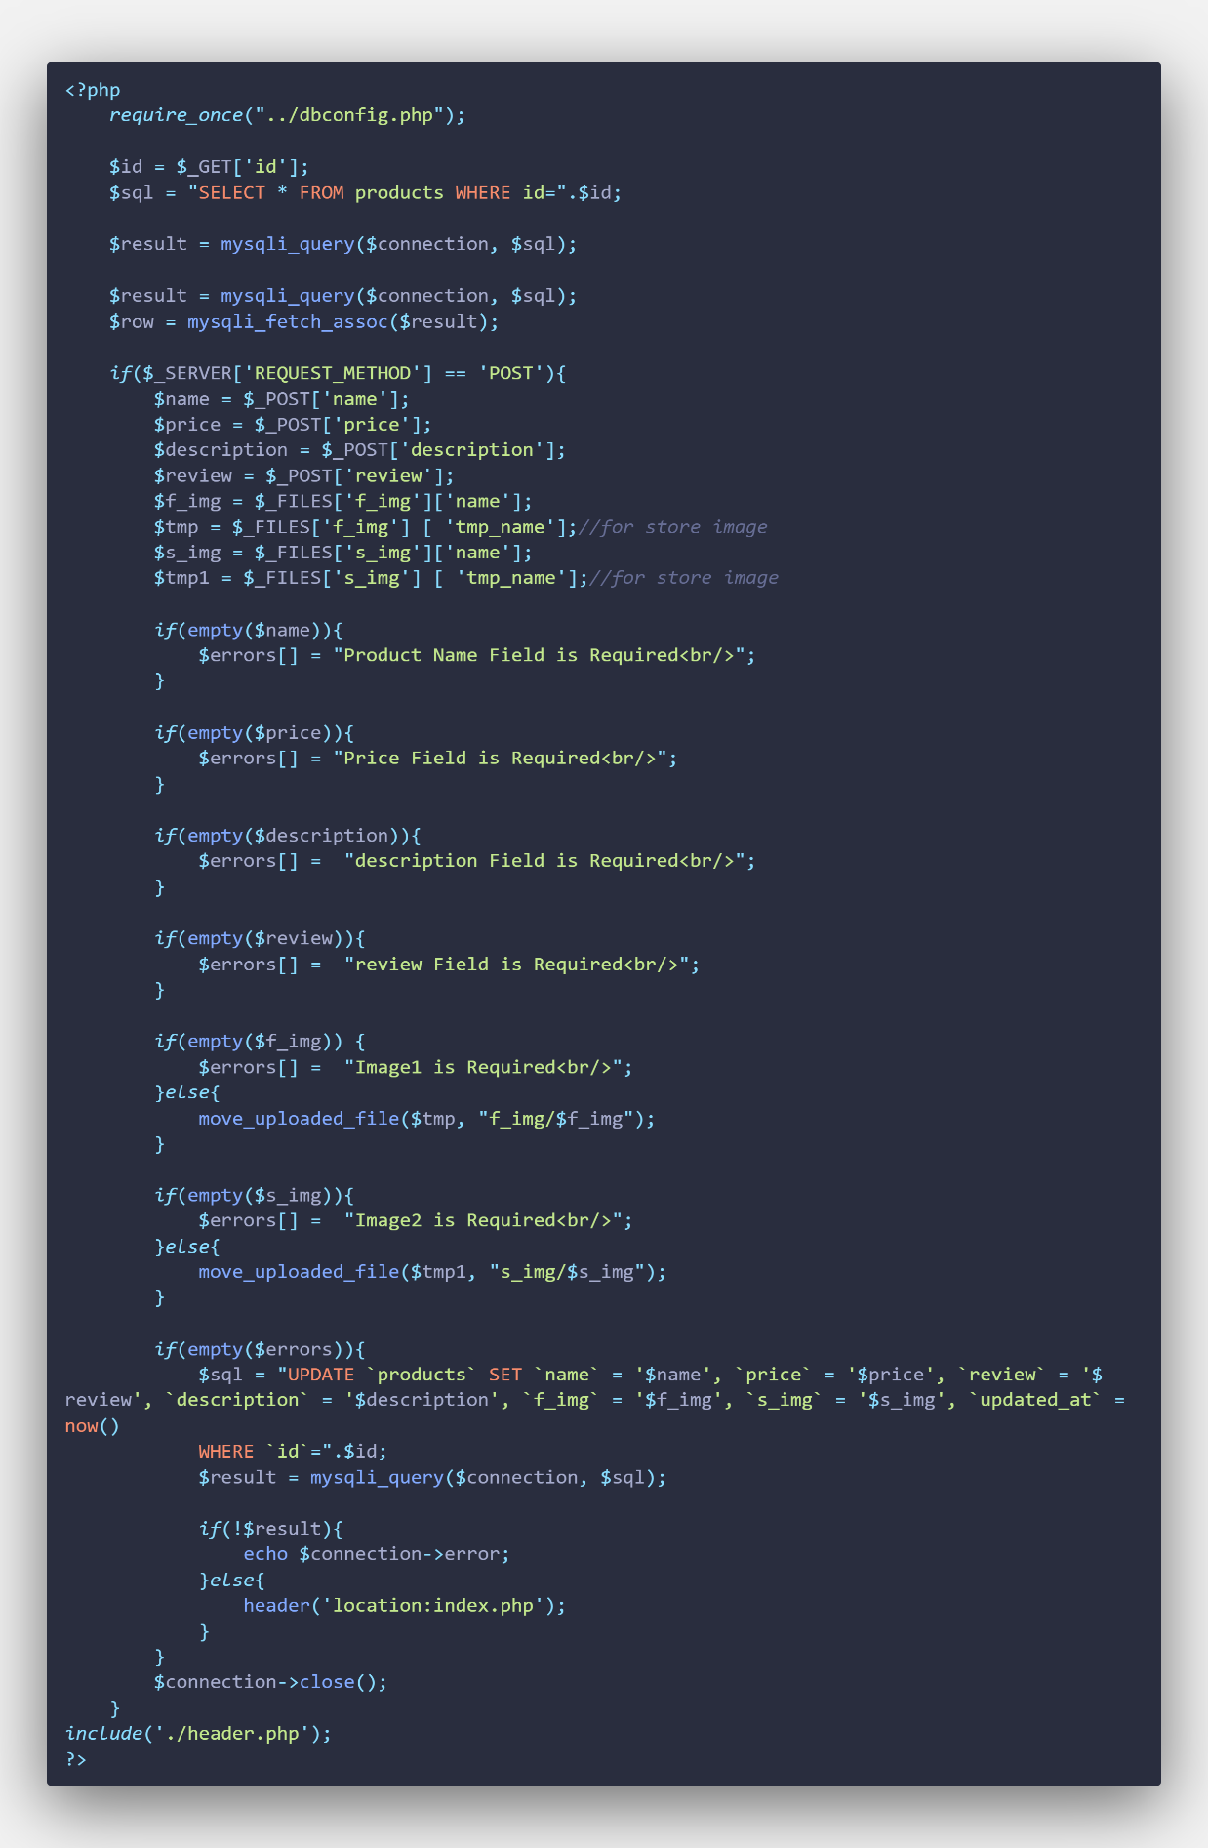

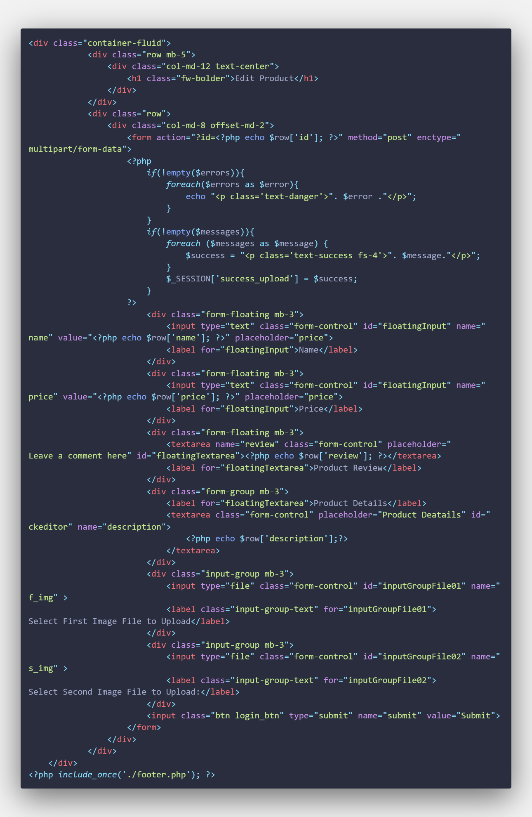

**Delete Page Code for Product Folder**

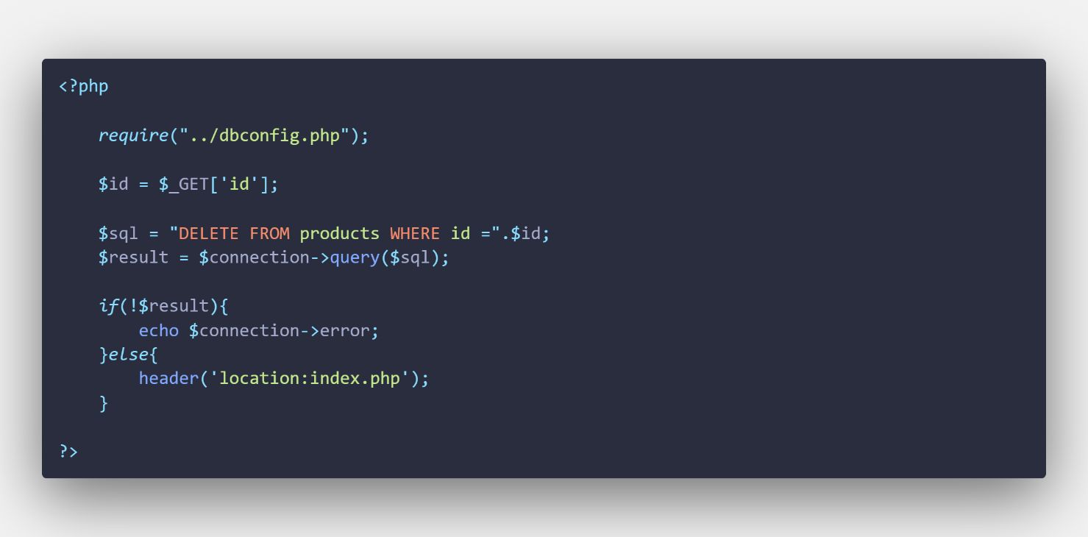

**Footer Page Code for Product Folder**

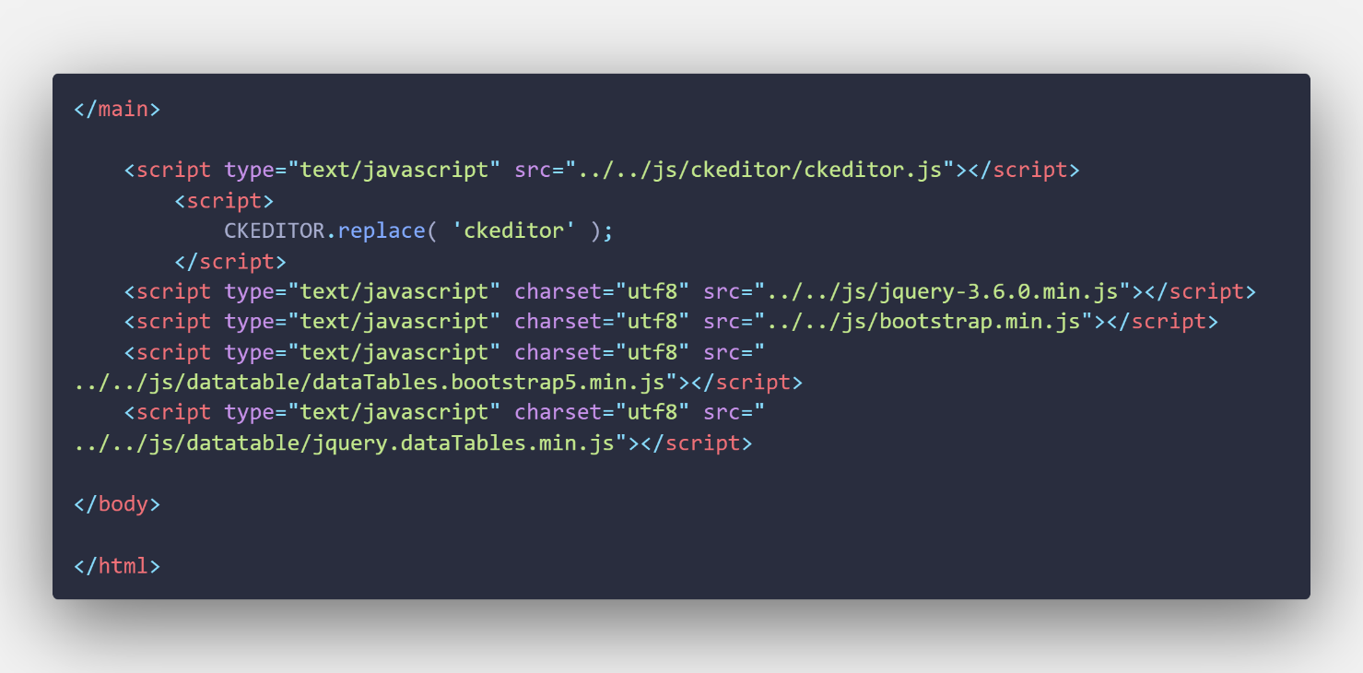

# Describe the Code in FAQ Folder

**Header Page Code for FAQ Folder**





**FAQ index page code**

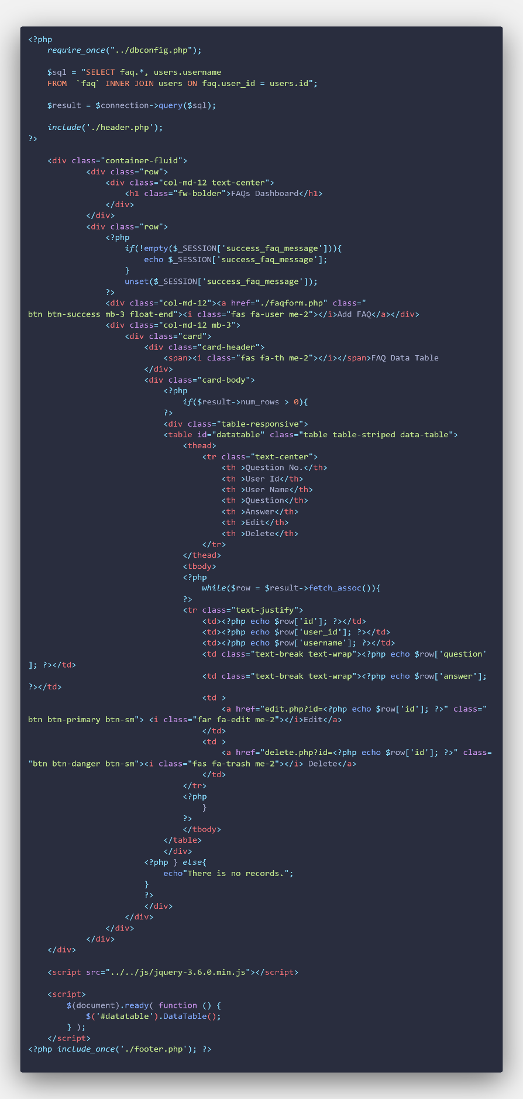

**FAQ From or FAQ Entry Page code**

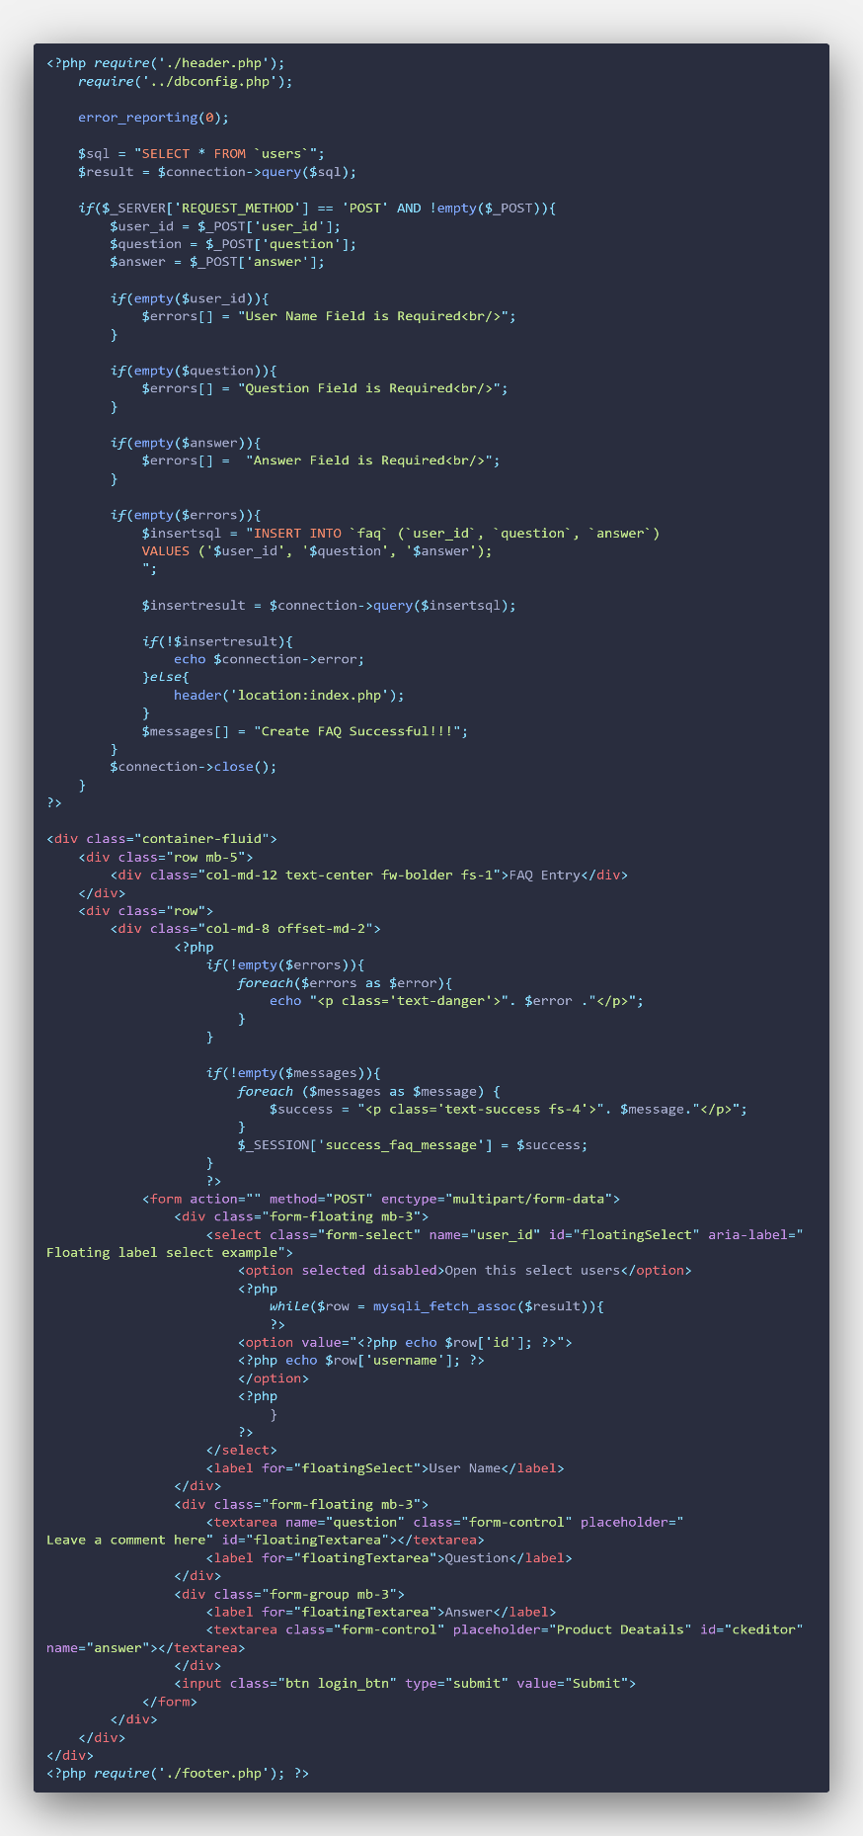

**FAQ Edit page**

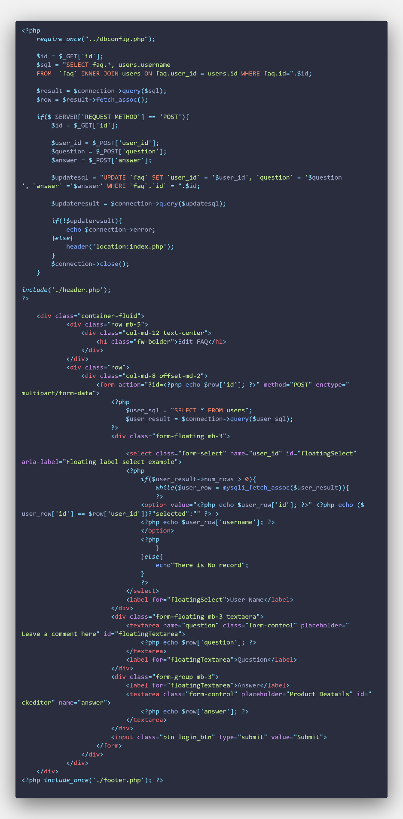

**Delete Page Code for FAQ Folder**

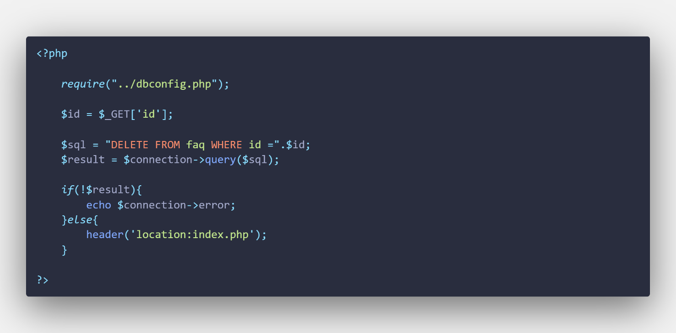

**Footer Page Code for FAQ Folder**



**CSS for admin pages**

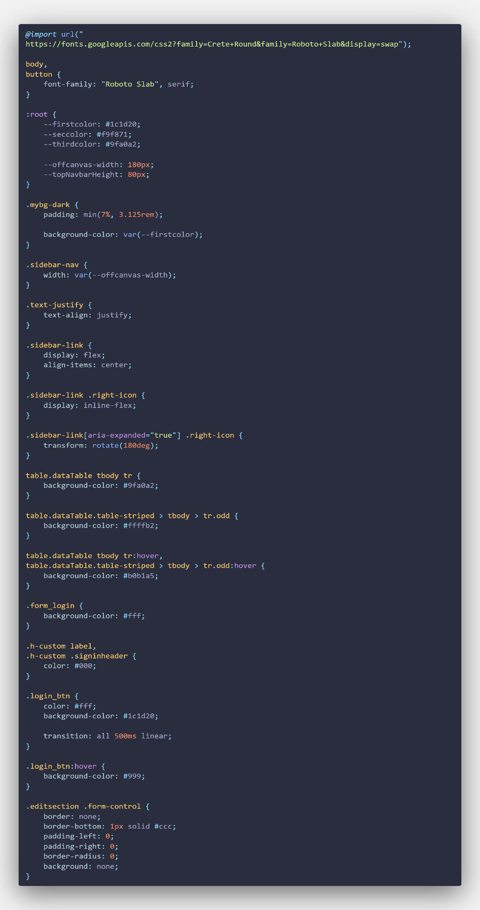

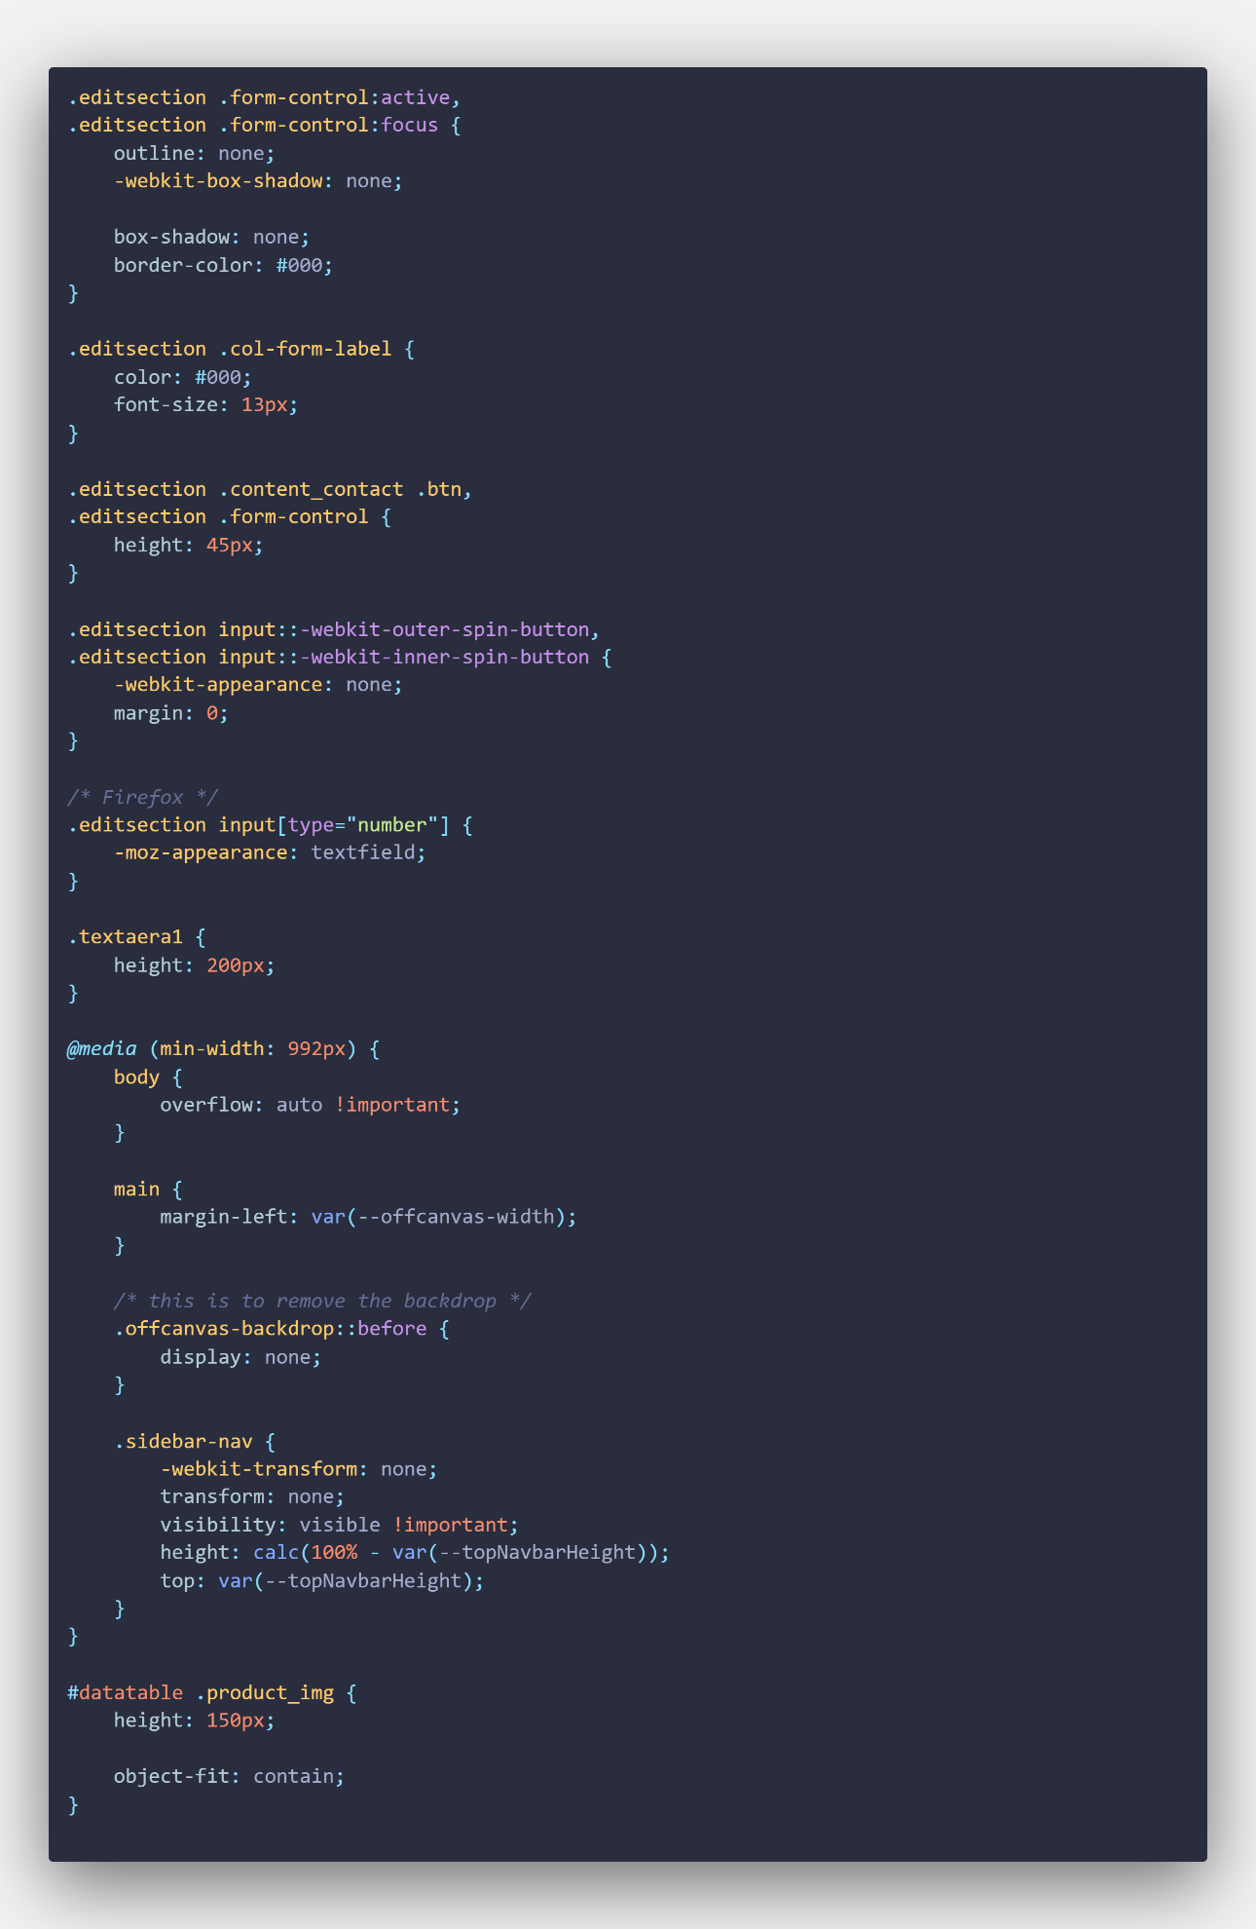

**Task 4**

Home Gym Equipment (HGE) is a corporation that specializes in the sale of sporting goods. Through the use of enterprise resource planning (ERP), the project websites are connected into the programmed website.

When developing HGE websites, web applications are critical to ensuring the website runs more efficiently and smoothly.   A web application cannot run without a Web server, an application server, and a database (Gibb, 2016). While web servers respond to user requests. A database can be used to store any type of data. The majority of Web apps are written in HTML5, CSS, JavaScript, and a variety of other languages. These languages are frequently used in client-side programming in order to assist in the development off web front-end. Server-side programming is frequently used to create the scripts that make up a Web application. Languages such as PHP are widely used in server-side programming.

Web Service is transferring data between separate software application. Web services require a network to communicate with one another, and this networking is typically accomplished via SOAP. SOAP encrypts data in XML, a widely used markup language for storing and sharing data, and transfers it via HTTP, the same protocol that web servers use to deliver web pages to browsers. To communicate with a web service, an application makes an XML request to the service, which responds with an XML-formatted response.

It should be emphasized that web services can also adhere to REST principles, however SOAP is the more prevalent web service design.

Each and every file in the folder is created in a systematic way.

In header page, there was connecting or linking CSS code to the fontawsome icon, css code and bootstrap framework code. So, the developer is writing the code that frame with bootstrap and customizing the CSS code. That why, the HGE website is responsive. So, the website can view with any device. Why header page is separated because it page will call every single page, and user can be used light weight and it also prevent the duplicate code.

In the navigation bar, it has the company logo, company name, six-page links and sign-up button. If the screen is smaller, the sign-up button will disappear.

In the home page, it has five image sliders, motivation texts and a sign-up button. If the screen is smaller the text will disappear.  It has two search functions, the Quick search and the Category search.  And then, there is a marquee text to buy the company's product. In the HGE, the bestselling products are described. This section makes the products were made to motivate the customer to buy. After that, the company was described as who they are. And then, the company described their vision and mission. The developer makes a content us form to advise their products and others.

In the product page, it has a lot of products that will describe and link to the product details page.

This page is dynamically created to connect with database. If the admin upload the new product, it will show the new product in the product page

In the service page, they provide three services in HGE.

In the about us page, the company described their story, COVID-19 pandemic, more about their vision and mission text. And then, there are review sections that have happy customers reviewing their website and products.  They describe the news and update their promotions, discounts, events and so on. After that, the company described their services like call center, free shipping and return and so on.

In the content page, there will be describe the company information and for more questions if the user wants to ask. And The developer describes the company's shopping center location to want to buy in the shopping center.

In the FAQ page, this page is dynamically created to connect with the database. the admin added the new faq question in the admin page, the faq question will dynamically show in the faq page. FAQ is an answer for commonly asking questions from users.

In the log in page, this page is created for user log in.

In the sign in page, this page is created for user sign in.

In the product detail page, if the user will click the product button, it will show about their product detail.

In the privacy policy page, it will describe how to take the user data and how to use the user data.

In the cookie policy page, this page shows their cookie.

In the payment page, the page provides payment for their product after clicking the buy now button in the product detail page.

In the web service page, this page is sharing the faq data to other customers.

In the footer section, there are three sections which are company information, quick links, subscribe the company news. After that footer, there is footer bottom which connect to the faq, privacy policy, cookie policy, make a copyright information and connect with social media link.

In footer page, there was also connecting or linking JavaScript.

Admin Dashboard

There are three admin dashboard that can only admin visible. They are user, product, and faq. The information about the user, the product, and the FAQ is maintained in a database that is linked to the administration dashboard. In user admin dashboard, admin can control or management the user data. In product admin dashboard, the admin only can add the new products. It will show dynamically show in product page. In faq admin dashboard, the admin the upload the FAQ data that is the process of the company organization and information. Some of the admin pages are using ck editor. This is because most developer recommend and when admin writing the content some text want to be bold, italic and etc, So, the developer add this library.

**Task 5**

There are a lot of errors and bugs in this project. The developer was used to HTML and CSS. But now, the developer is not only using the bootstrap frame to responsive their website and adding the custom CSS code to make attractive their website.

The website has some weakness. So, the company need to update the system. Now, all over coding are good but they had a lot of problems. They are forgetting add the div closing tag, calling wrong class name or id name and installing wrong bootstrap version and wrong version class name and template. Some functions are not complete yet. After doing the assignment, the developer want ed to update the user log in and register. The privacy page and cookie page want to extend to dynamically like faq page.

"The experience obtained from the project, regardless of whether or not it earned a good grade, may be extremely beneficial in achieving the goals," the view is when the project is completed and the desirable portion is mixed. However, after employing Bootstrap, the website is responsive and has components, whereas it did not previously solve some of these very essential concerns.

# References

Gibb, R., 2016. *blog.stackpath.com.* [Online]   
Available at: https://blog.stackpath.com/web-application/  
[10 2 2022].